Recruiting Assistance For The HR Managers

## NAAN MUDHALVAN PROJECT REPORT

Submitted by

## KIRUTHIKA D (au620120104049)

**JEEVITHA T (au620120104040) AASHA BEGUM A (au620120104501)**

## KOKILA J

**(au620120104050)**

*In partial fulfillment of the award of the degree* of

## BACHELOR OF ENGINEERING

*in*

## COMPUTER SCIENCE AND ENGINEERING

**AVS ENGINEERING COLLEGE AMMAPET, SALEM- 636 003**

**ANNA UNIVERSITY :: CHENNAI 600 025**

# BONAFIDE CERTIFICATE

## Certified that this project report **“Recruiting Assistance For The HR Managers**” is the bonafide work of “KIRUTHIKA D (au620120104049), JEEVITHA T (au620120104040), AASHA BEGUM A (au620120104501), KOKILA J (au620120104050)**”** who carried out the project work under my supervision.

## SIGNATURE SIGNATURE

**HEAD OF THE DEPARTMENT**

## Prof. V. Meena, M.E.,

**PROJECT SUPERVISOR**

## Mr. G. ArokiaNathan, M.E.,

Assistant Professor, Department of CSE,

AVS Engineering College, Salem- 636003.

Assistant Professor, Department of CSE,

AVS Engineering College, Salem- 636003.

**SPOC HEAD OF THE DEPARTMENT**

# ACKNOWLEDGEMENT

We would like to express our gratitude and appreciation to all those who gave us the possibility to complete this report. We would like to acknowledge with much appreciation to our honorable Chairman, **Shri.K.KAILASAM**, Secretary, **Shri.K.RAJAVINAYAKAM, MBA.,** and also to our Correspondent, **Shri.K.SENTHILKUMAR, B.Tech.,** for providing all necessary facilities for the successful completion of the project.

We have immense pleasure in expressing our gratitude to our beloved Principal, **Dr.J.SUNDARARAJAN, M.E,Ph.D.,** for allowing us to have extensive use of our college facilities to do this project. It gives us a great sense of pleasure in expressing our gratefulness to our beloved Vice Principal’s, **Dr.R.VISWANATHAN, M.E.,Ph.D.,** and **Dr.D.R.JOSHUA, M.E.,Ph.D.,** for

their professional guidance in scheduling the project work to complete on time.

We express our heartiest gratitude to **Dr.M.VILASINI, M.E.,Ph.D.,** Dean R&D and Head of the Department **Prof.V.MEENA, M.E.,** Department of Computer Science and Engineering for her guidance and encouragement throughout the Project Period. We are indebted to our project coordinator **Mr. G. AROKIANATHAN, M.E.,** Assistant Professor for their constant help and excellent direction.

We specially thank all our Teaching and Non-Teaching Staff Members and Lab Technicians of the **Computer Science and Engineering** for their consistent encouragement to do the project work with full interest and zeal. We pay our profound gratitude to the Almighty God for his invisible vigilance and would like to thank our Parents for giving us support, encouragement and guidance throughout the course of our work.

# TABLE OF CONTENTS

## Chapter No

**LIST OF FIGURES**

## Title Page No

**5**

1. PROJECT SPECIFICATION 6
   1. Project Goal 6
   2. Project Scope 7
   3. Problem Statement Definition 8
   4. Empathy Map Canvas 8
   5. Proposed Solution 10
   6. Functional & Technical Requirements 11
   7. Project Road Map 12
2. PREPARATION DATA MODELING 14
   1. Salesforce Developer Org 14
   2. Object Creation 16
   3. Tabs 18
   4. The Lightning App 20
   5. Fields and Relationship 21
   6. Page Layouts
3. USERS & DATA SECURITY 24
   1. Profile 24
   2. Setup Roles 30
   3. Users 32
   4. Permission Set 34
   5. Setup for OWD

3.4 User Adoption

1. AUTOMATION 41
   1. Flow 41
   2. Apex Trigger
2. REPORTS & DASHBOARD 43
   1. Reports 43
   2. Dashboard 47
3. **CONCLUSION 49**
4. **Project Demonstration 50**

GitHub & Project Video Demo Link

## LIST OF FIGURES

|  |  |  |
| --- | --- | --- |
| **Figure No** | **Name of Figure** | **Page No** |
| 1.7.1 | Data Flow Diagram | 12 |
| 1.7.2 | Technical Architecture | 13 |

## ProjectGoal

# CHAPTER-1

# PROJECT SPECIFICATION

The project goal for "Recruiting Assistance For The HR Managers Salesforce Project" is to ensure the successful and efficient recruitment of qualified individuals to support the HR managers in implementing and managing a Salesforce project. The specific project goals can be broken down as follows:

* + - **Staffing:** Ensure that the project team is appropriately staffed with skilled professionals in roles such as Salesforce administrators, developers, consultants, and project managers.
    - **Competency Alignment:** Match the skills and competencies of the recruited candidates with the specific technical and soft skill requirements of the Salesforce project.
    - **Efficiency:** Streamline the recruitment process to minimize the time and resources required to identify, interview, and onboard the right talent.
    - **Quality:**  Focus on recruiting high-quality candidates who can contribute effectively to the success of the Salesforce project.

The ultimate project goal is to provide the HR managers with the right team of professionals who can successfully implement and manage the Salesforce project, contributing to its overall success and efficiency. This requires careful planning, recruitment, on-boarding, and ongoing support throughout the project's life cycle.

## Project Scope

The primary objective of this project is to provide comprehensive recruiting support for the implementation of the Salesforce project led by HR managers.This project will focus on identifying, selecting, and onboarding the right talent to support the successful execution and management of the Salesforce project. The recruitment efforts will be tailored to the specific needs of the project, including positions like Salesforce administrators, developers, consultants, and project managers.

**Key Deliverables:**

**-**  The project's key deliverables include:

a. Job descriptions for all required positions.

b. Shortlisted and qualified candidates for each position.

c. Conducted interviews and assessments.

d. Verified candidate references.

e. Successfully extended offers to selected candidates.

f. Facilitated the onboarding process for new hires.

g. Feedback and performance monitoring reports.

**Project Boundaries:**

This project will focus on the recruitment and onboarding aspects only. It does not include ongoing HR management, salary negotiations, or performance evaluations, which will be handled by the HR department.

**Approval:**

This project scope statement is subject to approval by HR managers and relevant project stakeholders.

**Project Timeline:**

The project will commence on [02/10/2023] and is expected to be completed by [31/10/2023], with specific milestones and deadlines to be outlined in the project plan.

**Risks:**

Potential risks for this project may include difficulties in finding qualified candidates, budget constraints, and extended timeframes for the recruitment process.

**Stakeholders:**

The primary stakeholders for this project include HR managers, project managers, recruiting team members, and candidates being recruited.

**Assumptions:**

The project assumes that HR managers and project stakeholders will provide clear and timely communication on the specific job requirements and objectives for the Salesforce project.

## Problem Statement Definition

|  |  |  |  |
| --- | --- | --- | --- |
| **Problem for** | **Trying to** | **But** | **Which makes** |
| **HR Managers** | The project aims to source and onboard qualified individuals proficient in Salesforce administration, development, consulting, and project management to support the successful execution of the Salesforce project led by HR managers. | The current recruitment approach lacks specificity and efficiency, resulting in extended hiring timelines, difficulty in identifying suitable candidates, and potential mismatch between the skill set required for the Salesforce project and the recruited talent. | This situation creates a bottleneck in the timely and effective implementation of the Salesforce project, leading to increased project risks, potential delays, and a higher probability of onboarding individuals who might not be optimally aligned with the project's needs and objectives. |

## Empathy Map Canvas

An empathy map is a simple, easy-to-digest visual that captures knowledge about a user’s behavior and attitudes.

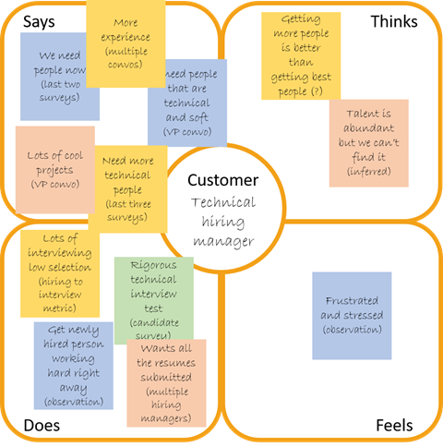

## Proposed Solution

|  |  |  |  |  |  |
| --- | --- | --- | --- | --- | --- |
| **S. No** | **Parameter** | | | | **Description** |
| 1. | Job Description Refinement  **Job Description Refinement** | | | | Create detailed and precise job descriptions for each role required for the Salesforce project, including Salesforce administrators, developers, consultants, and project managers. These descriptions should clearly outline the technical and soft skills needed, as well as the project's objectives. |
| 2. | Specialized Recruitment Channels | | | | Utilize specialized recruitment channels and platforms to target individuals with expertise in Salesforce. This can include Salesforce-specific job boards, professional networking sites, and partnerships with industry associations to reach a more focused talent pool. |
| **Th** |  |  | |
| 3. | Focused Interview Process | **Pains** | |  | Implement a structured interview process that assesses both technical skills related to Salesforce and interpersonal skills relevant to teamwork and project management. Consider including technical assessments and scenario-based questions related to Salesforce to evaluate candidates effectively |
|  | | | |
| 4. | Reference Verification | **Gains** | |  | Facilitate a smooth onboarding process for new hires, which includes providing project-specific training and resources. Ensure that the recruited team members are integrated seamlessly into the Salesforce project, allowing them to contribute quickly and efficiently. |
|  | | | |
| 5.. | Onboarding Support  **Feels** | | | | acilitate a smooth onboarding process for new hires, which includes providing project-specific training and resources. |
| Performance Monitoring and Feedback  6. |  | | | | This allows for tracking the effectiveness of the recruited team members and making necessary adjustments to ensure their success within the project. |
|  | **Does** | |  |

## Functional & Technical Requirements

* + 1. Functional Requirements

|  |  |  |  |
| --- | --- | --- | --- |
| **Requirement** | | | **Description** |
| **Compliance Tracking** | | | Ensure that the system supports compliance with labor laws and regulations, including documentation and reporting requirements |
| **Reporting and Analytics** | | | Provide reporting and analytics features to generate insights into the recruitment process, such as time-to-fill, cost per hire, and candidate source effectiveness. |
| **User Access Control** | | | Implement user access control to ensure that only authorized individuals have access to candidate information and recruitment data |
| **Integration with HR Systems** | | | Integrate with existing HR and project management systems to share relevant data seamlessly and avoid redundancy |
| **Scalability** | | | Ensure the system is scalable to handle an increasing number of recruitment activities as the project grows or evolves. |
|  | **Mobile Accessibility** |  | The system should be accessible on mobile devices to enable HR managers and project stakeholders to manage recruitment tasks while on the go |
|  | | |

* + 1. Technical Requirements

|  |  |  |  |  |  |  |  |
| --- | --- | --- | --- | --- | --- | --- | --- |
| **Requirement** | | | | | | | **Description** |
|  | | | **System Documentation** |  | | | Maintain comprehensive system documentation that includes system architecture, user manuals, and technical specifications to assist in troubleshooting and future enhancements |
|  | | | | | | |
| **Data Security** | | | | | | | Robust data security measures, such as encryption and access controls, should be in place to protect sensitive customer  information and transaction data. |
|  | | **Scalability and Load Testing** | | | |  | Perform scalability and load testing to ensure that the system can handle a surge in recruitment activities without performance degradation |
|  | | | | | | |
| **Technical Support** | | | | | | | Establish a support mechanism for technical issues and software maintenance to address bugs, updates, and enhancements promptly |
| **User-Friendly Interface** | | | | | | | The system should feature a user-friendly interface to ensure ease of use and rapid  adoption by our staff.. |
|  | **Technical Support and Updates** | | | |  | | Ongoing technical support, system maintenance, and regular updates should be provided to keep the system up  to date and secure. |
|  | | | | | | |

## Project Road Map

* + 1. Data Flow Diagram

A Data Flow Diagram (DFD) is a traditional visual representation of the information flows within a system. A neat and clear DFD can depict the right amount of the system requirement graphically. It shows how data enters and leaves the system, what changes the information, and where data is stored.

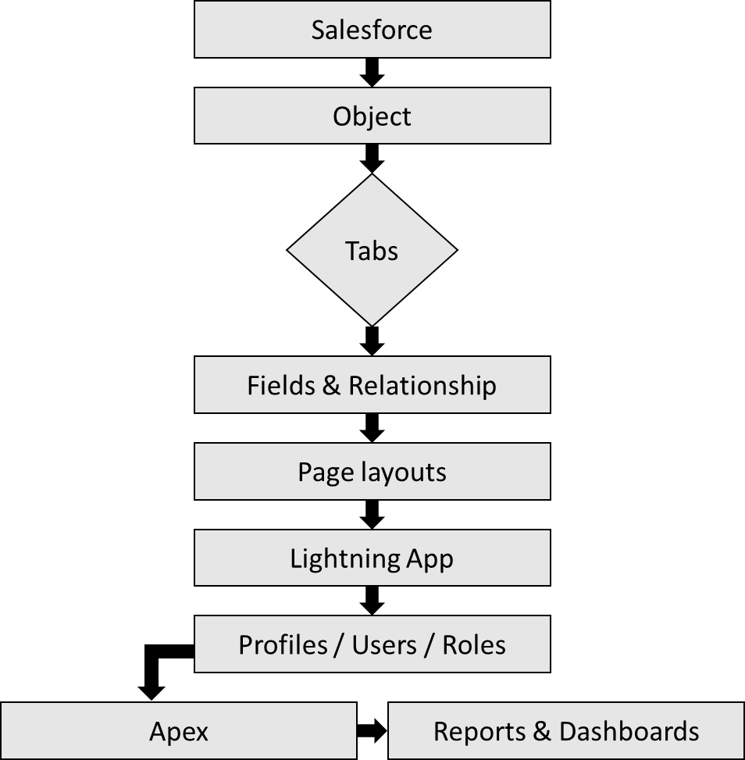

* + 1. Technical Architecture

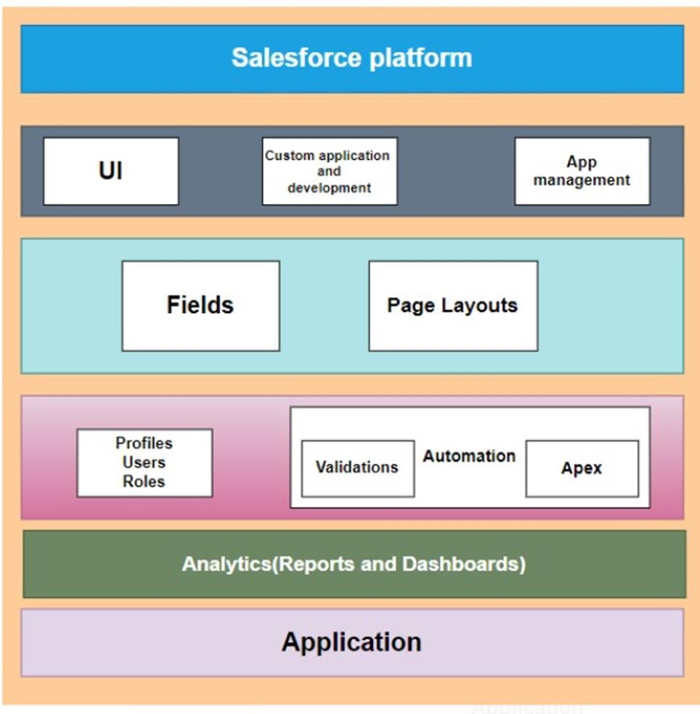

# CHAPTER-2 PREPARATION DATA MODELING

## Salesforce Developer Org

In Salesforce, a Developer Sign Up or Developer Edition is a special type of Salesforce environment that is primarily used for development, testing, and learning purposes.

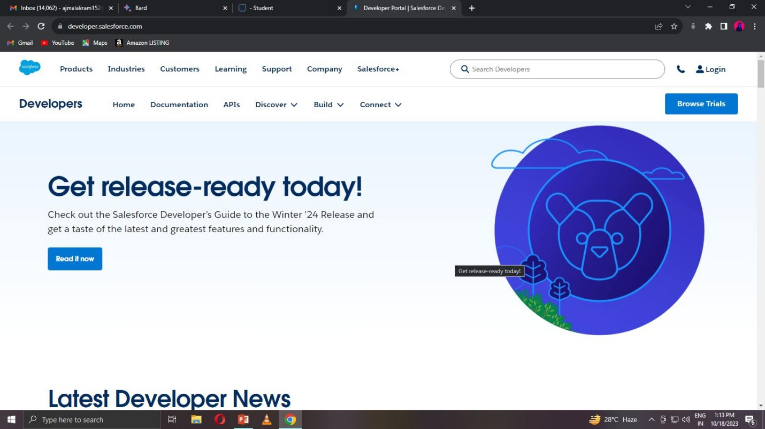

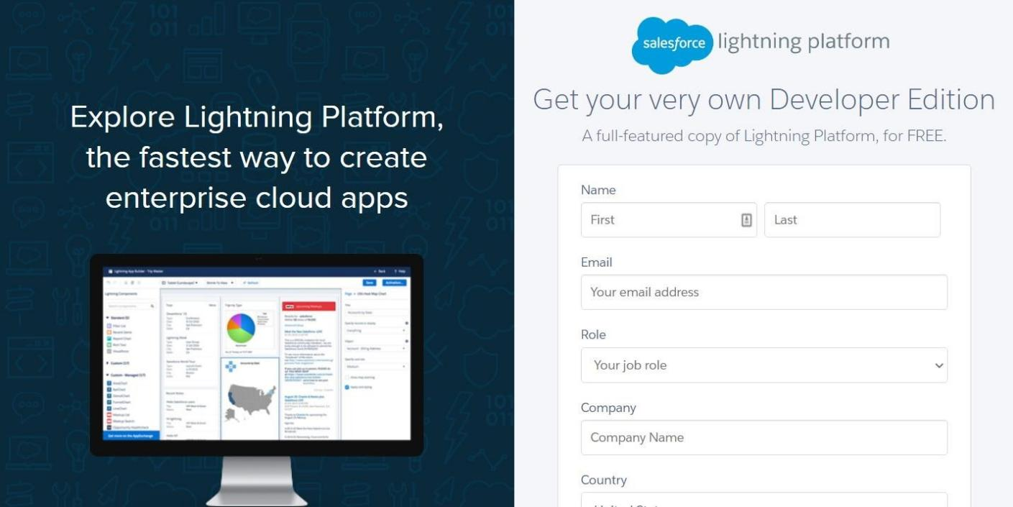

## Account Activation

Activation tracks information about devices from which users have verified their identity.

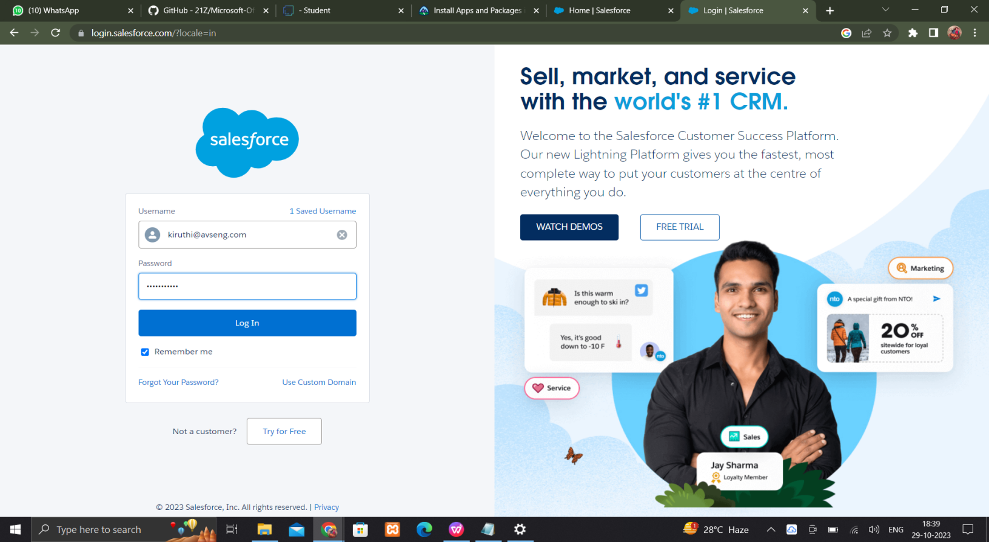

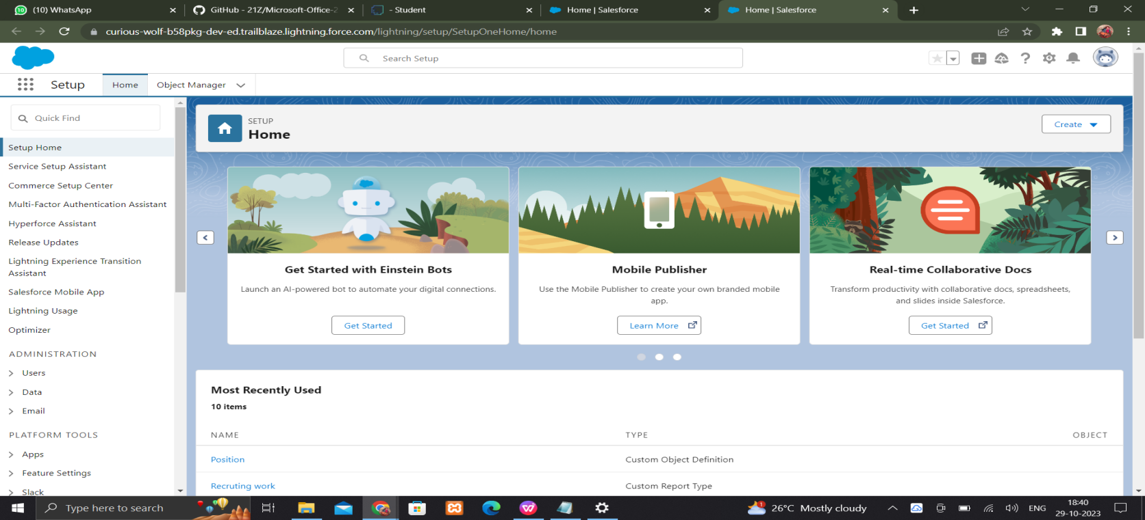

## Object Creation

Salesforce objects are database tables that permit you to store data that is specific to an organization. Salesforce objects are of two types: Standard Objects: Standard objects are the kind of objects that are provided by salesforce.com such as users, contracts, reports, dashboards, etc. Custom objects: job posting sites,Reviews and Job posting

## Create the Job posting site Object

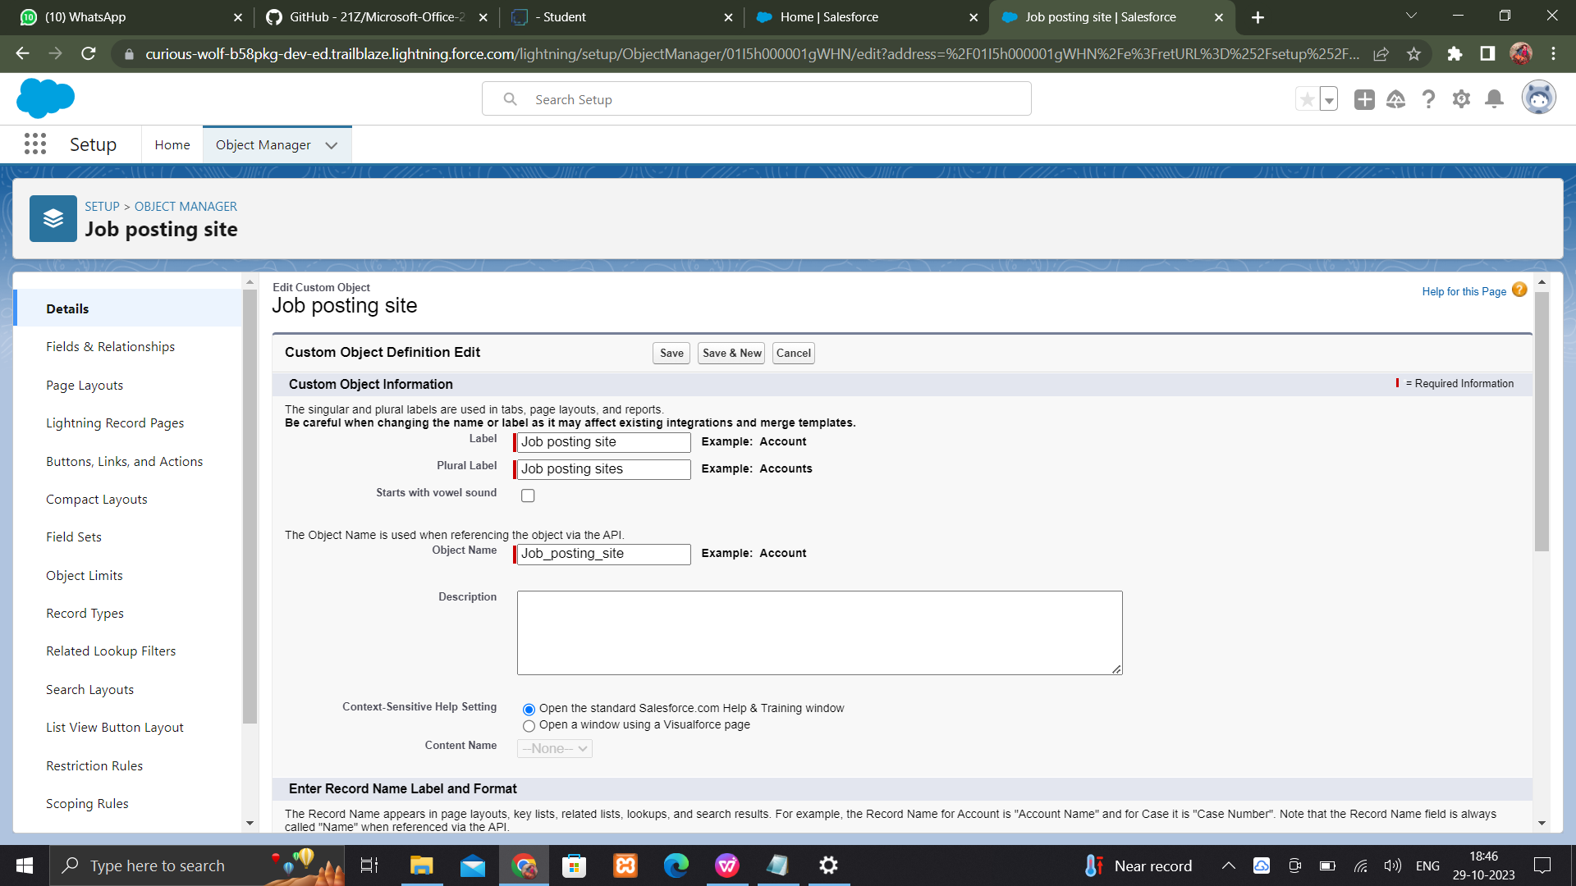

**Create the Job posting Object**

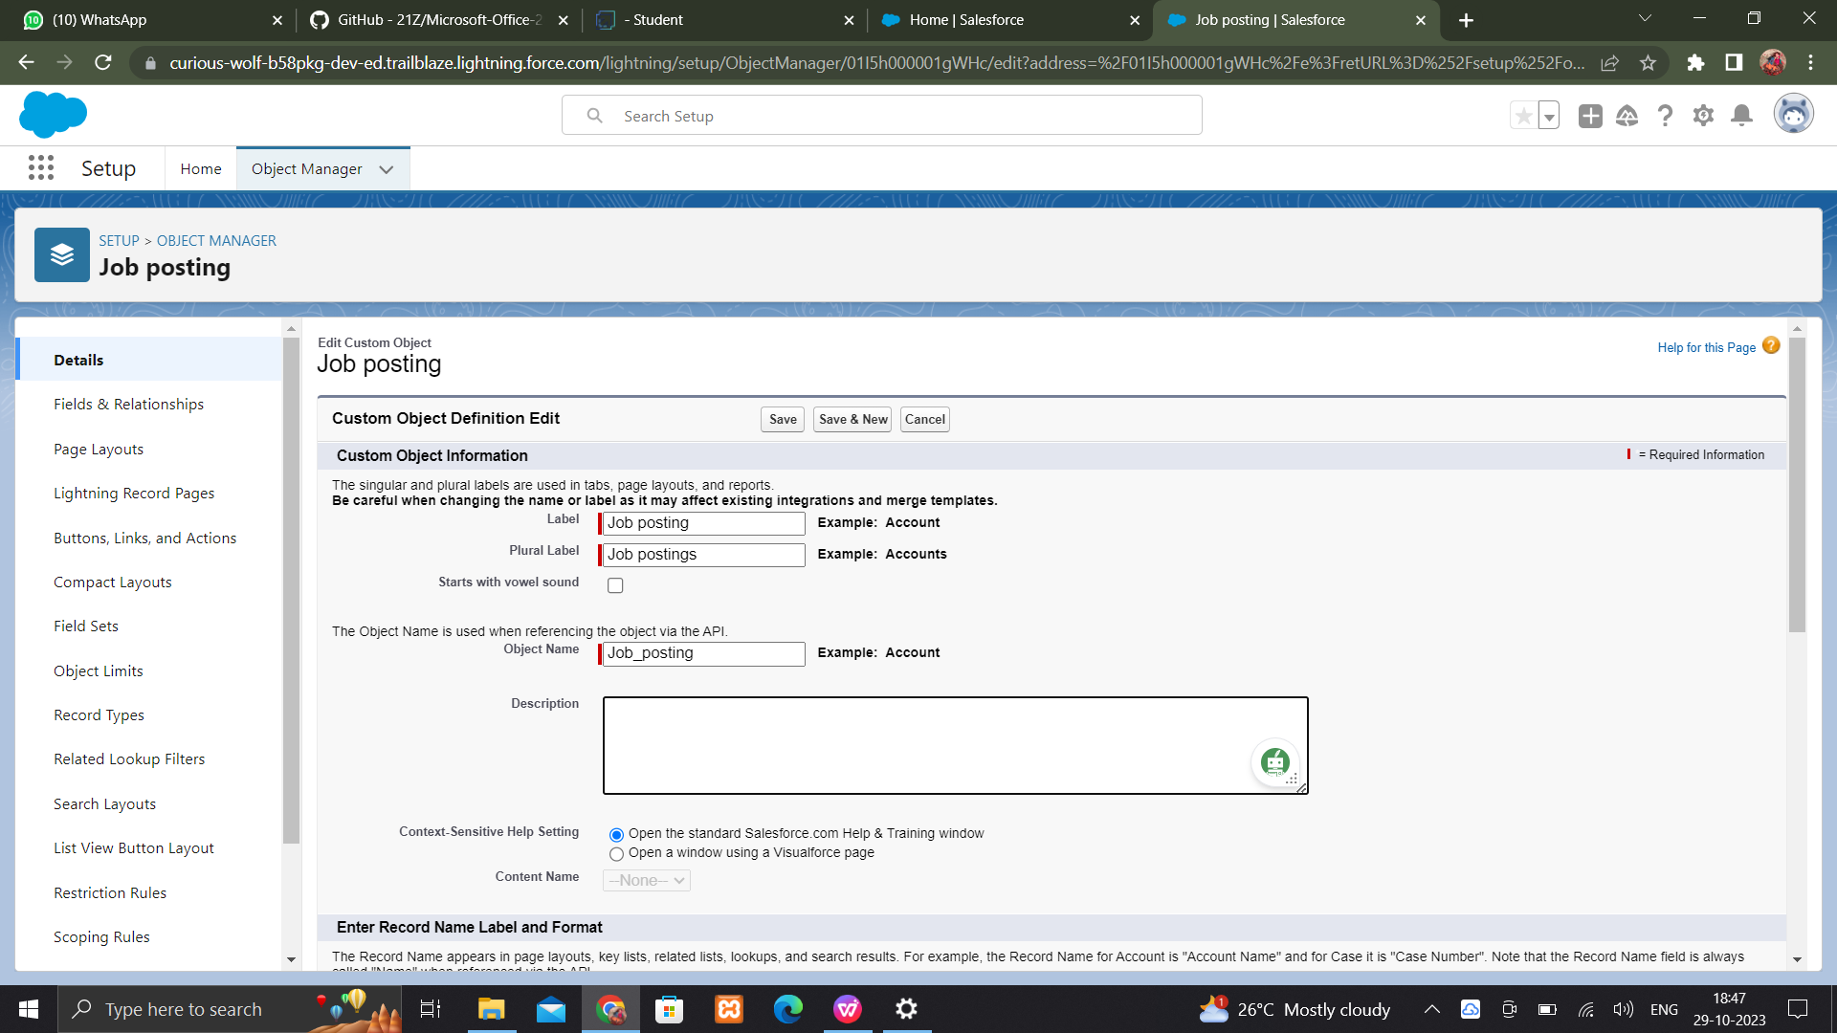

## Create the Review Object

## Screenshot (40)

**Create the junction object**

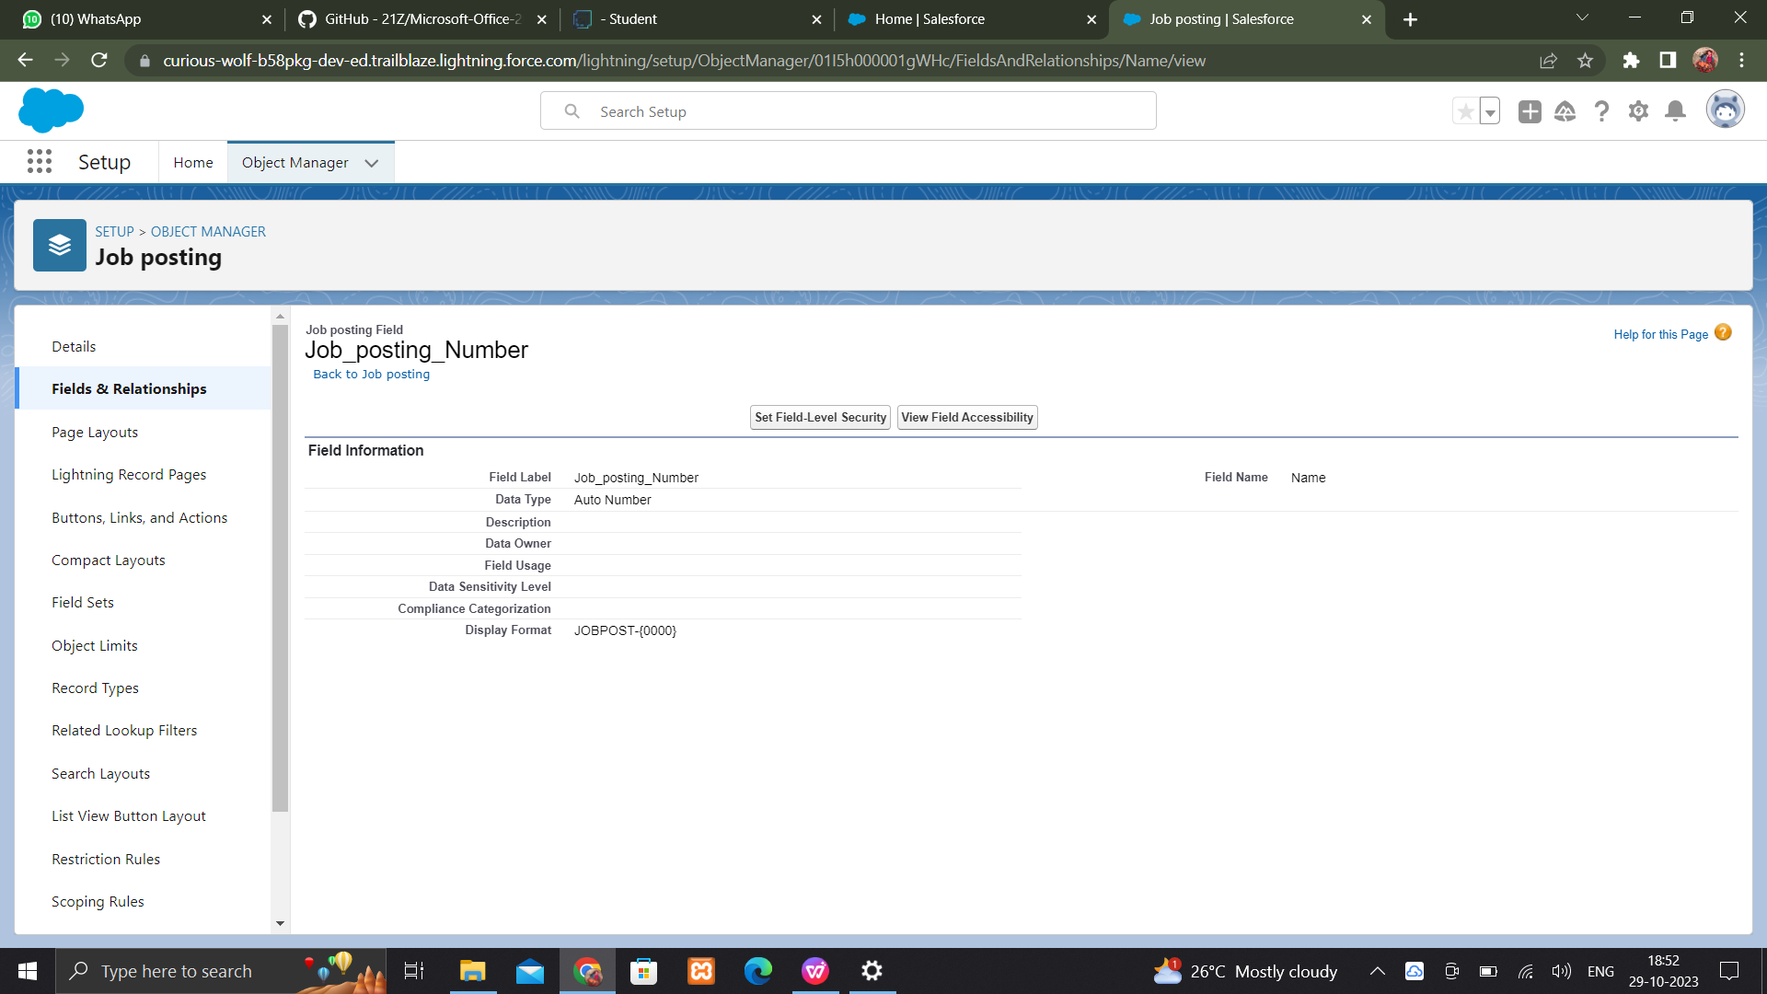

## Tabs

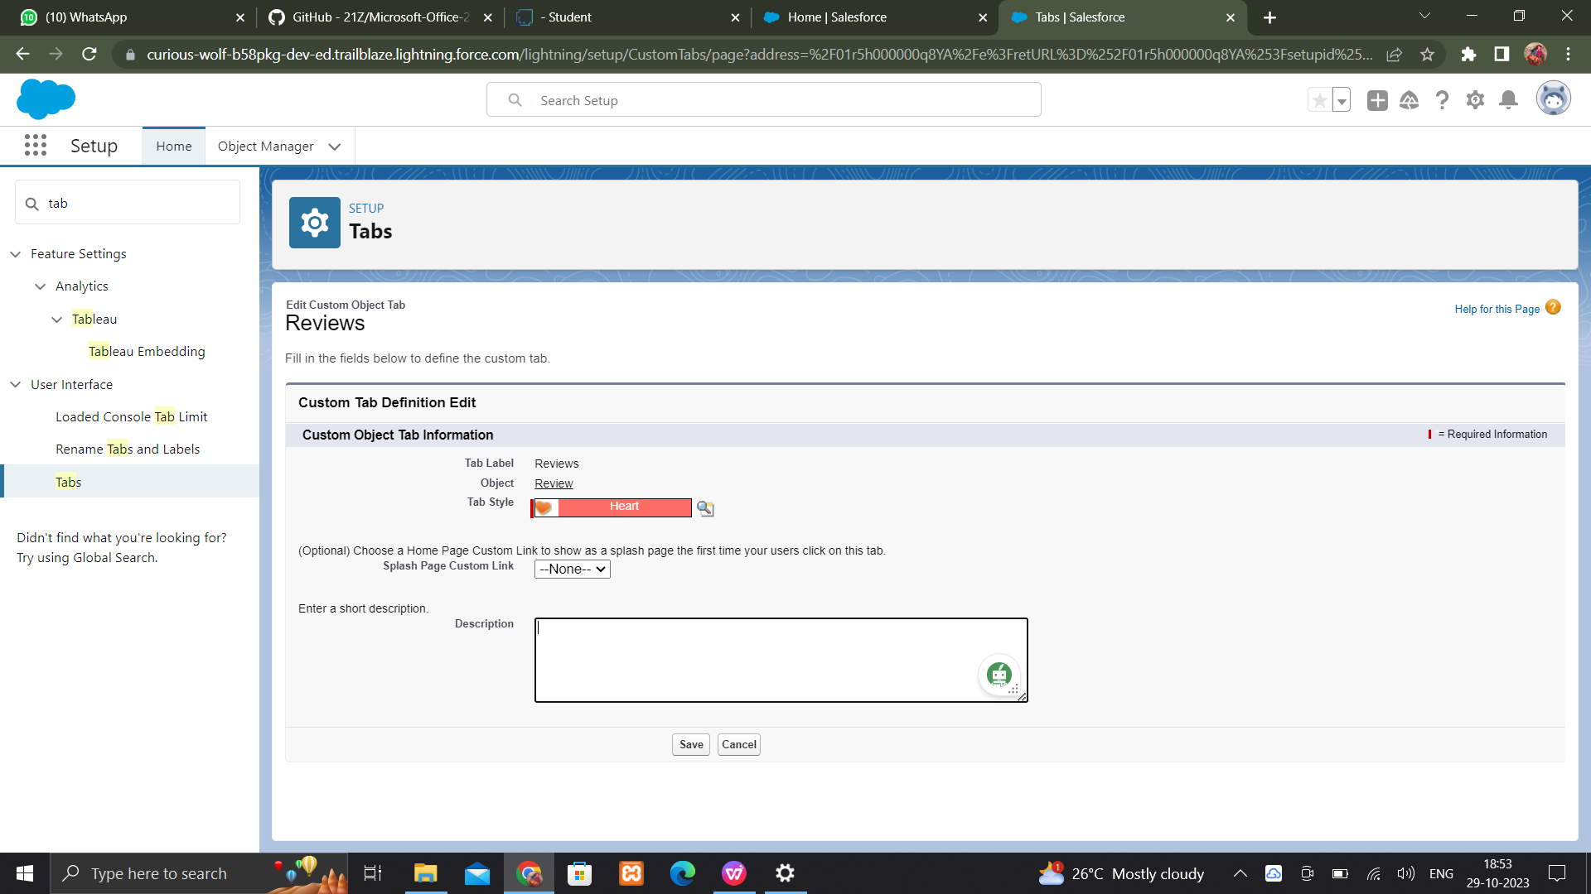

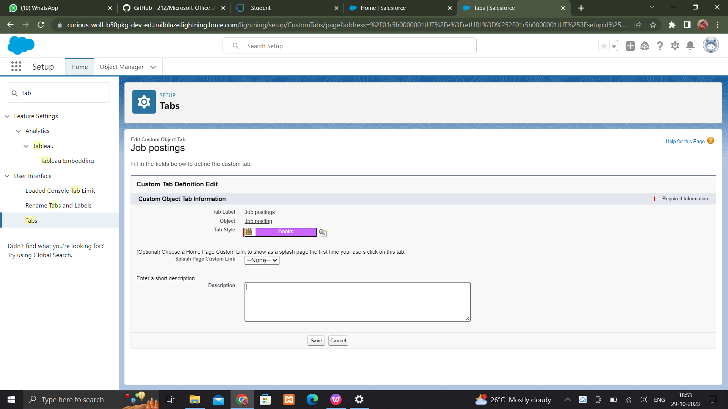

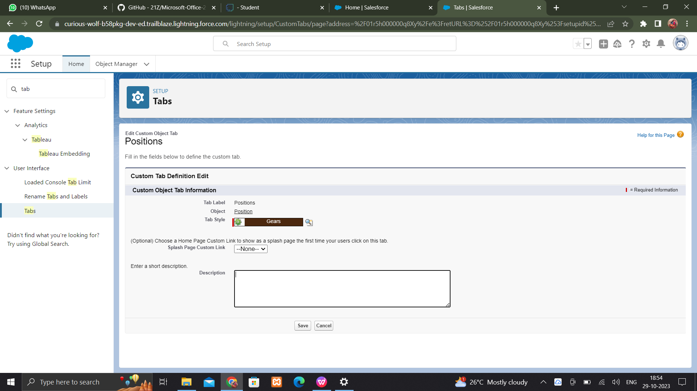

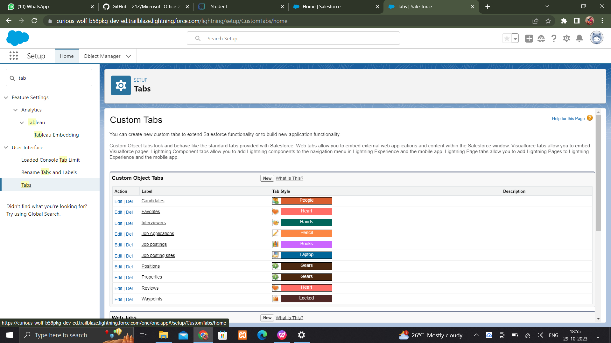

## The Lightning App

An app is a collection of items that work together to serve a particular function. In Lightning Experience, Lightning apps give your users access to sets of objects, tabs, and other items all in one convenient bundle in the navigation bar.

Lightning apps let you brand your apps with a custom color and logo. You can even include a utility bar and Lightning page tabs in your Lightning app. Members of your org can work more efficiently by easily switching between apps.

## Create a Lightning App

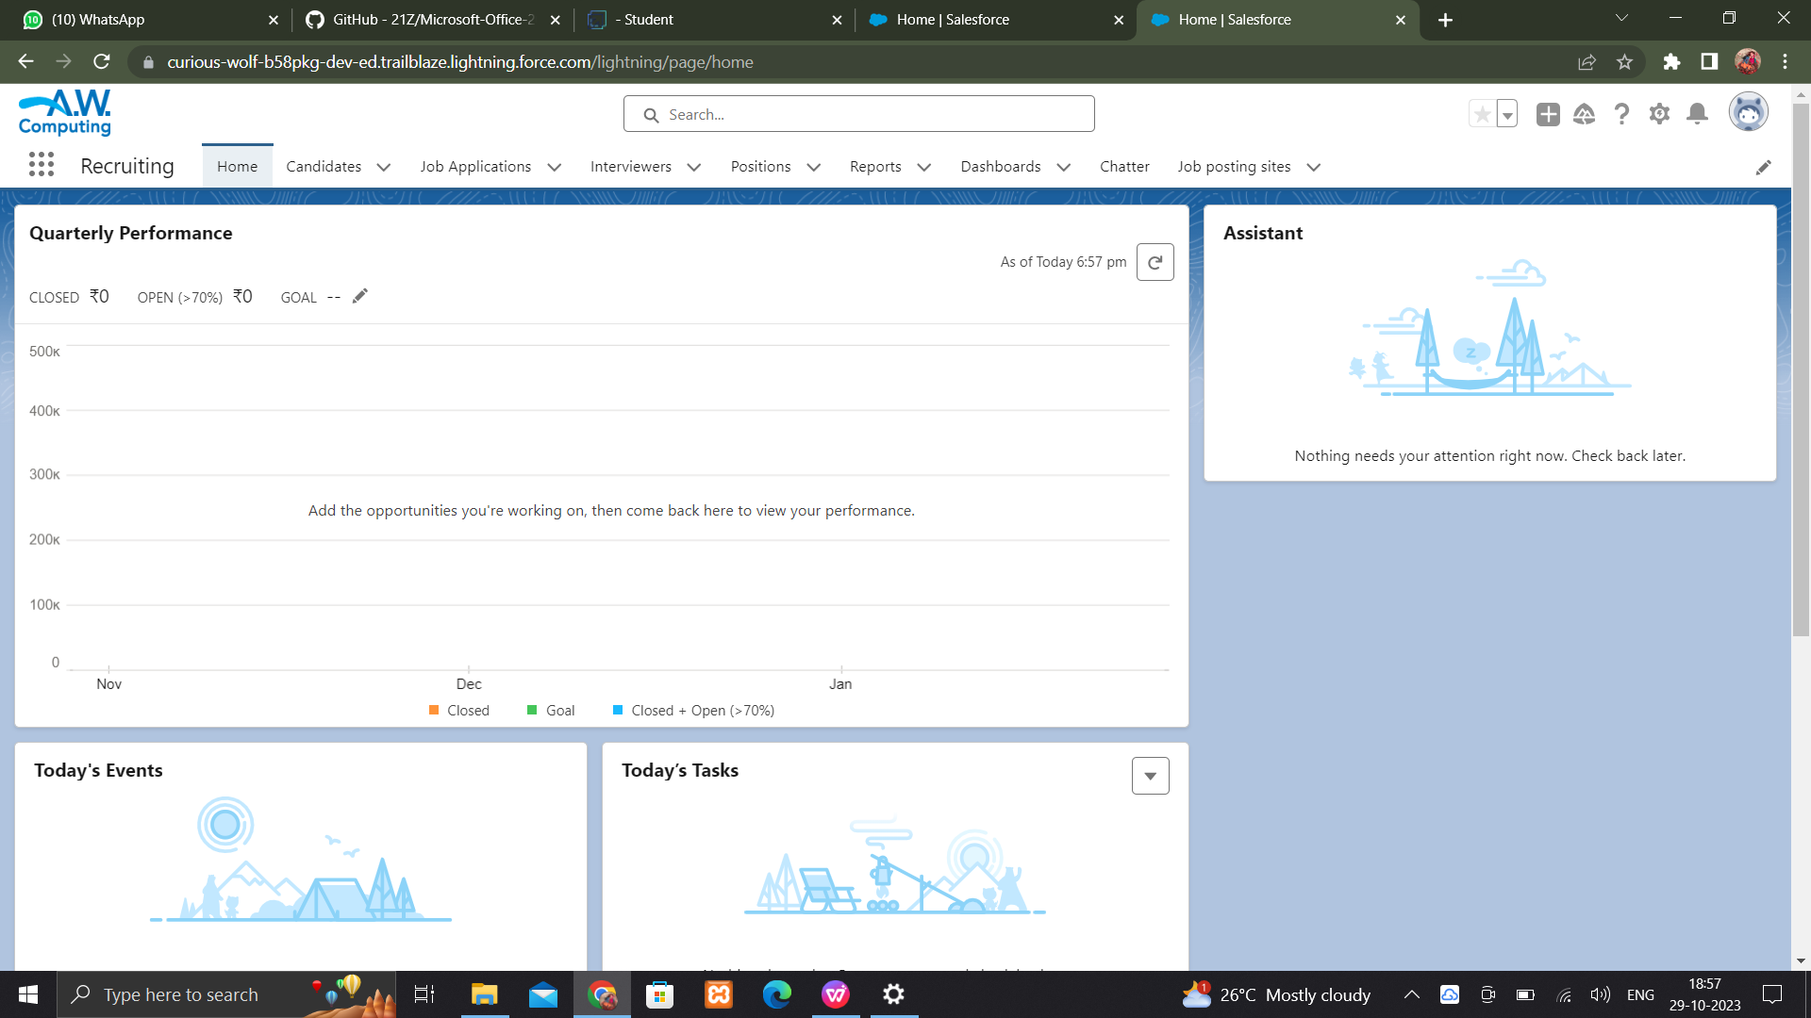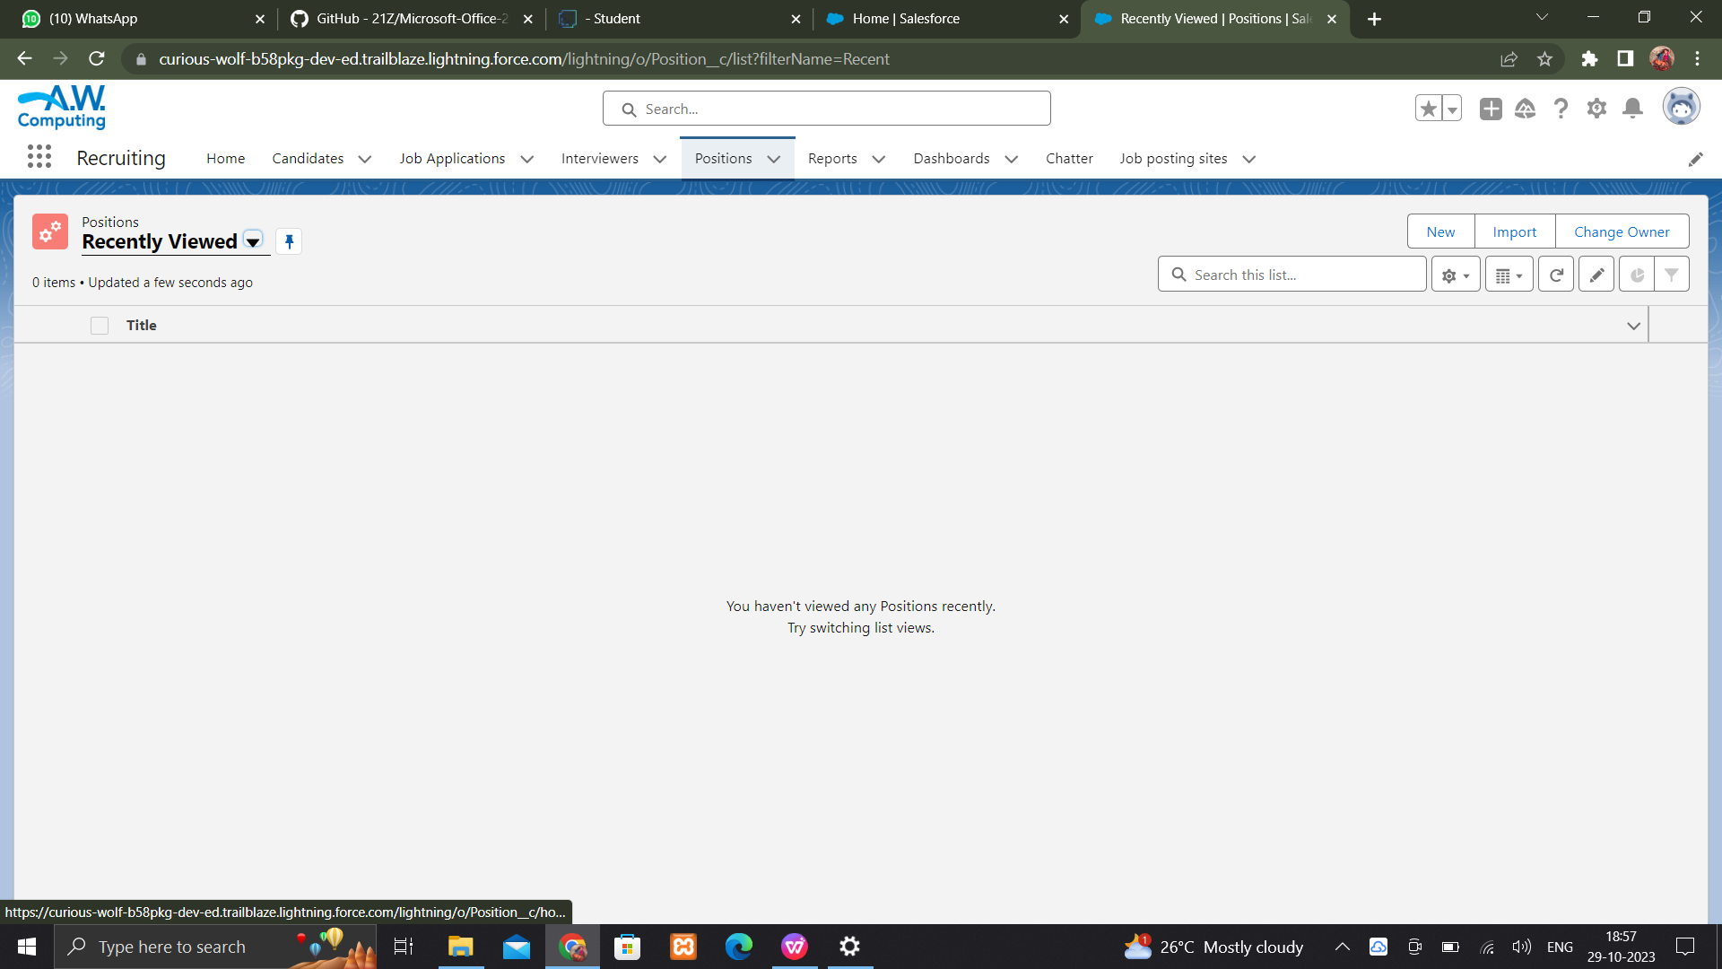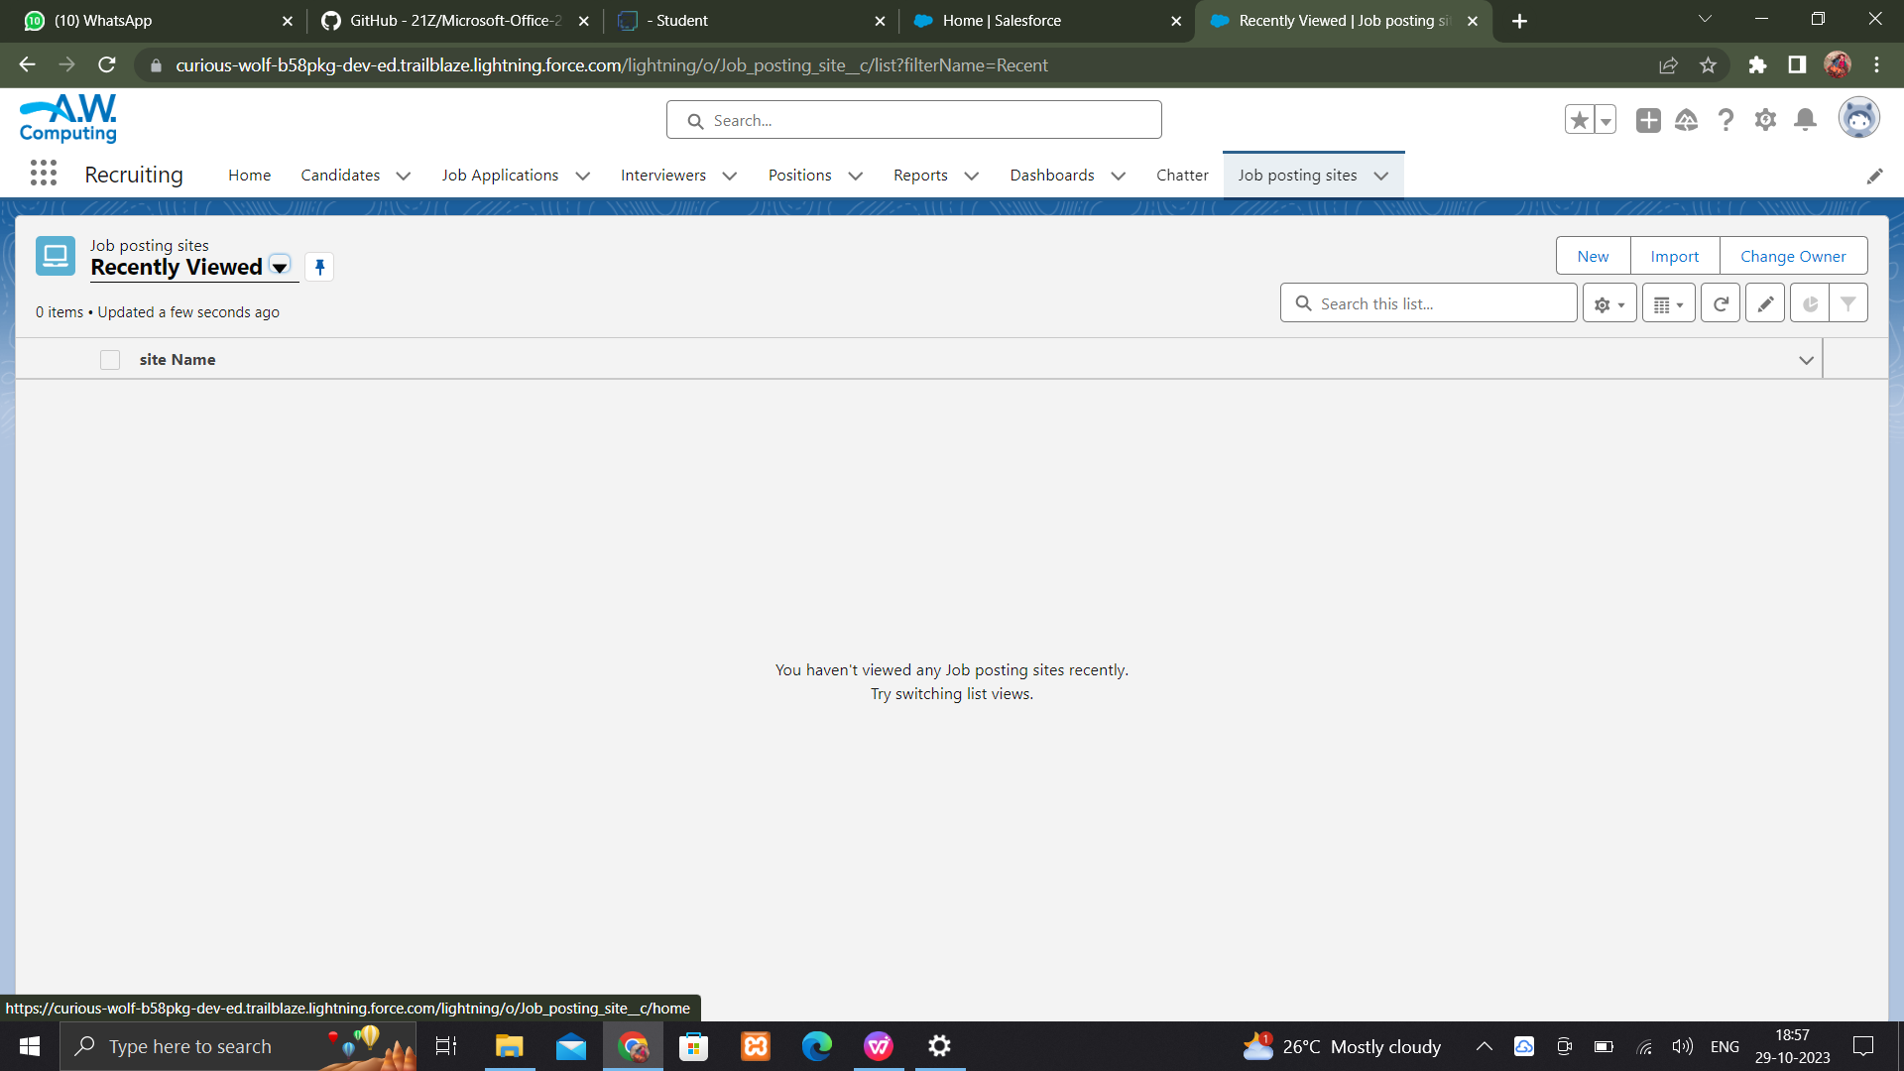

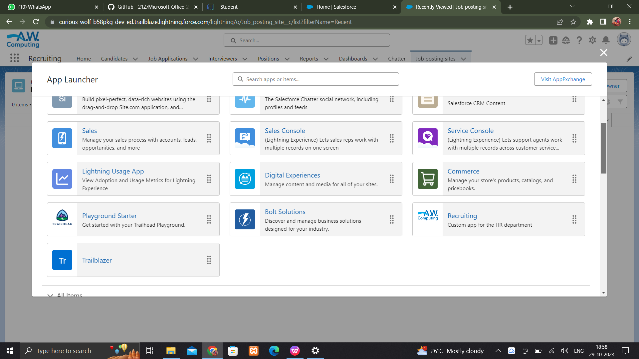

## Fields and Relationship

An object relationship in Salesforce is a two-way association between two objects. Relationships are created by creating custom relationship fields on an object. This is done so that when users view records, they can also see and access related data.

## Fields in Job posting sites Objects

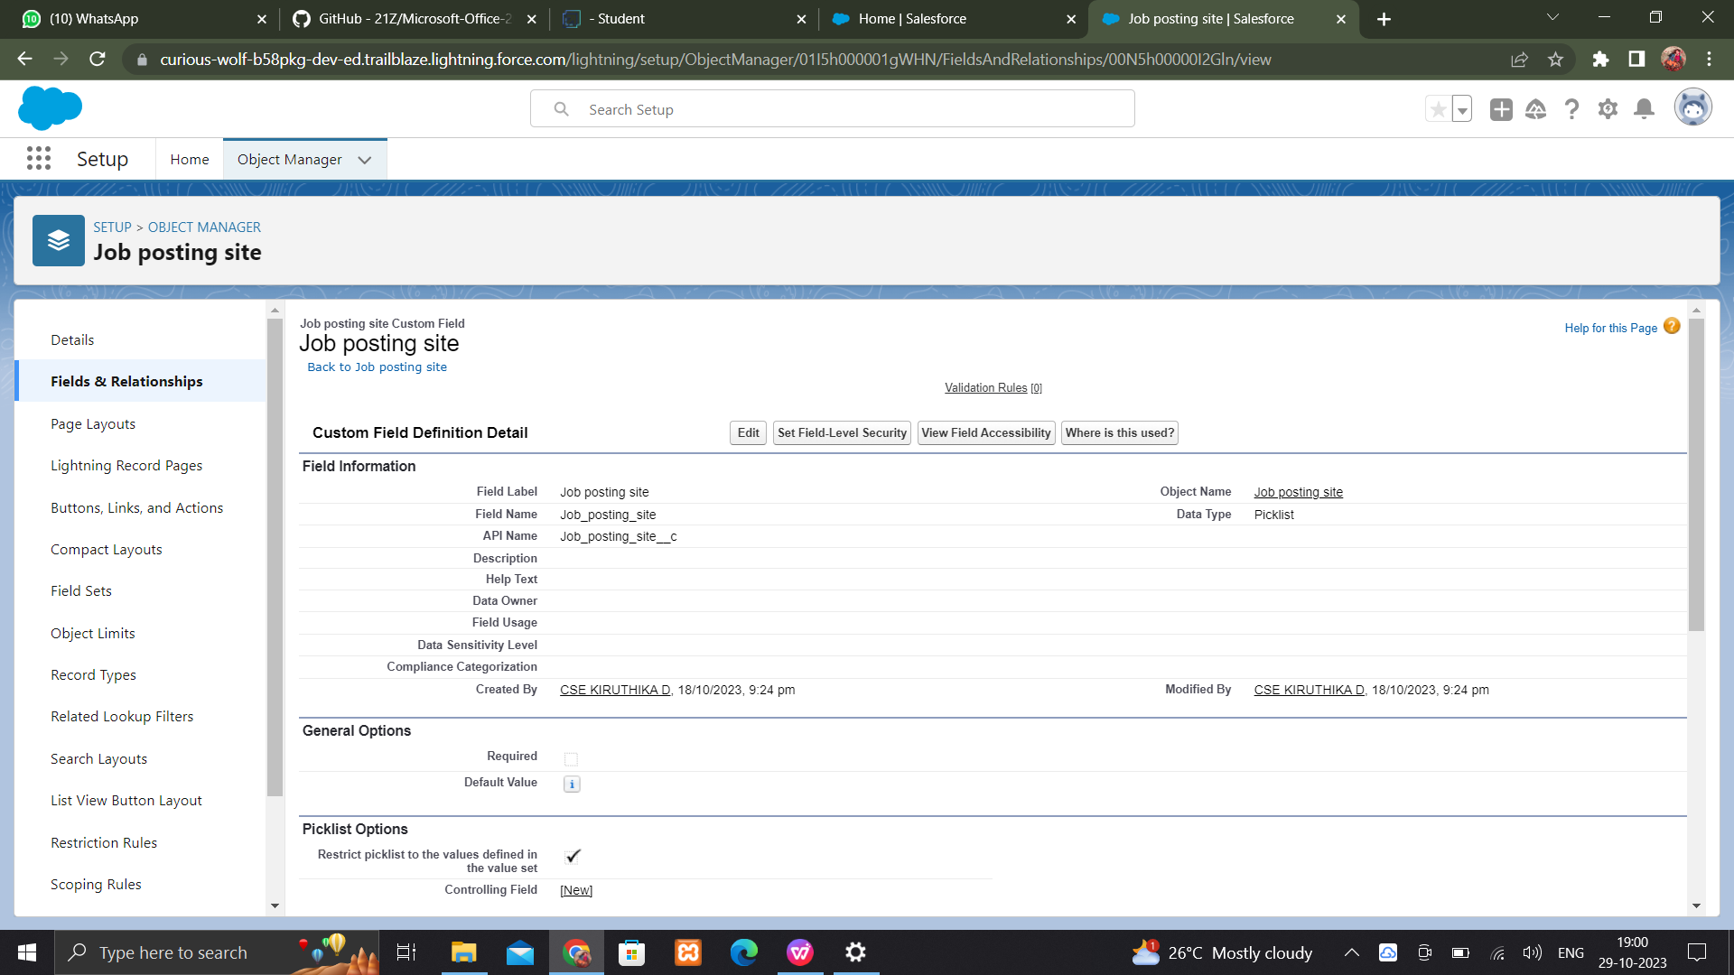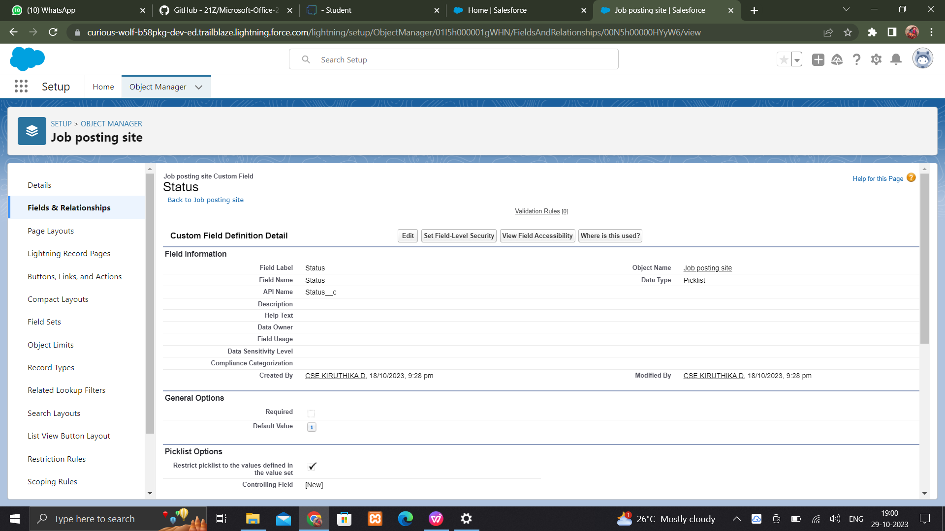

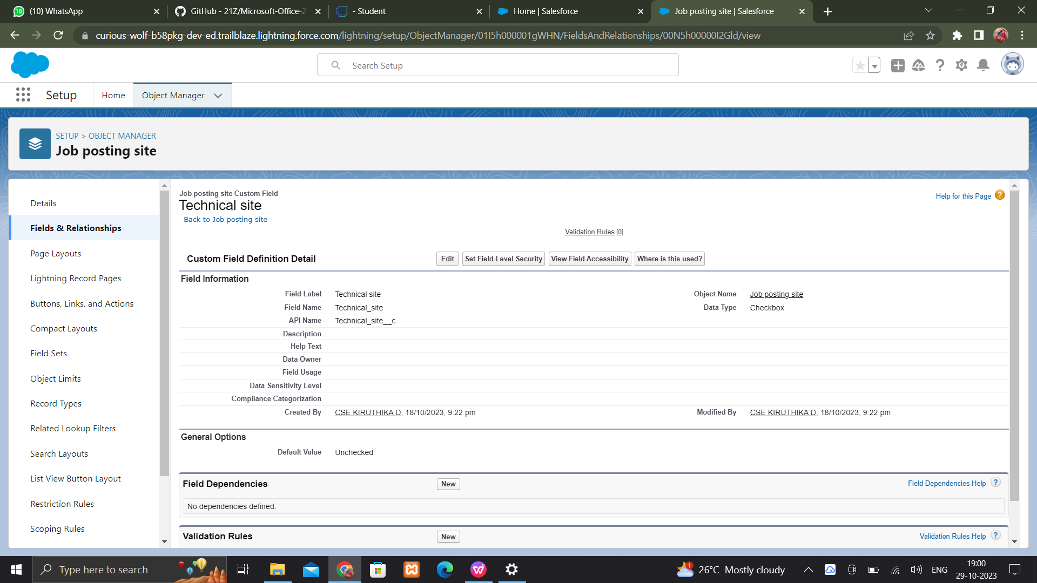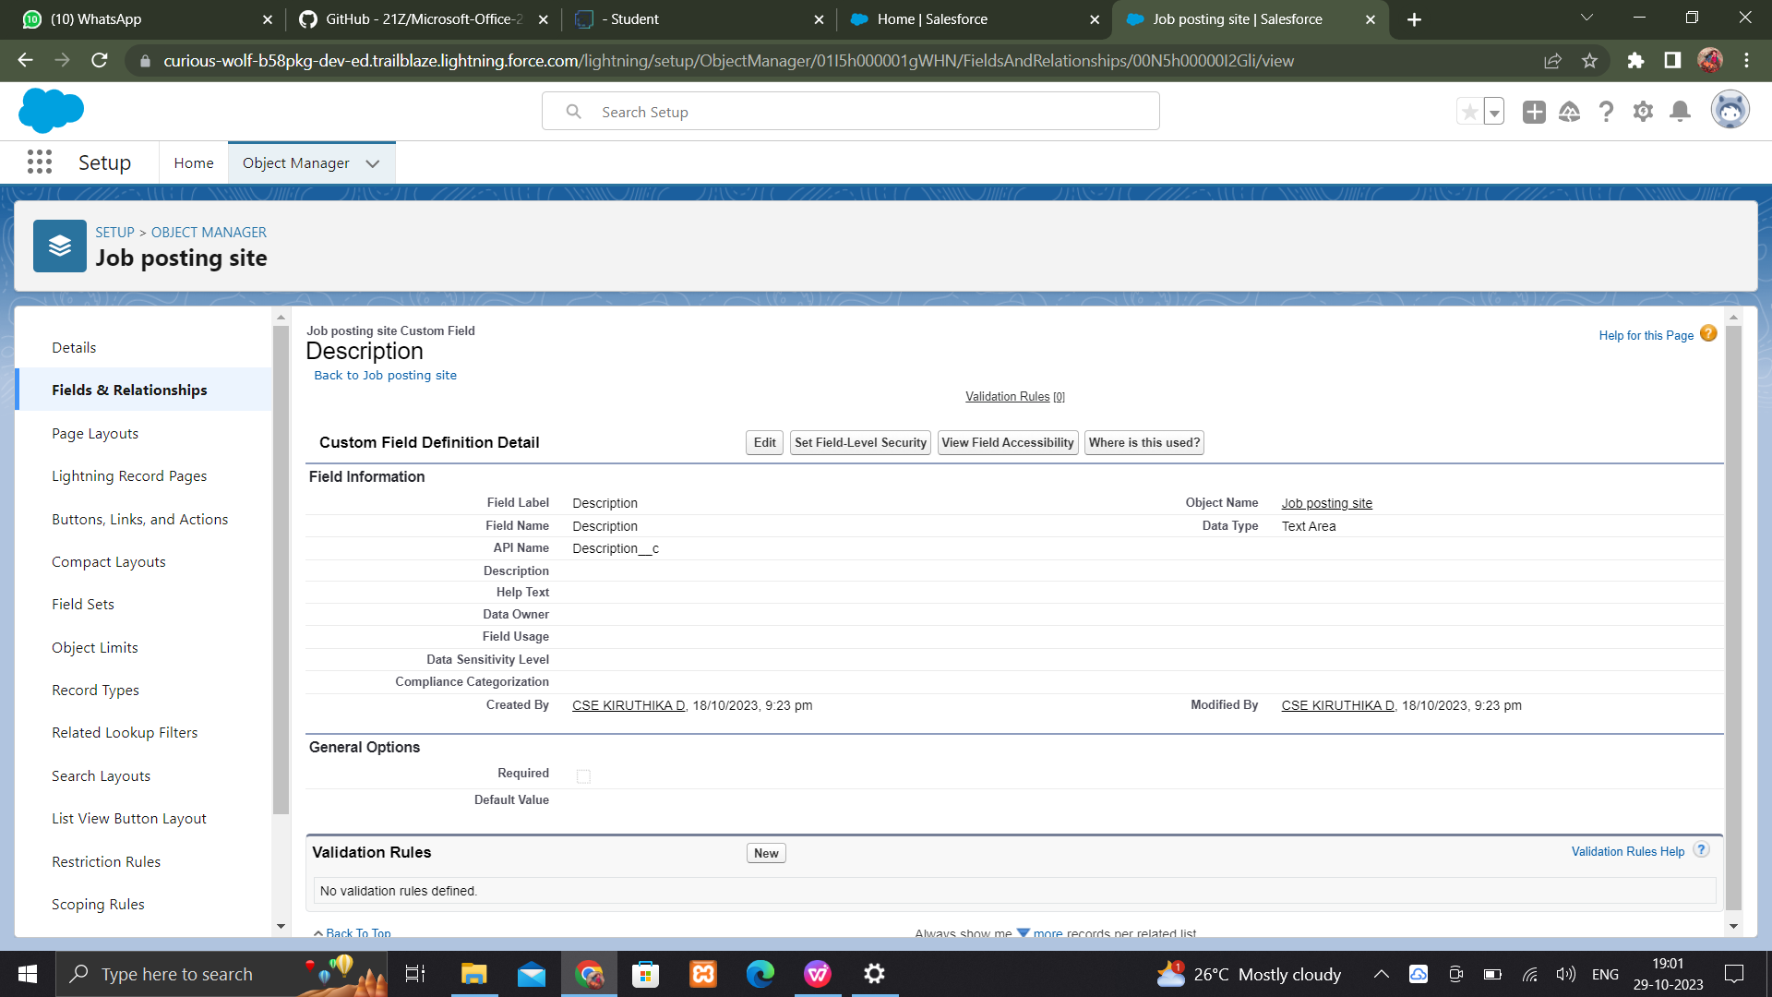

## Creating a Job posting

## Screenshot (56)Screenshot (57)Screenshot (58)

## Screenshot (59)Screenshot (60)

## Screenshot (61)

**Create fields for review**

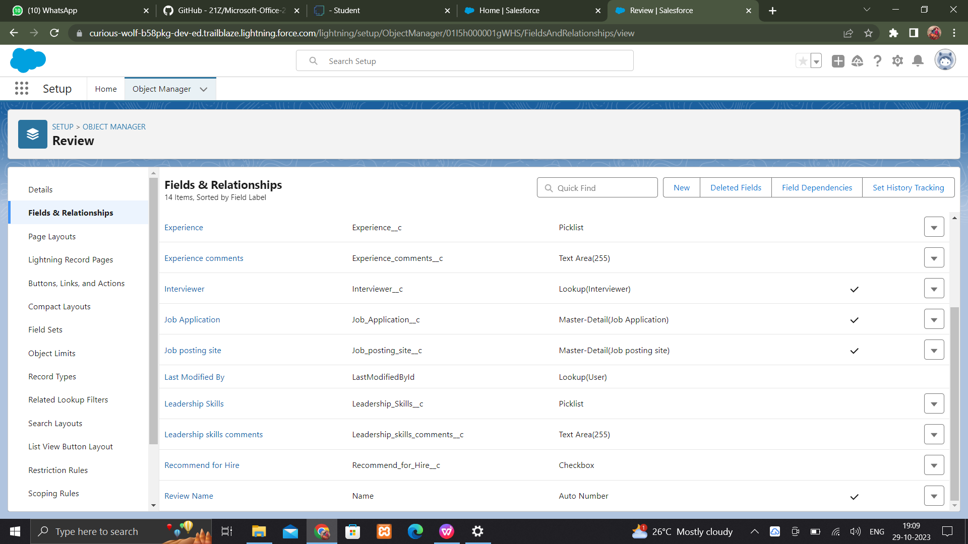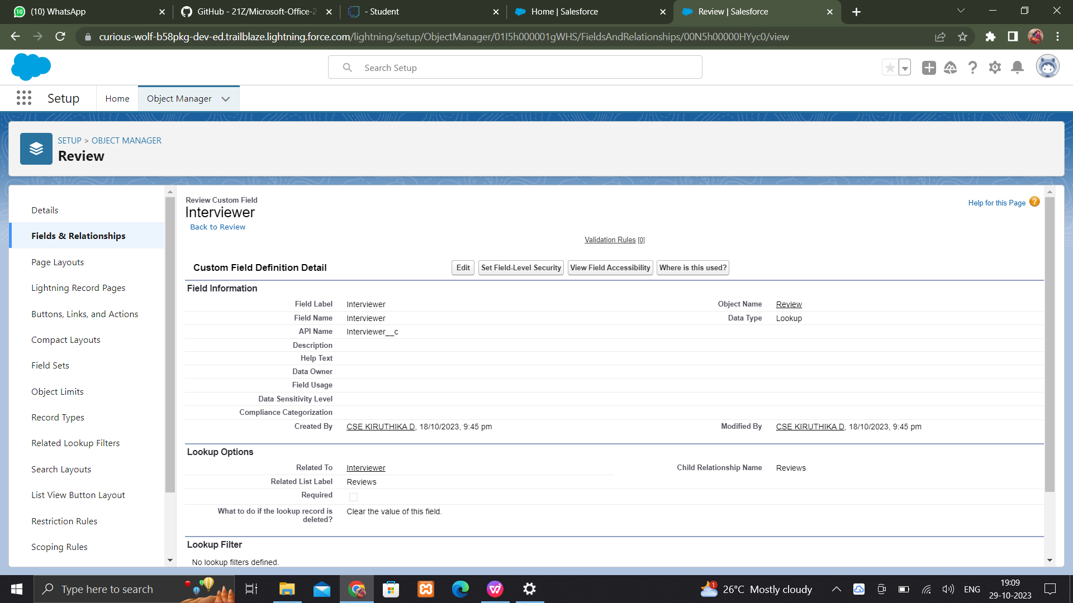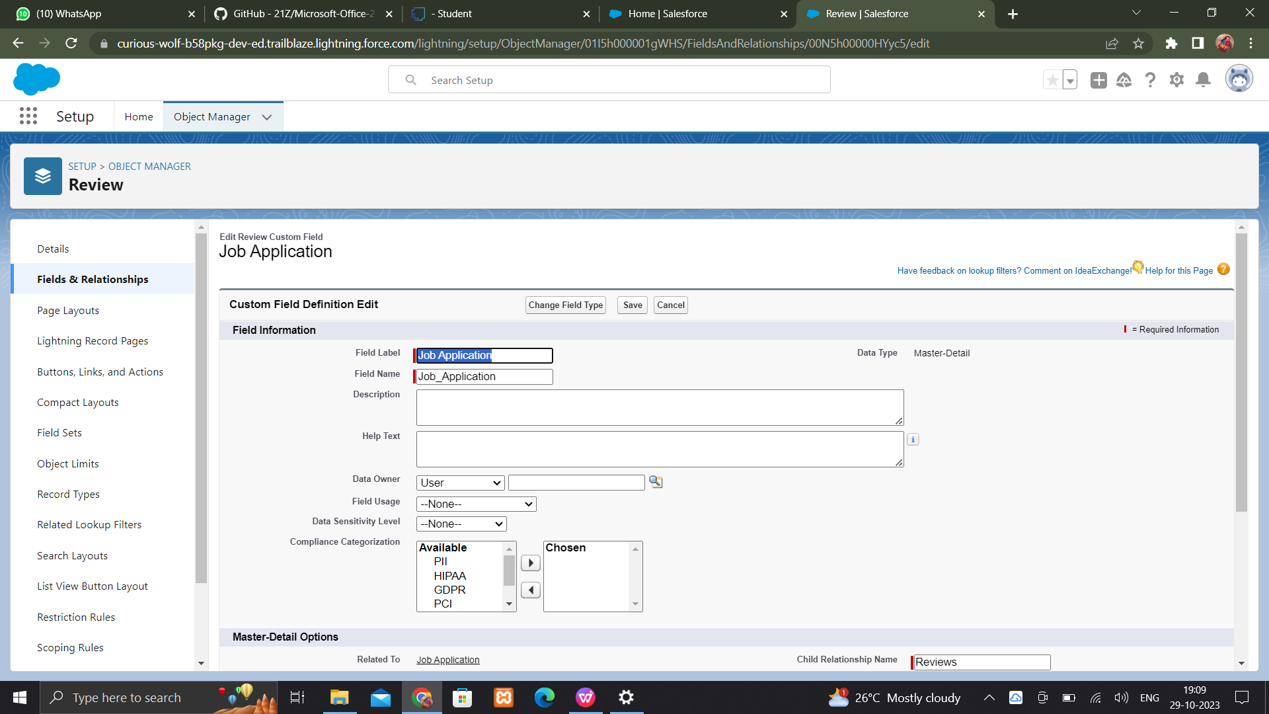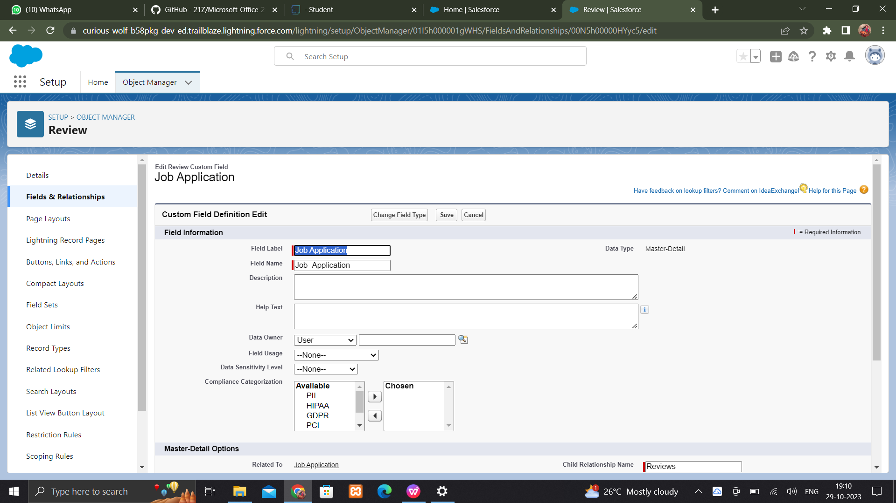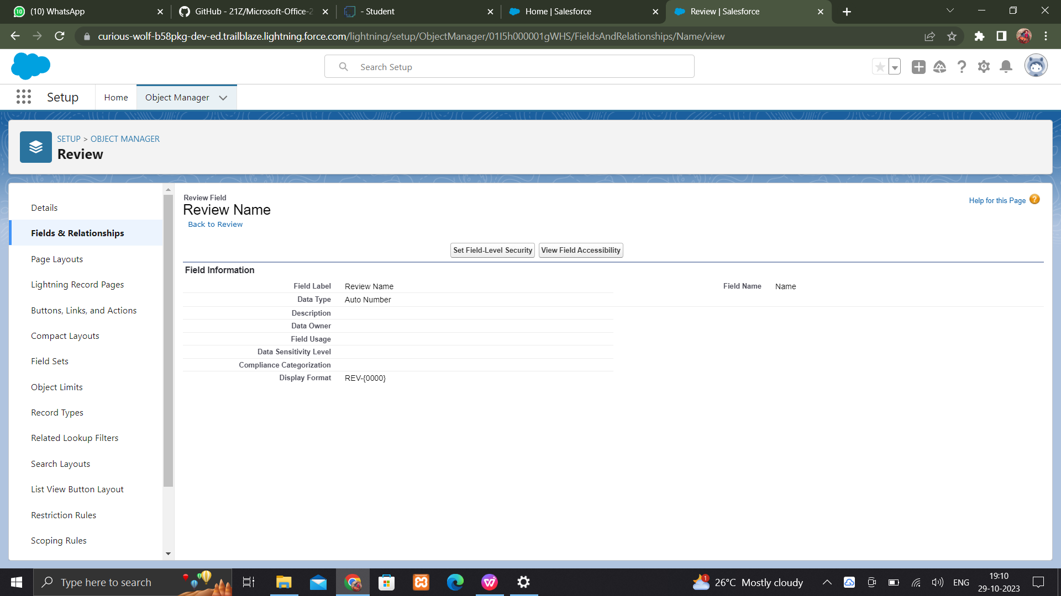

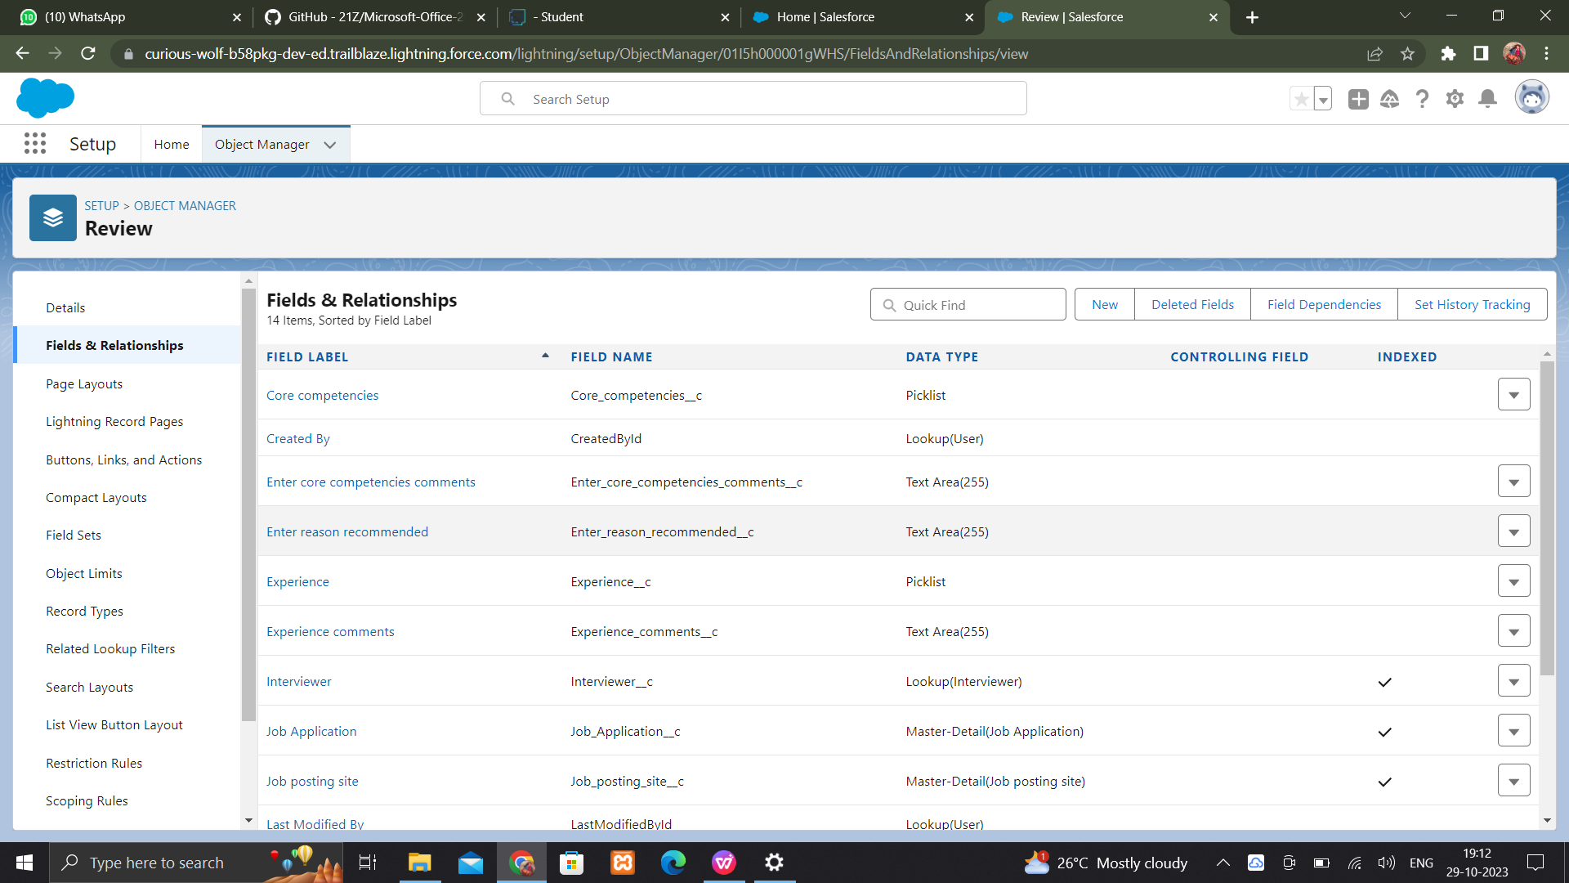

**Create a Master detail relationship**

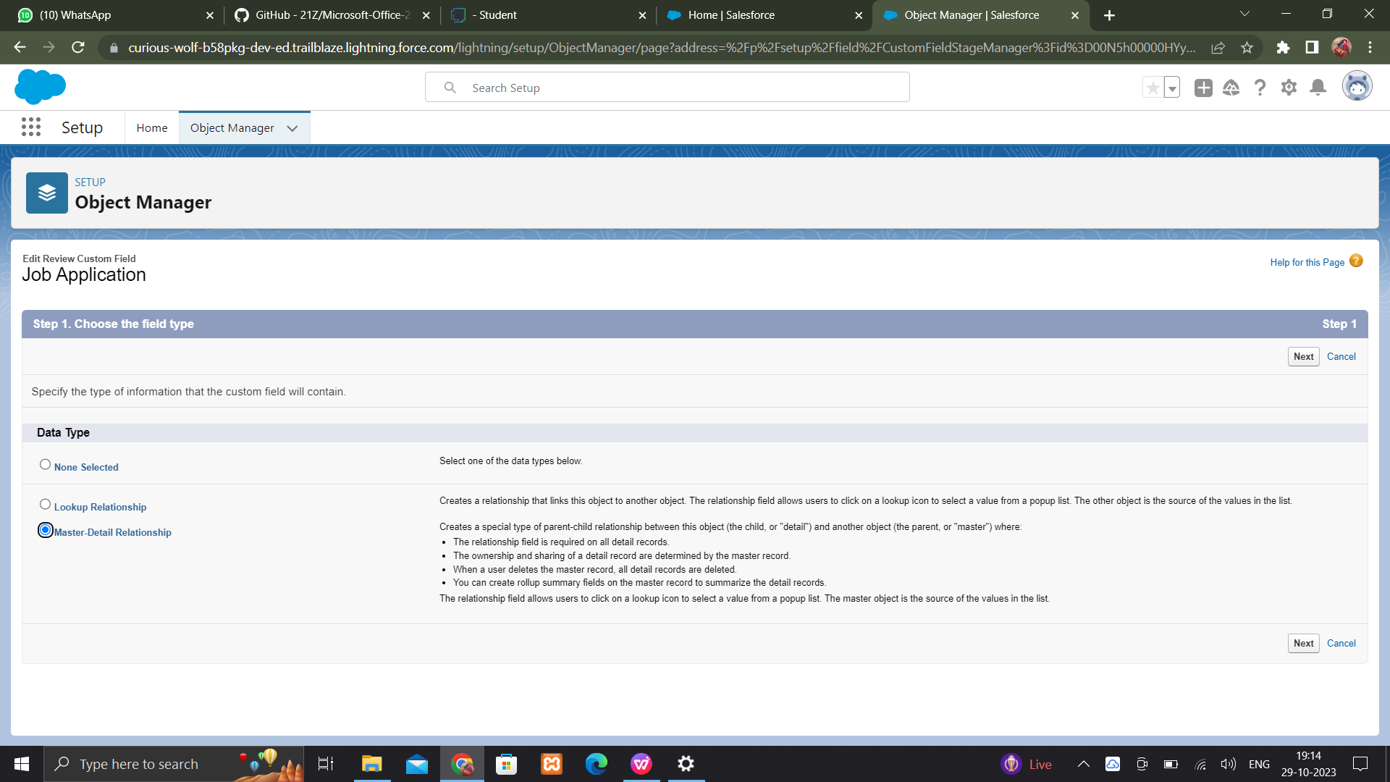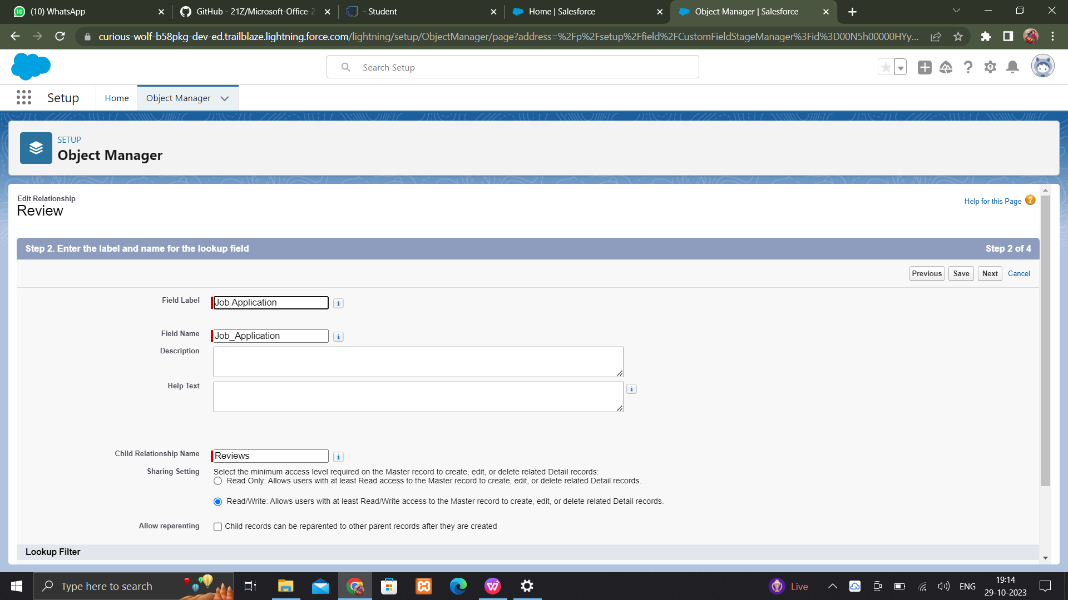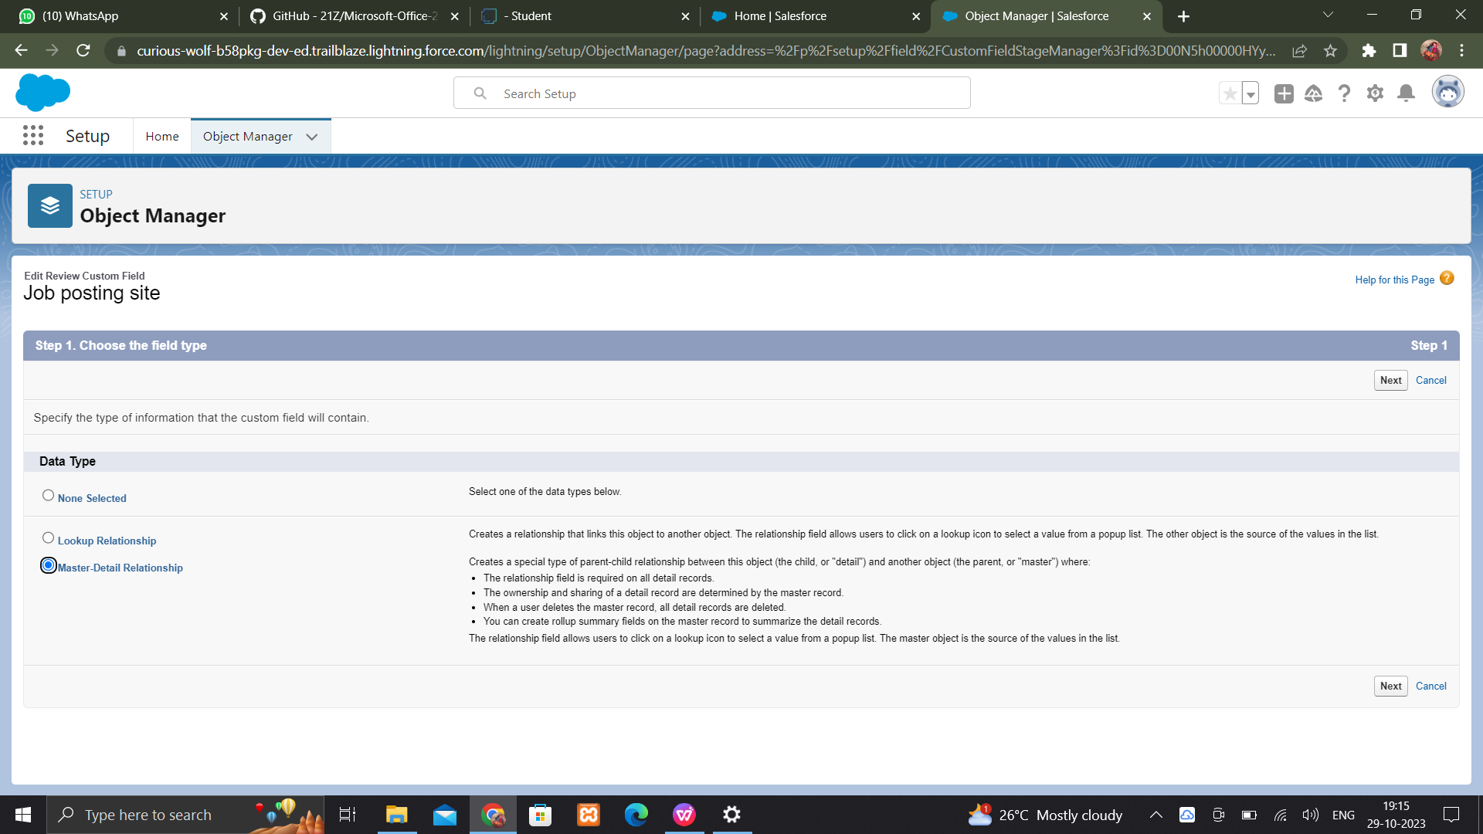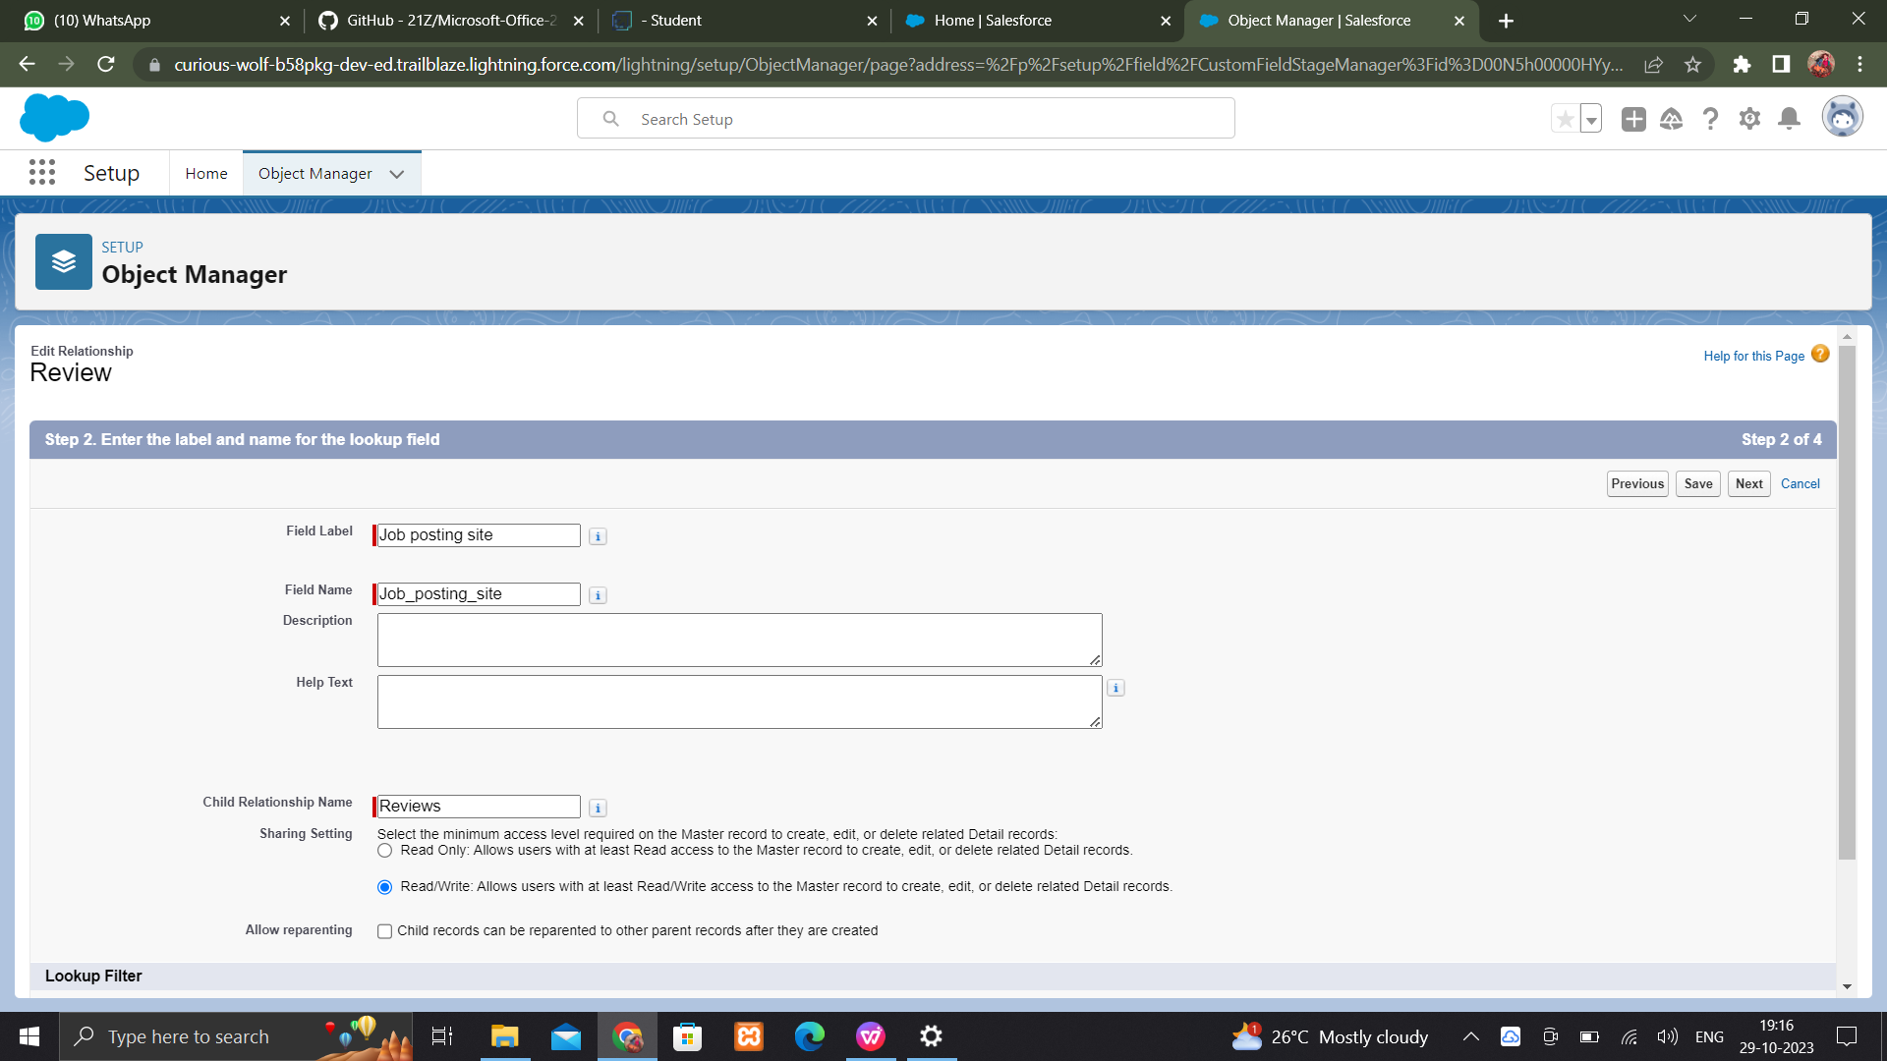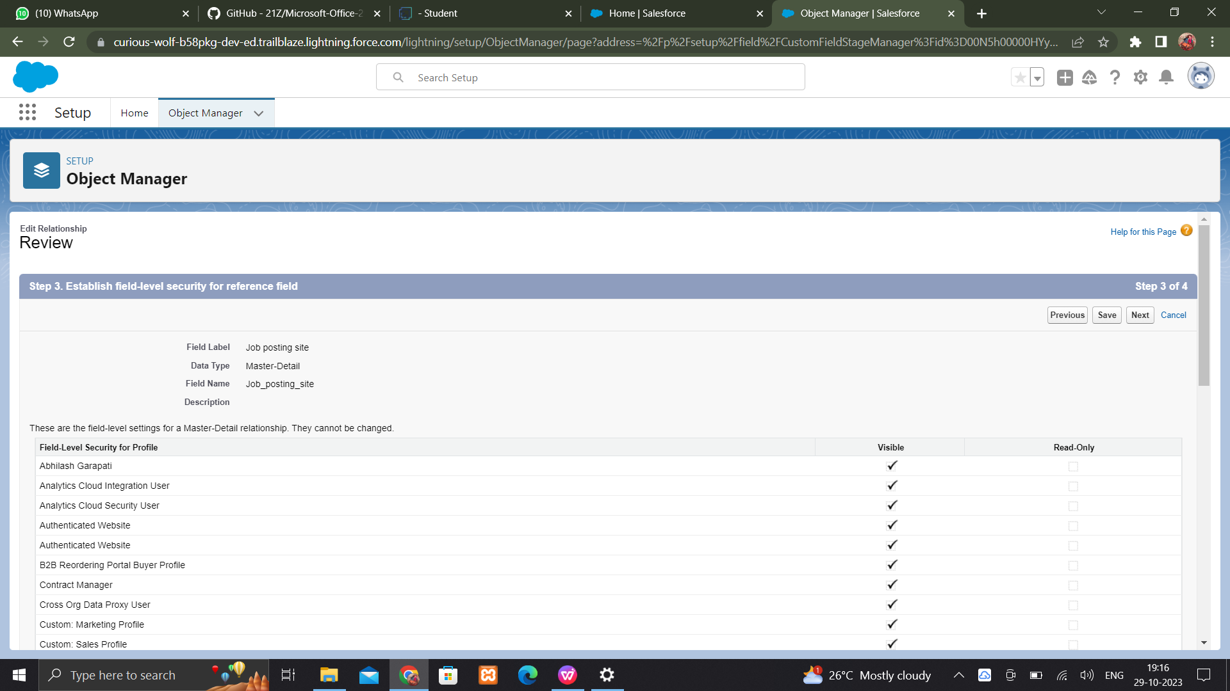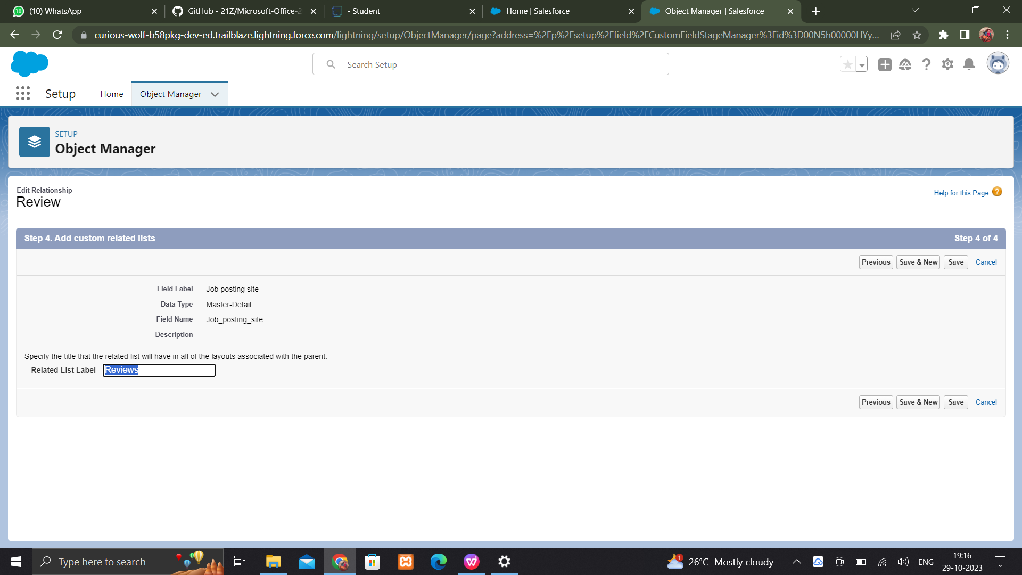

**PAGE LAYOUTS**

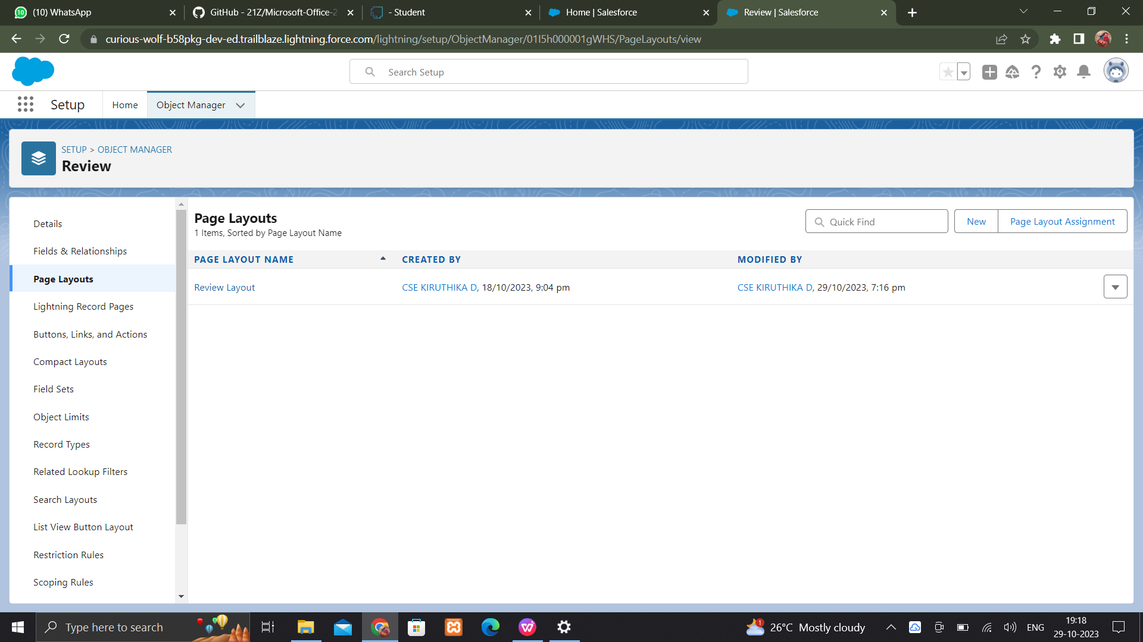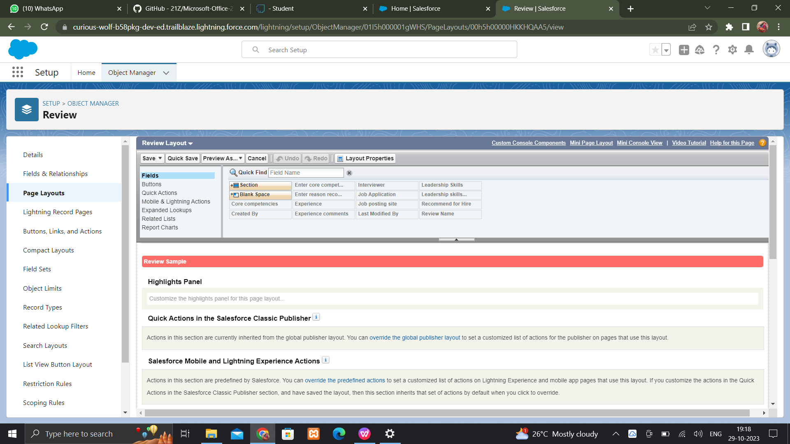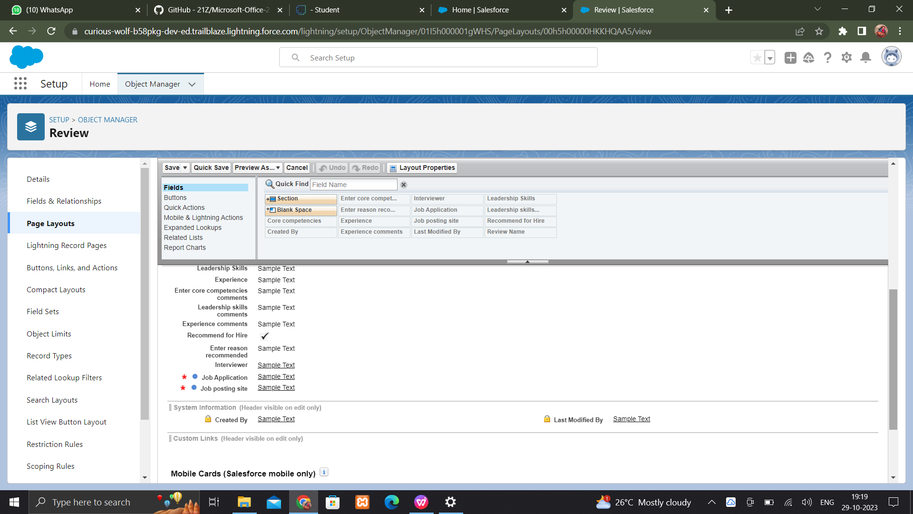

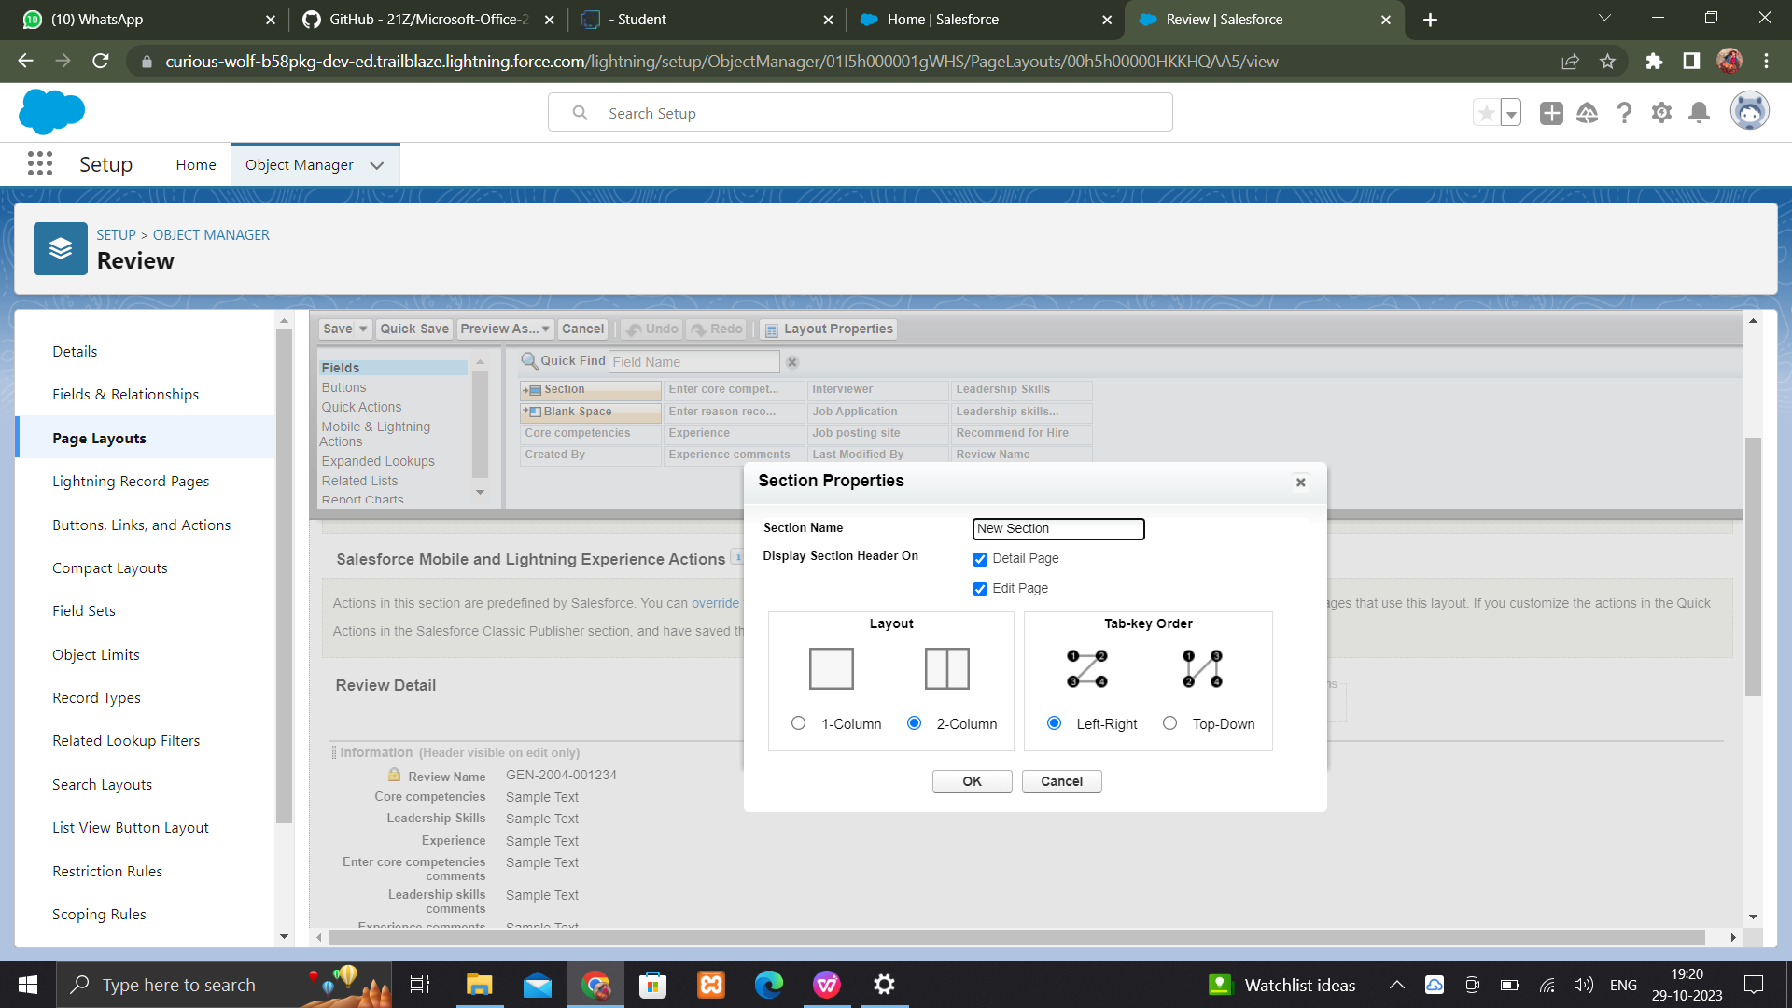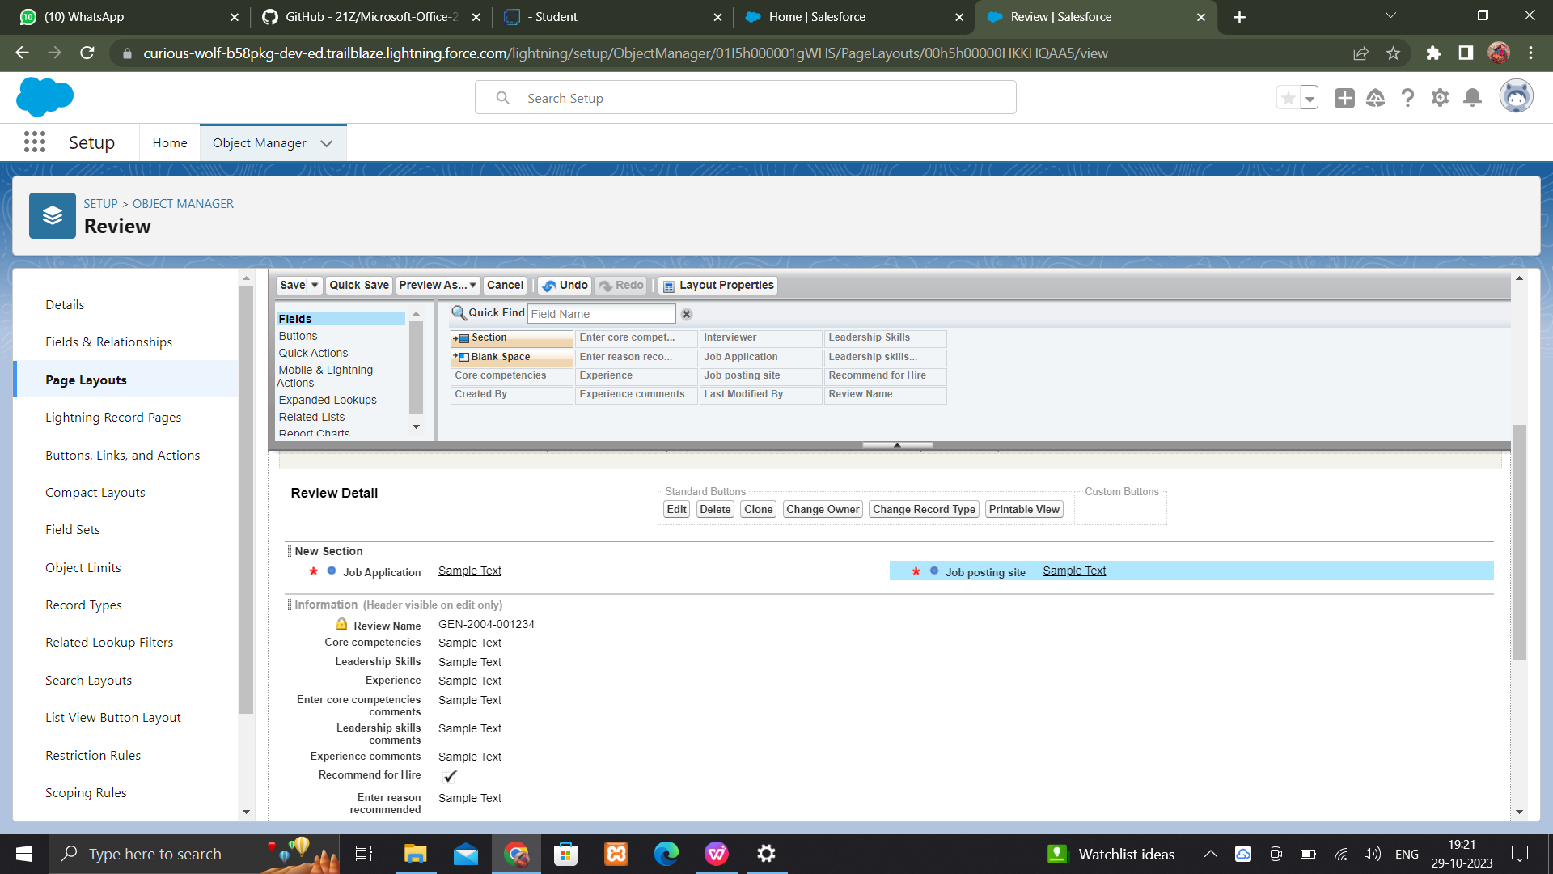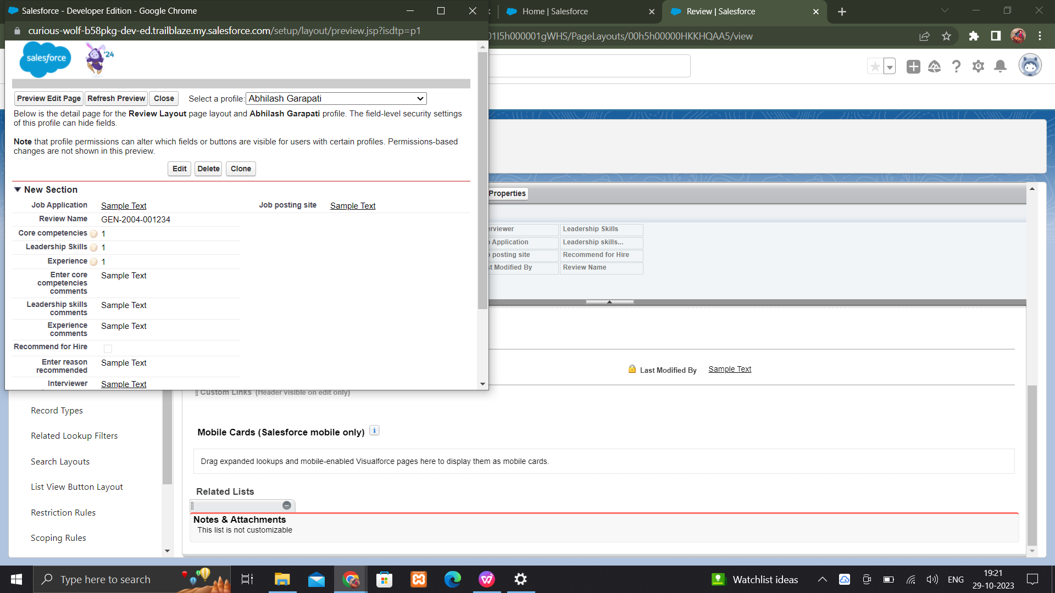

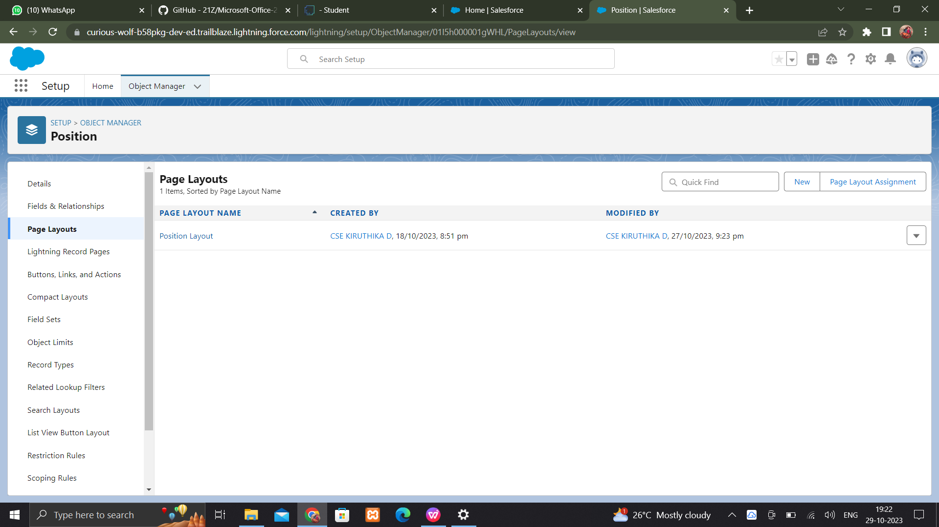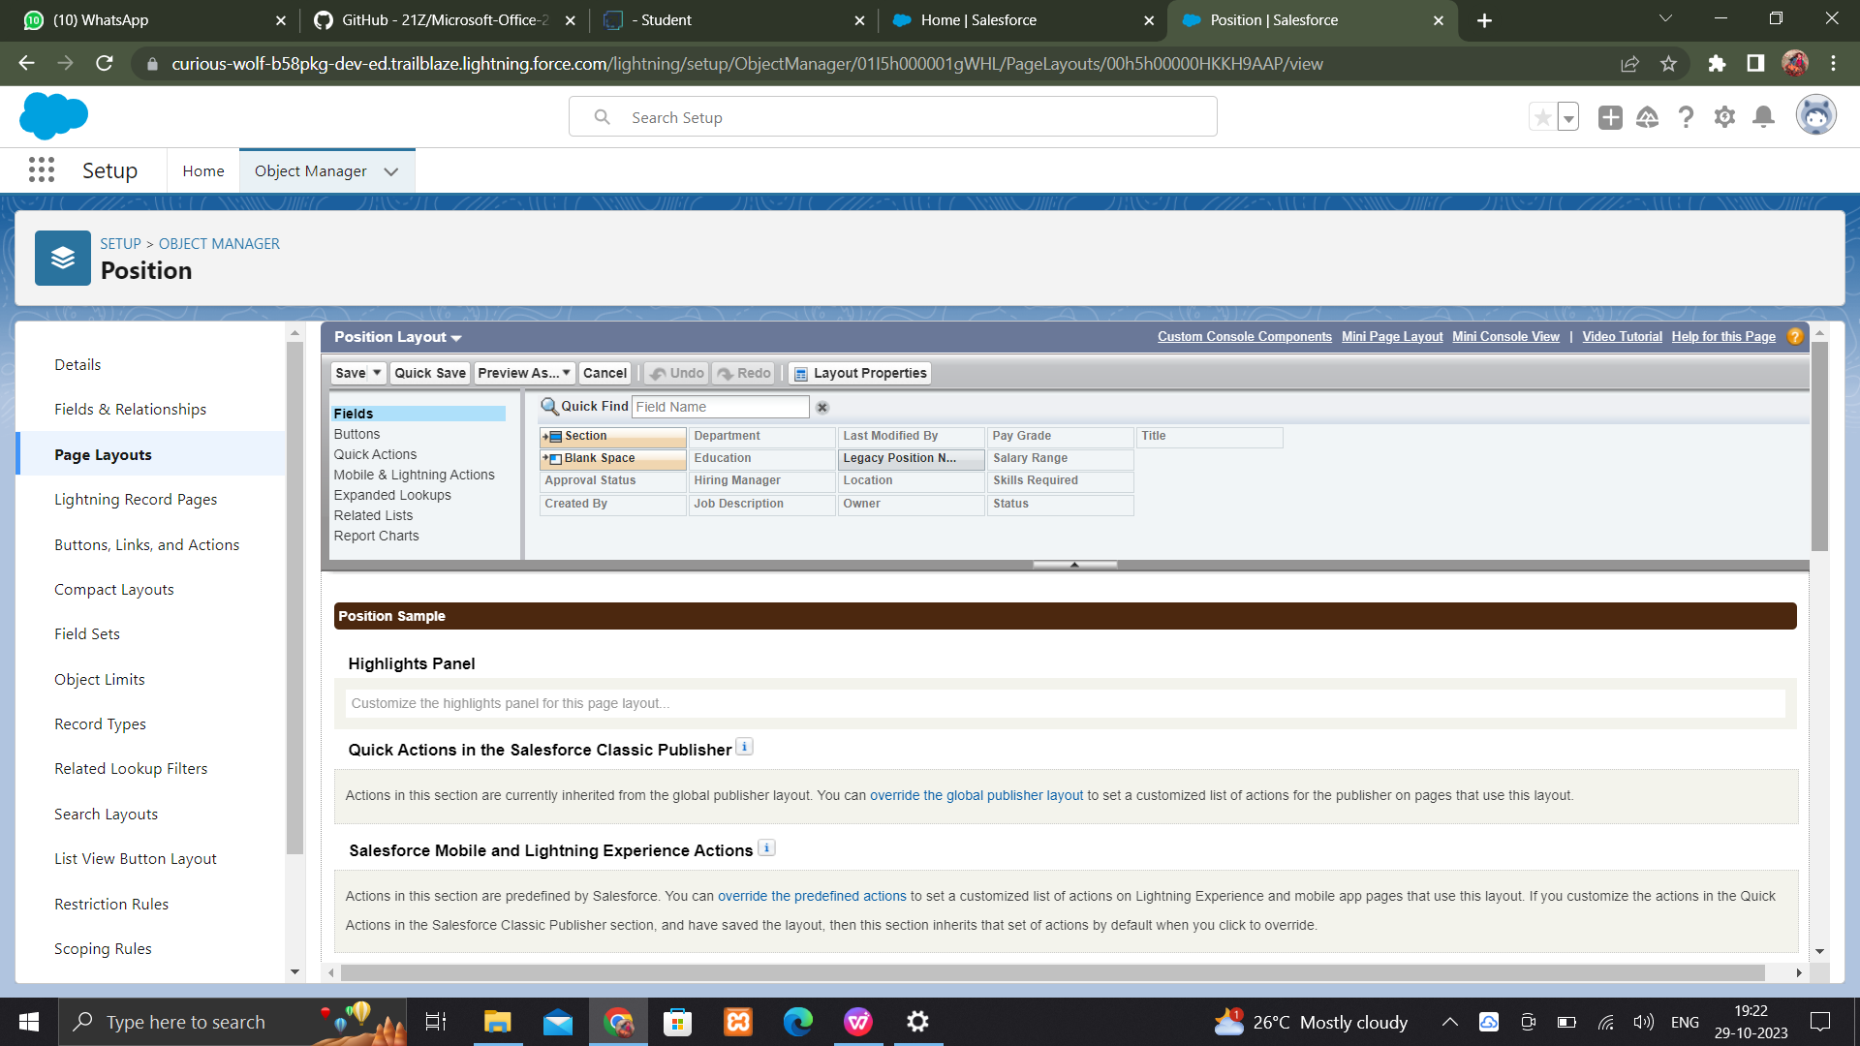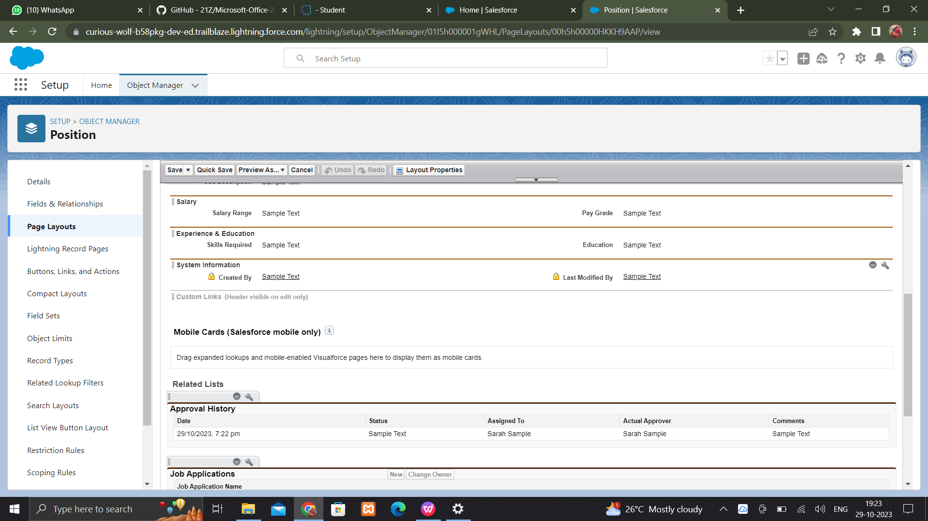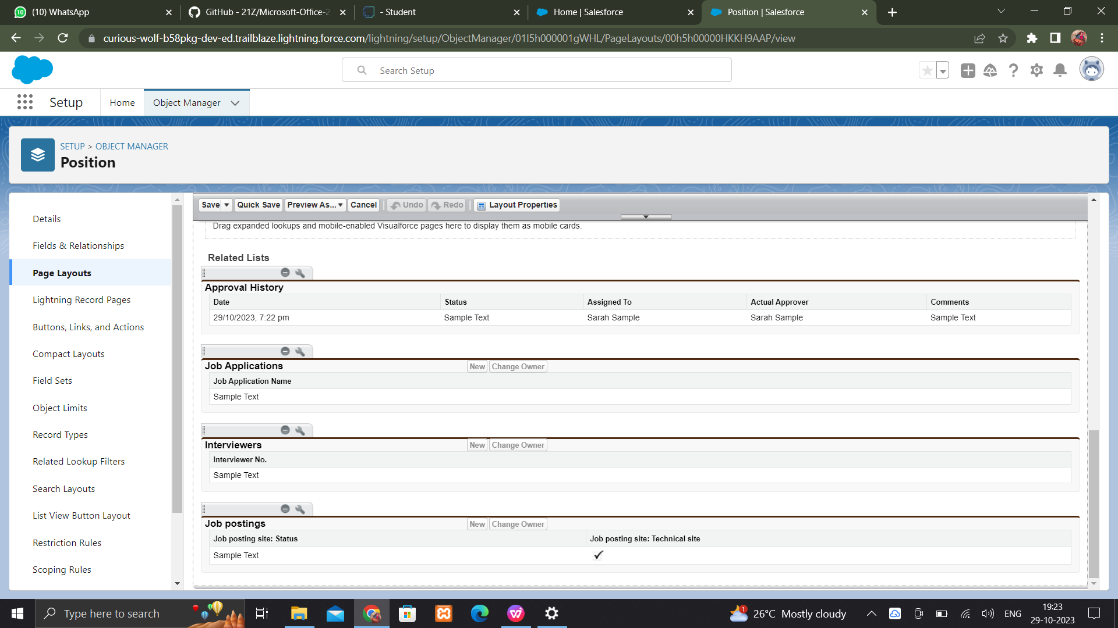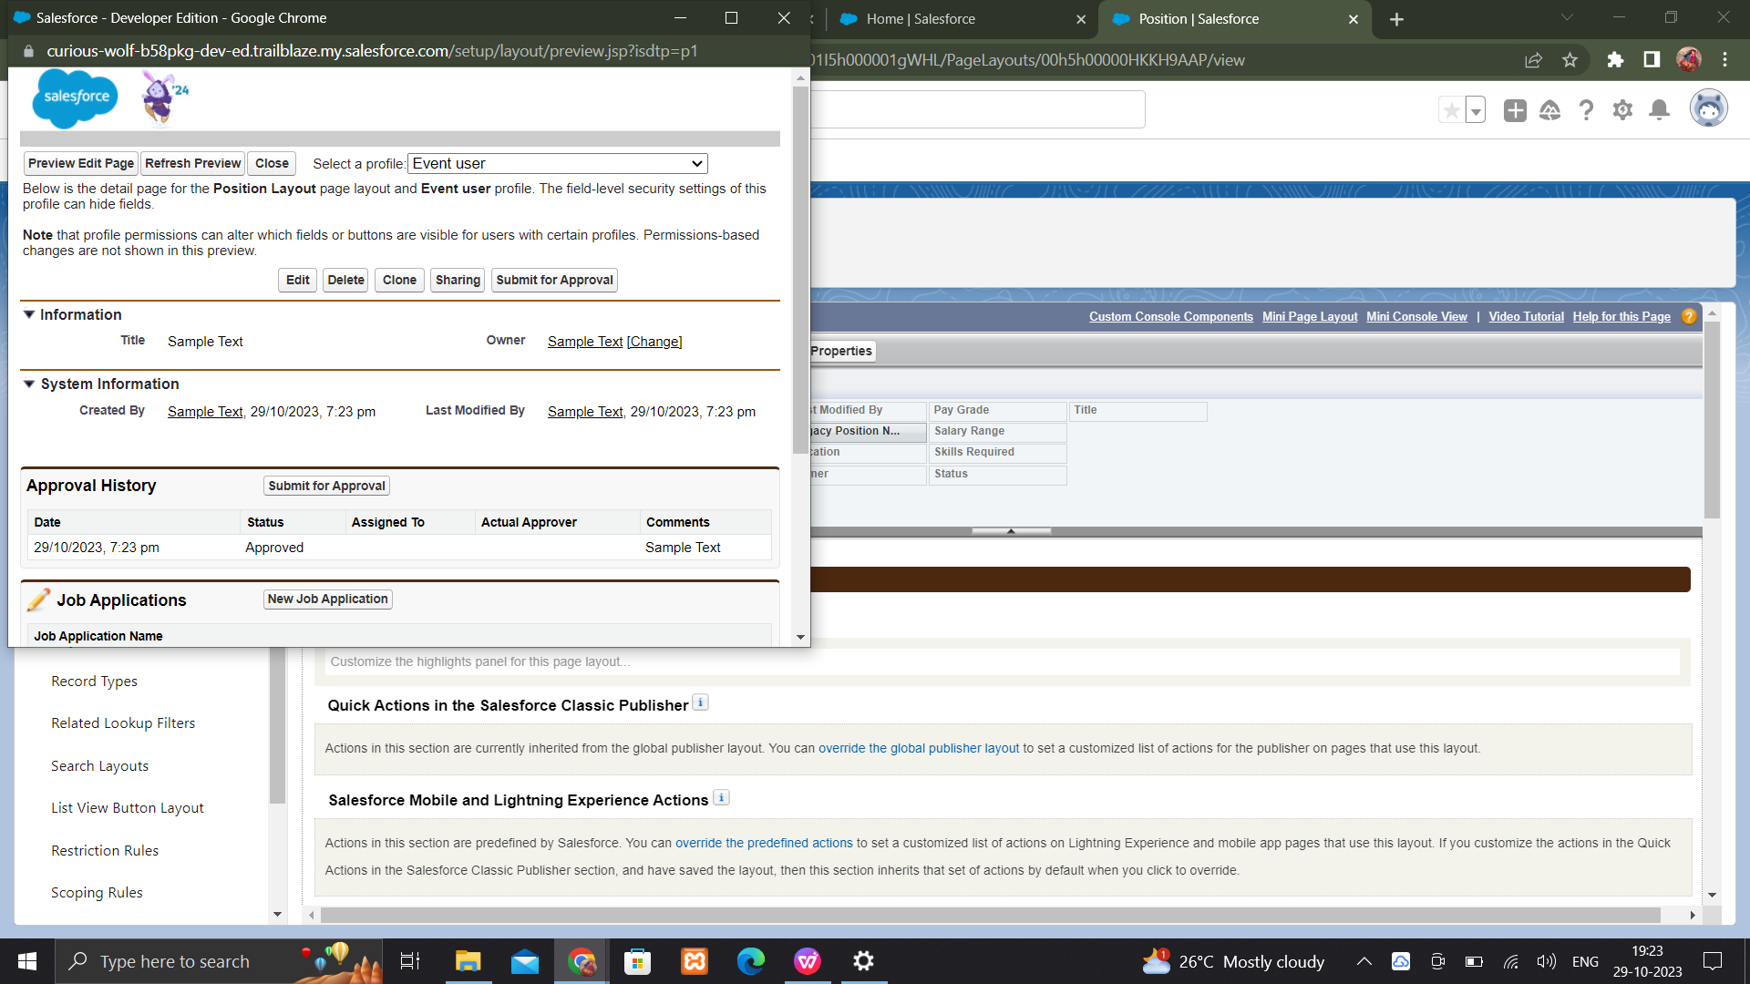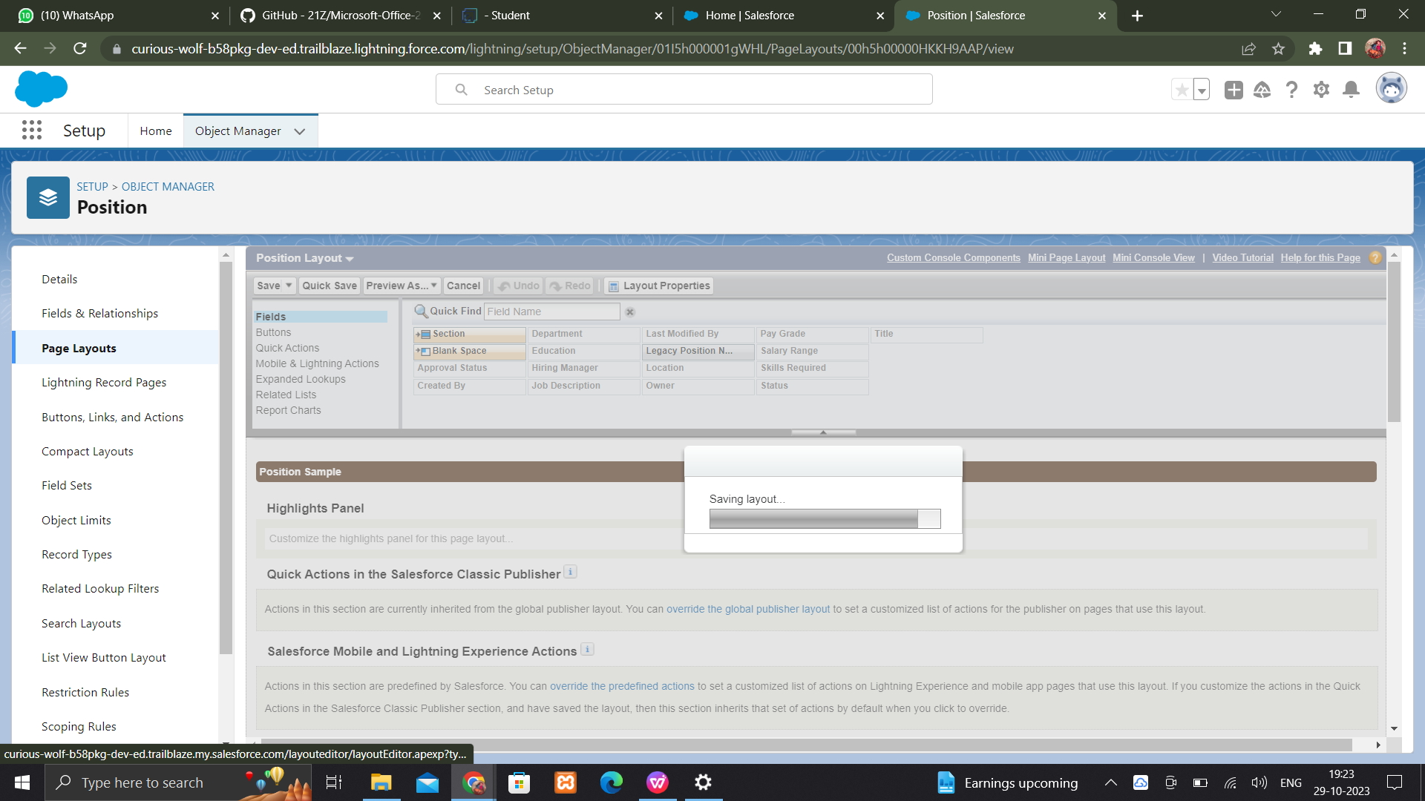

**VALIDATION RULES :**

Create a validation rule phone__c

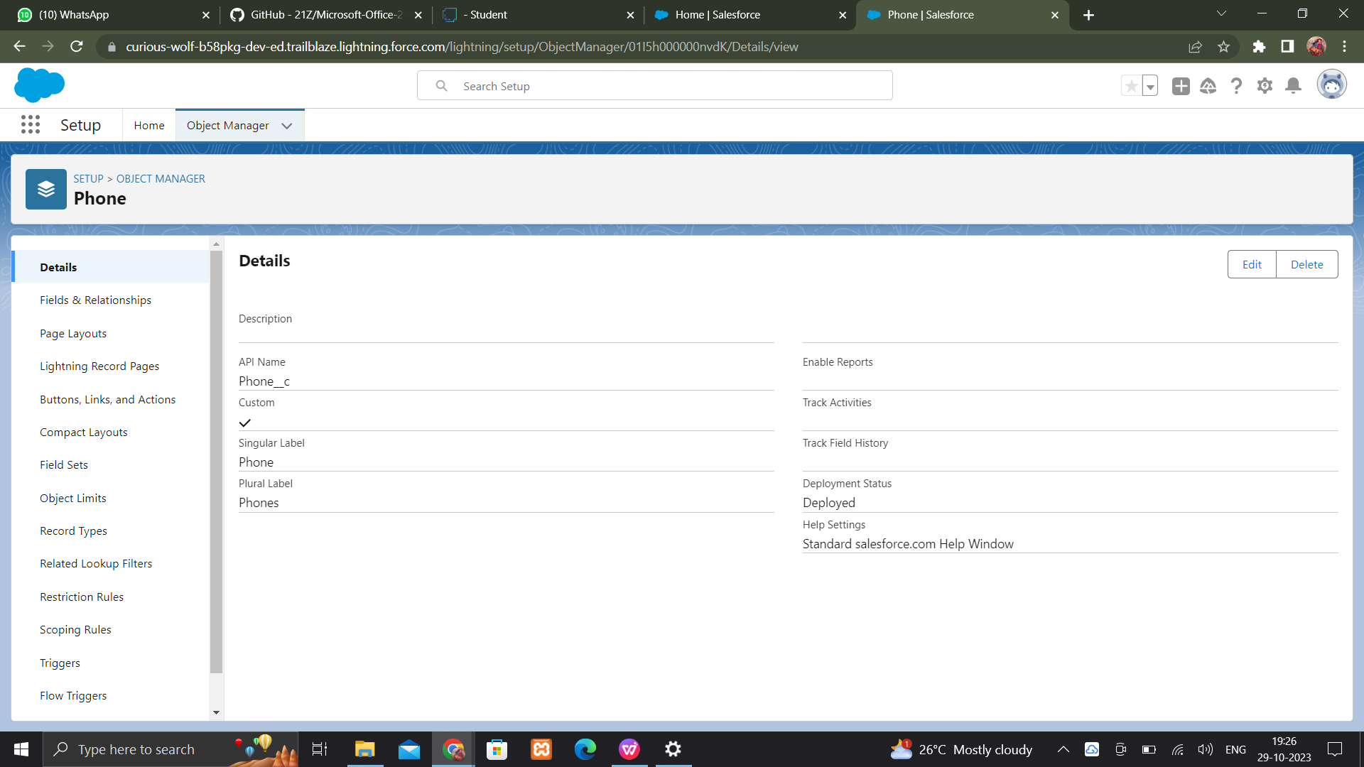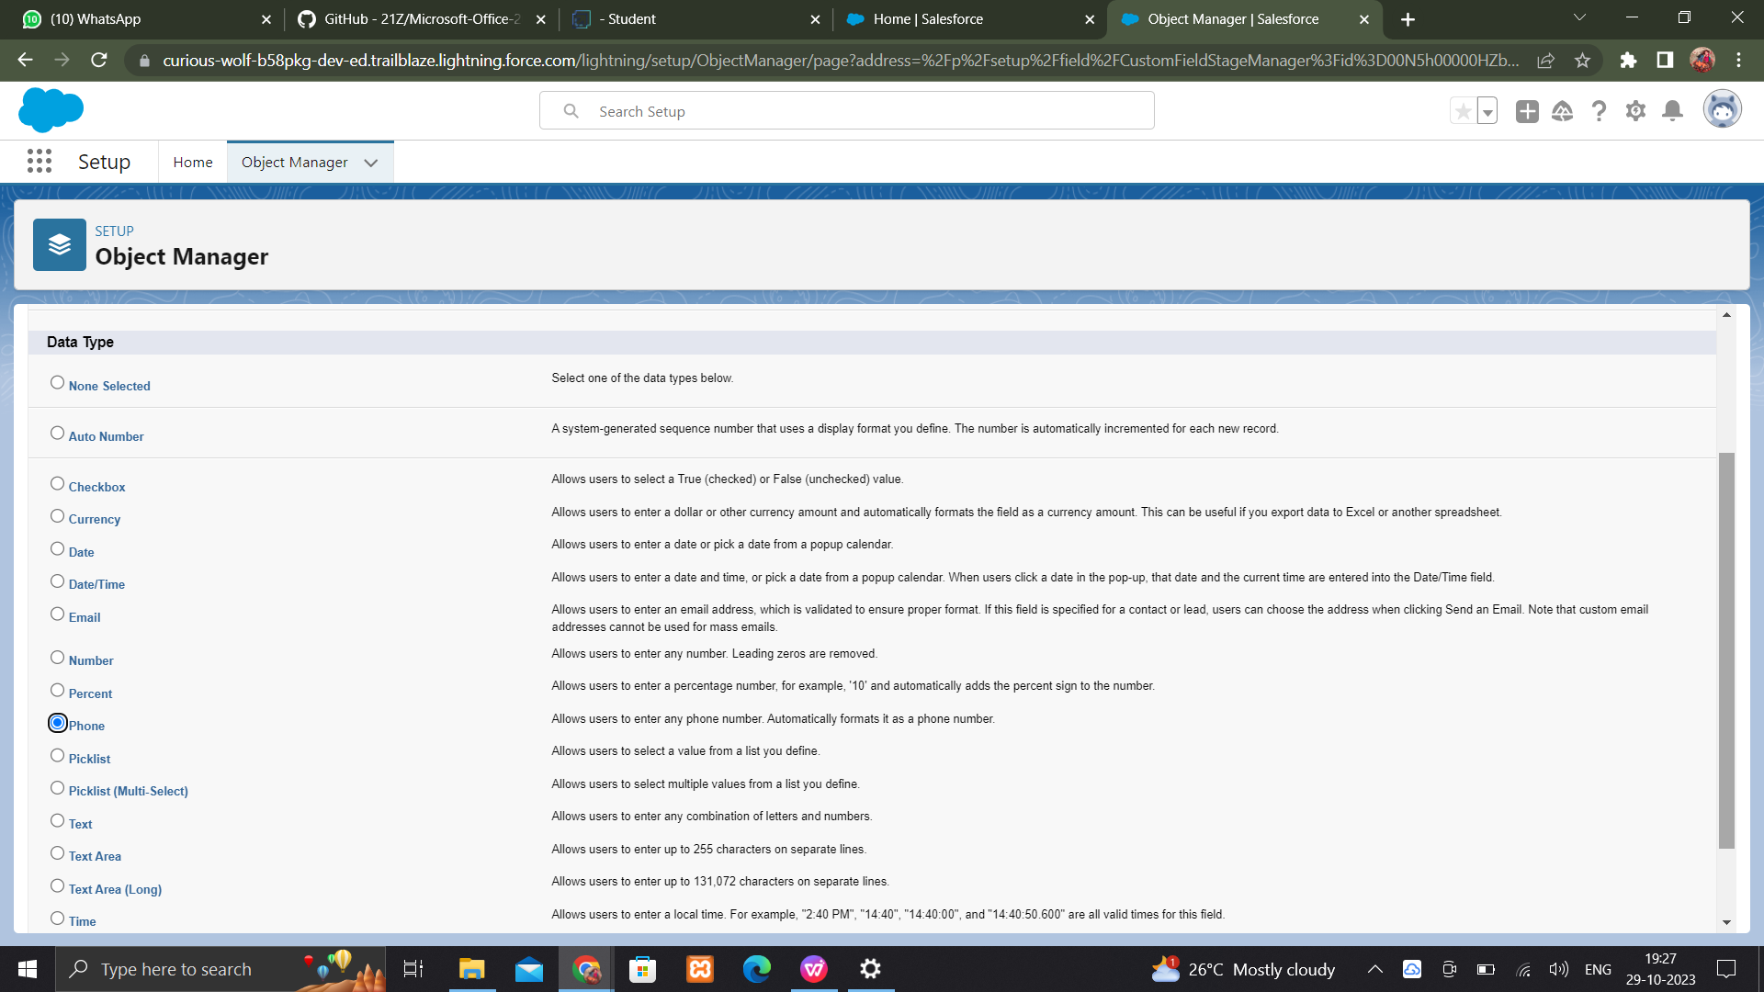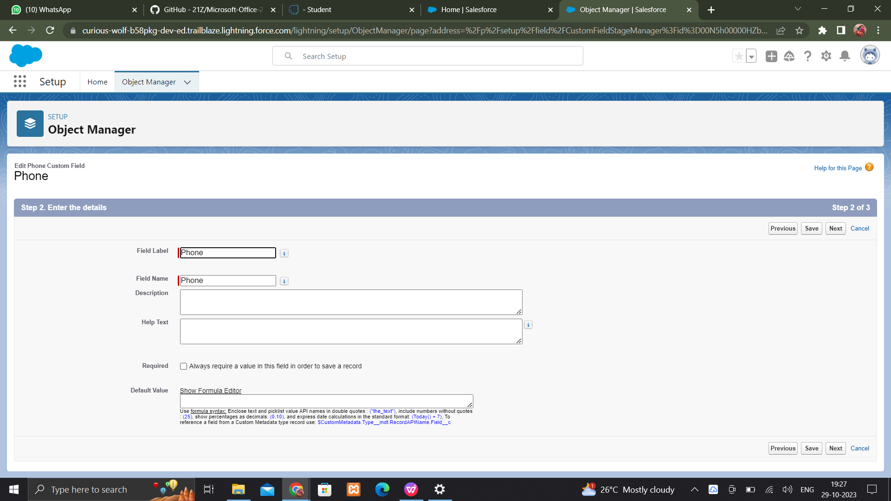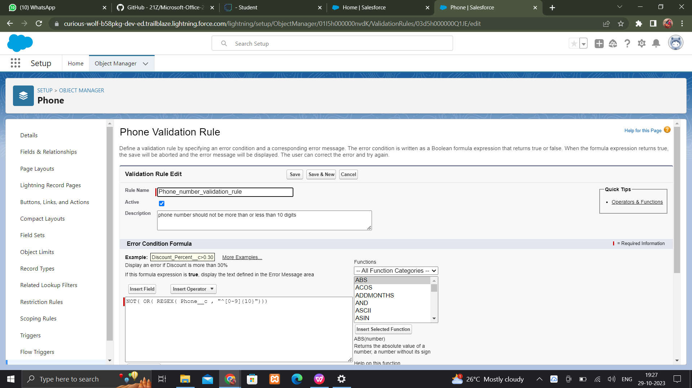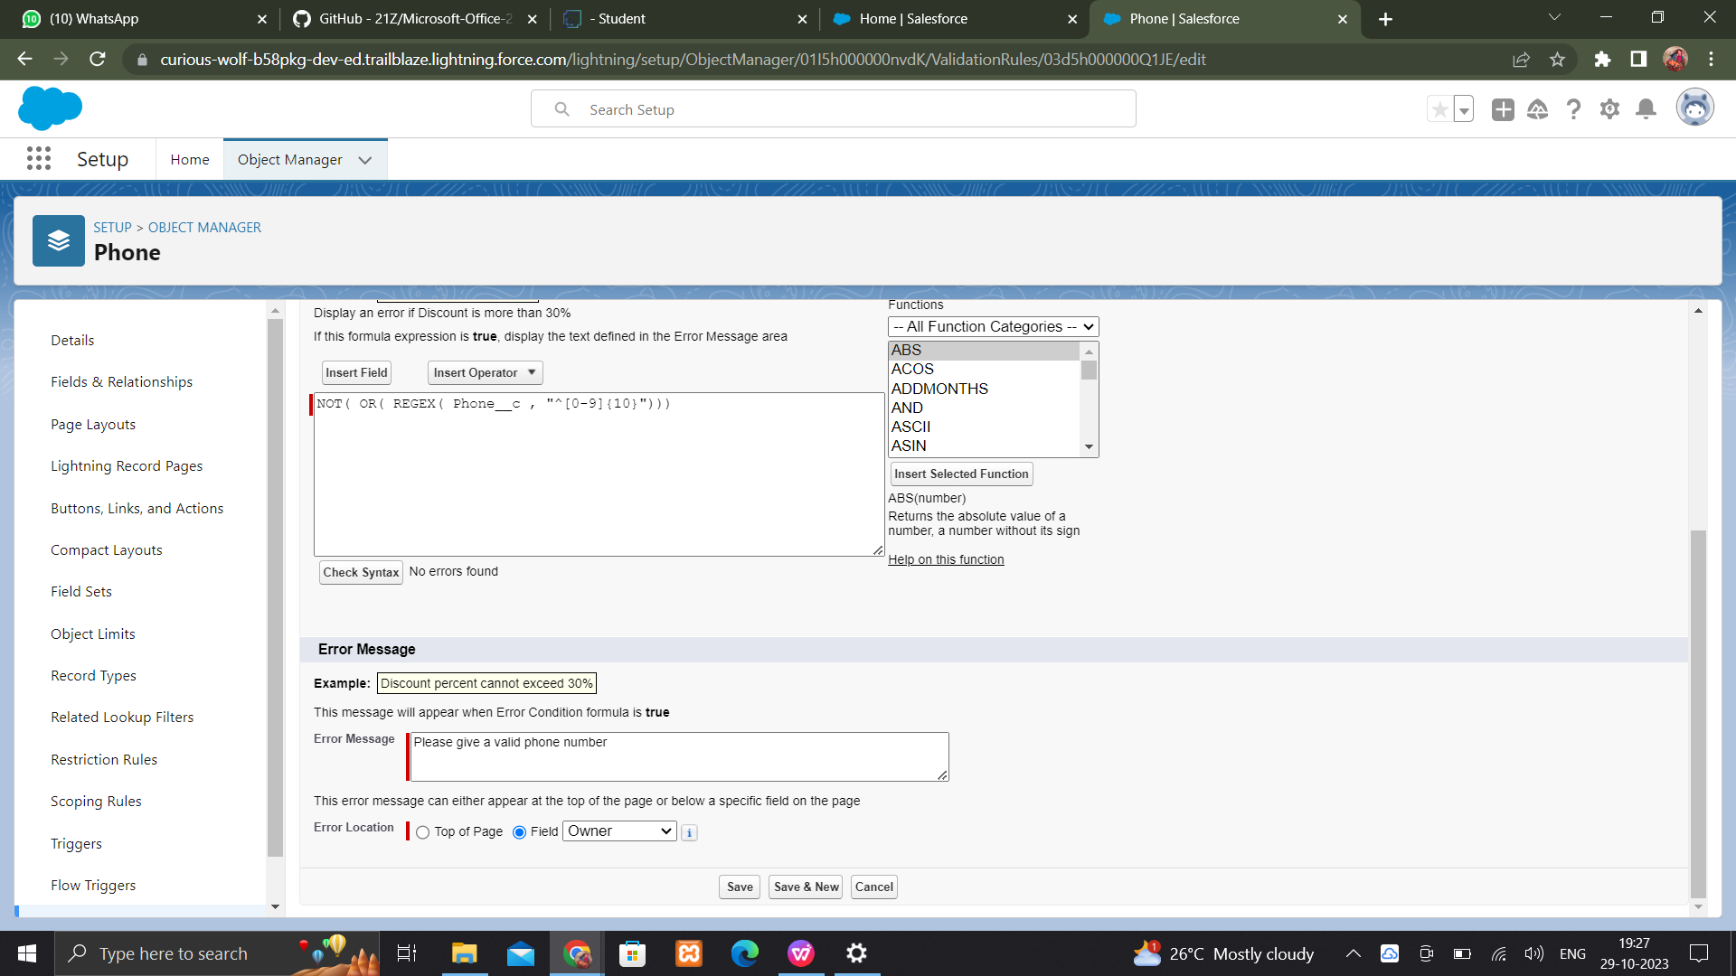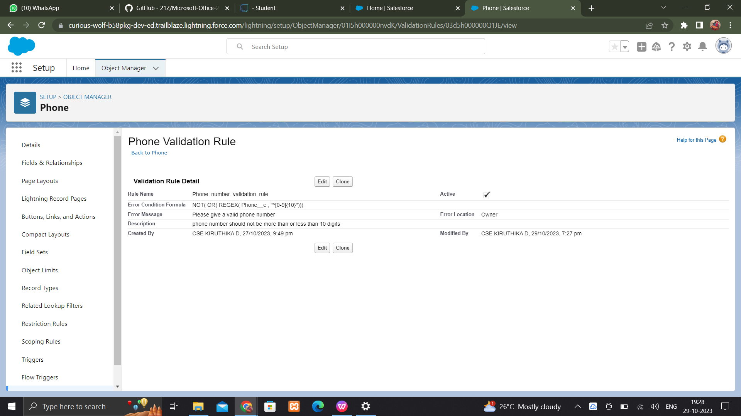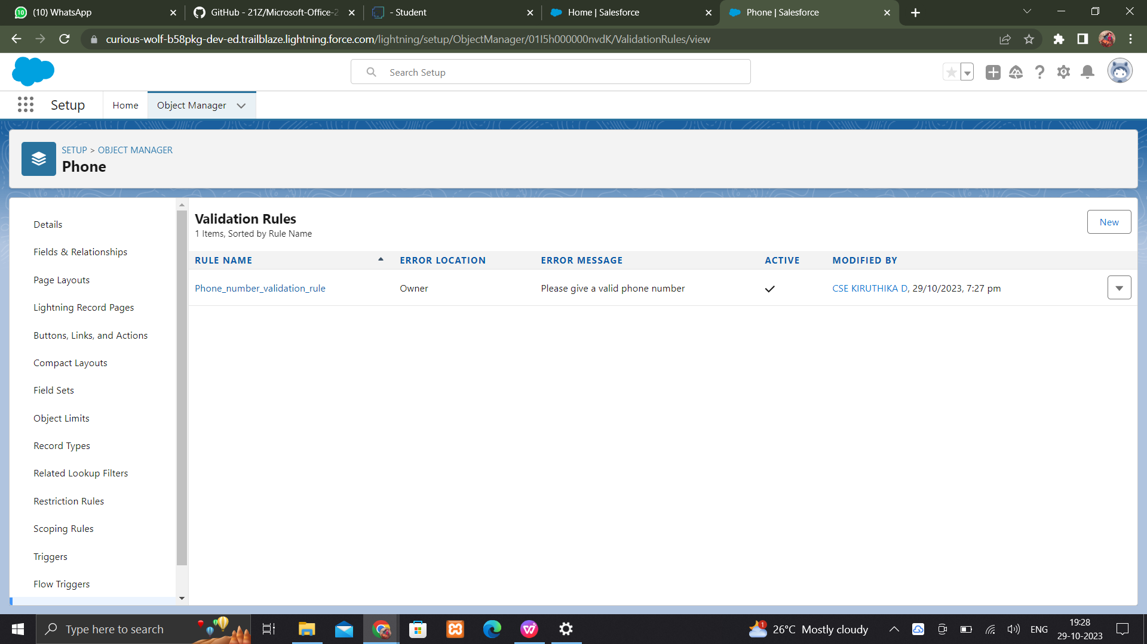

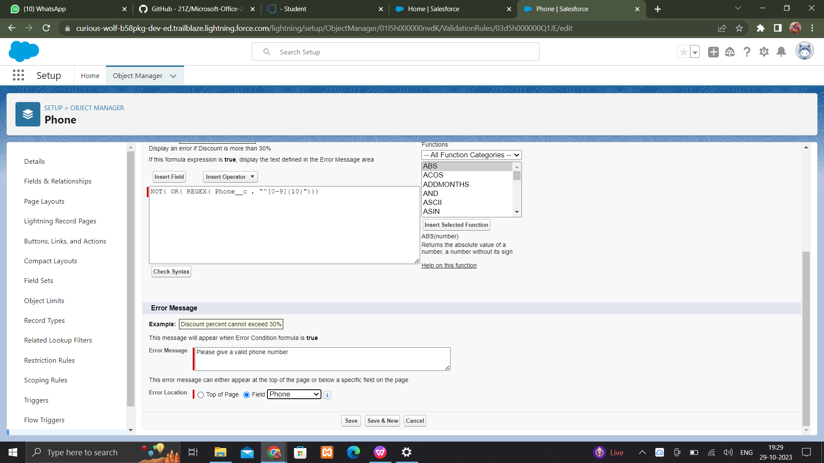

CREATE A PROFILE

Create a profile

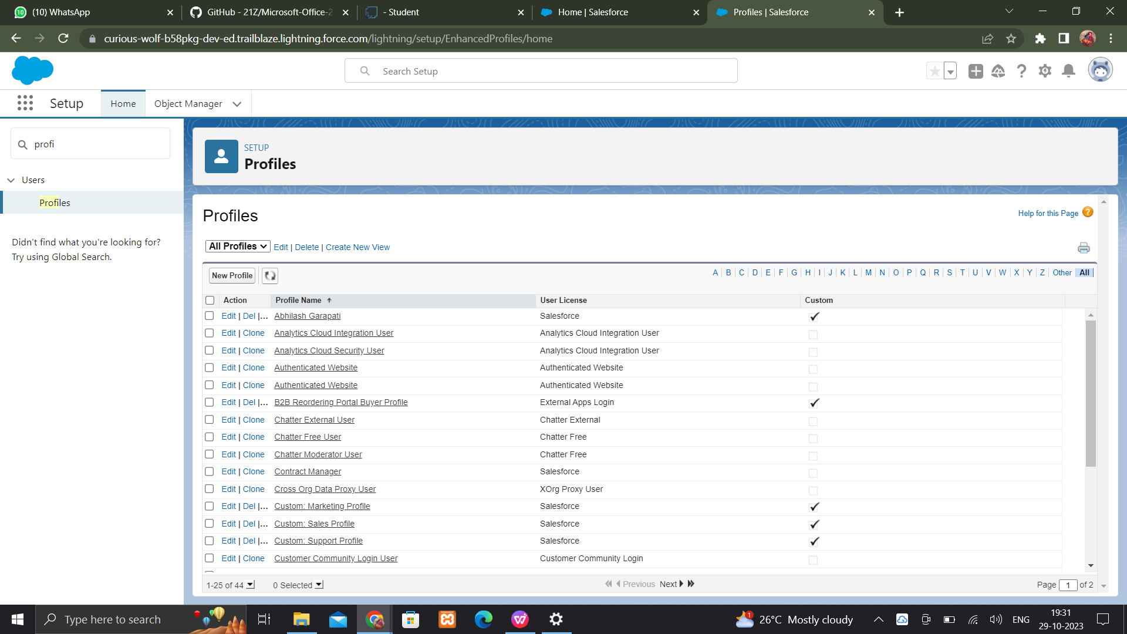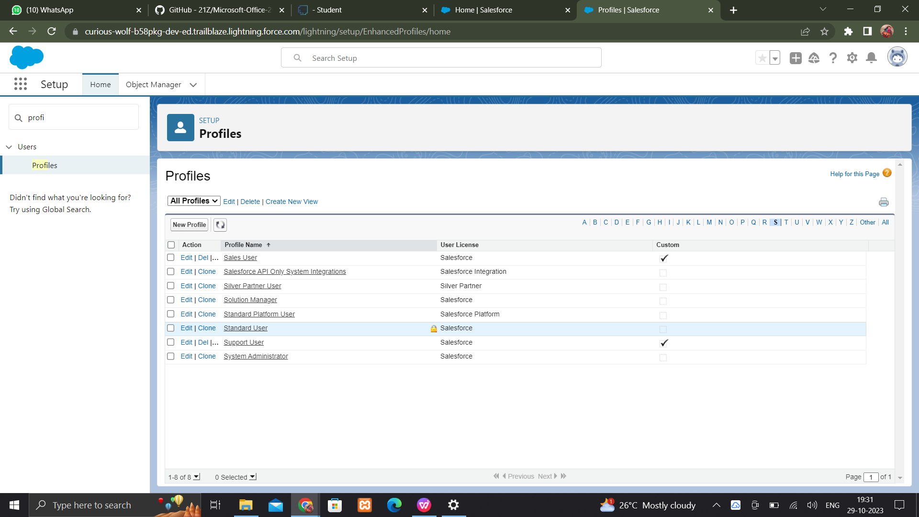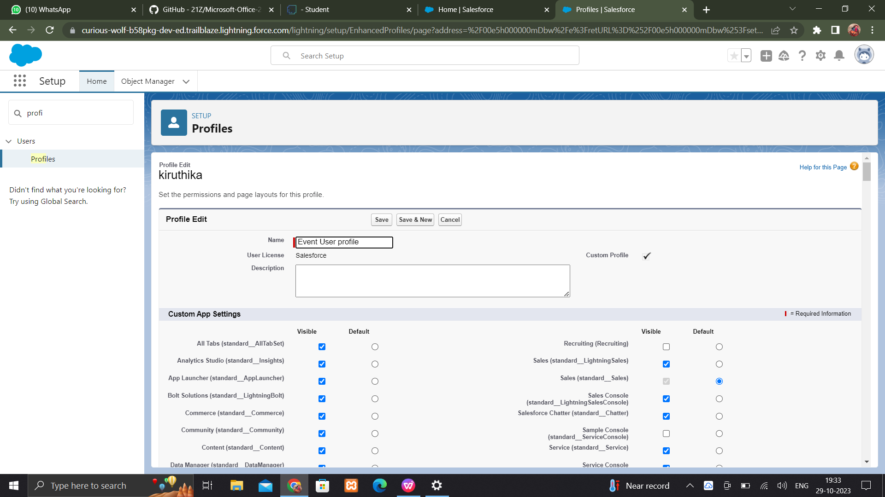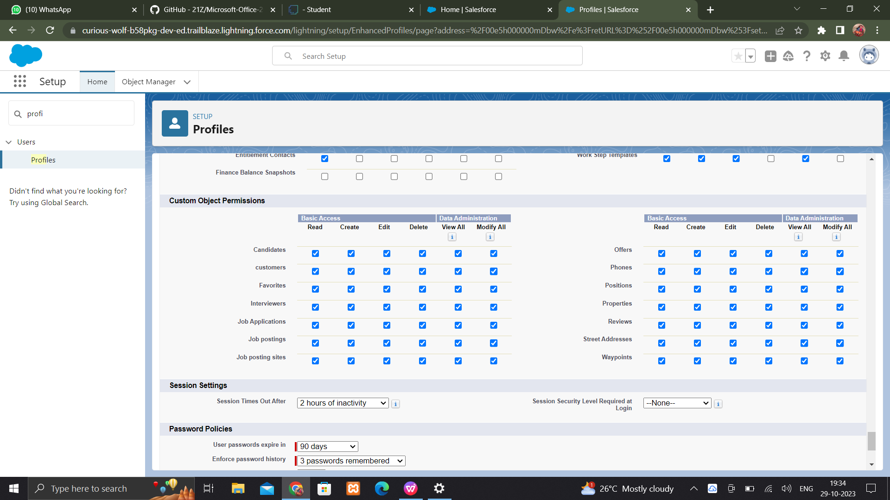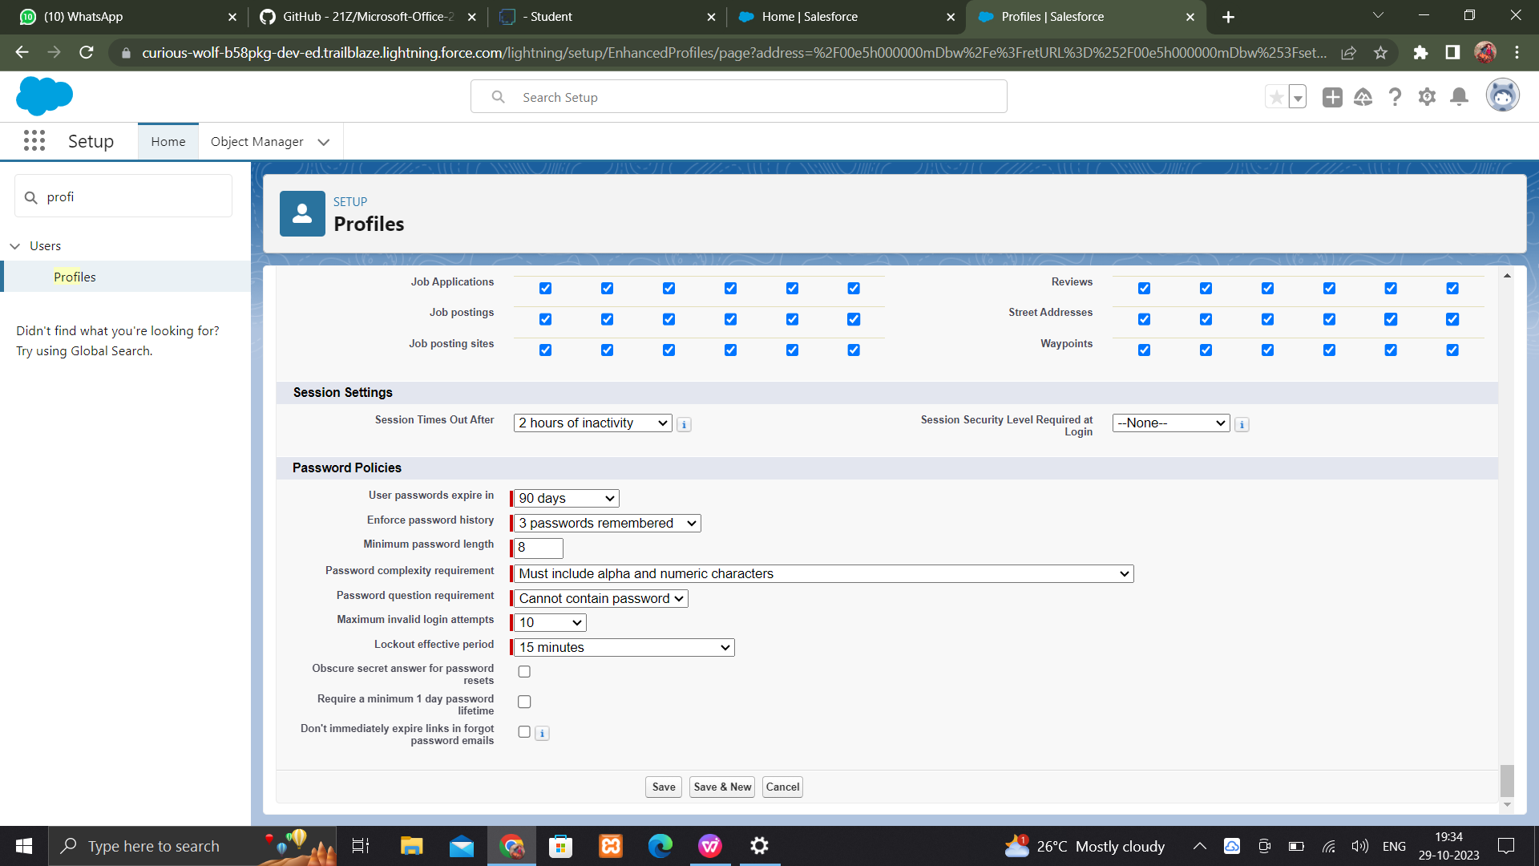

Creating a user

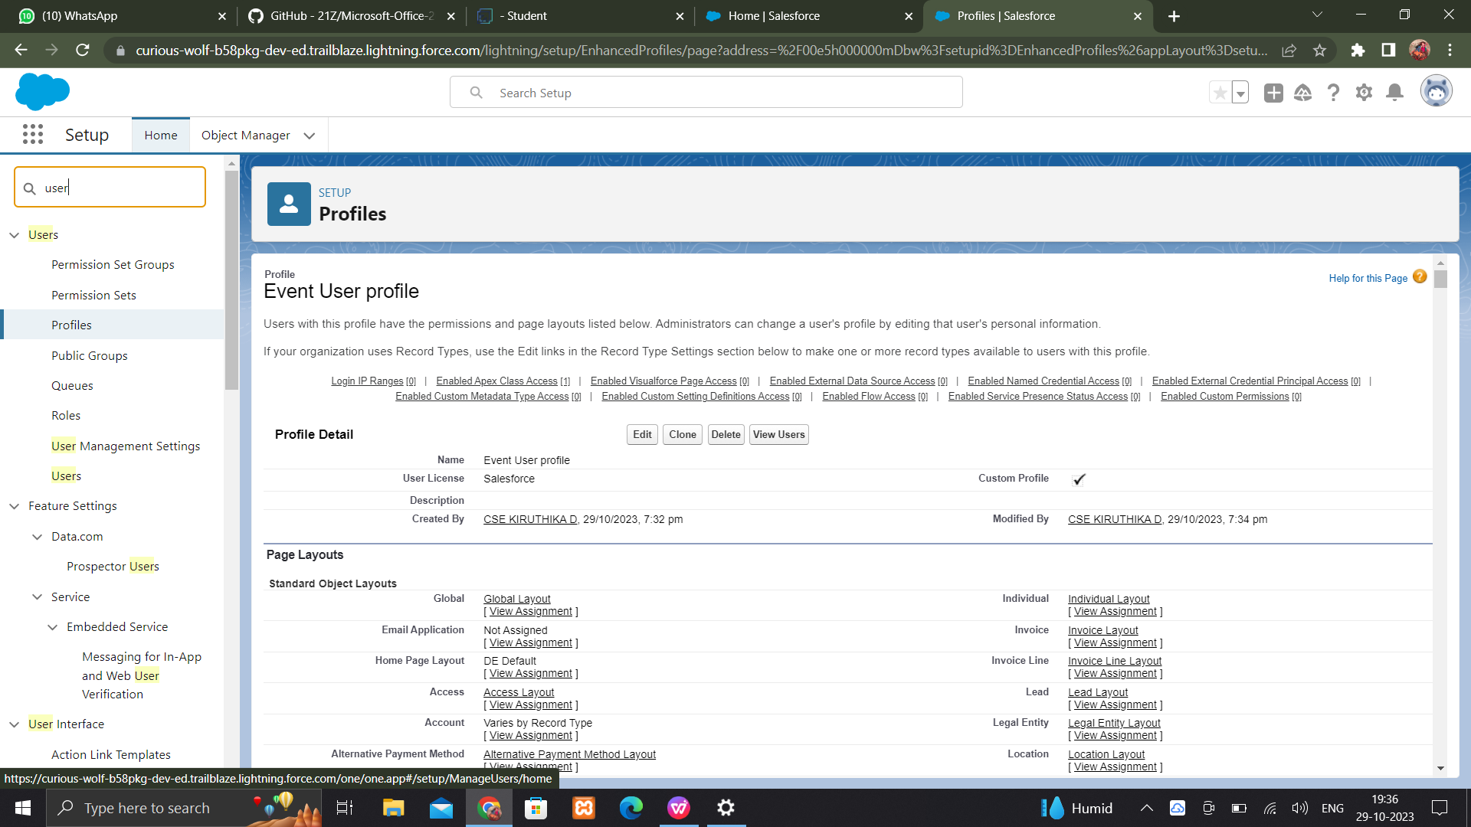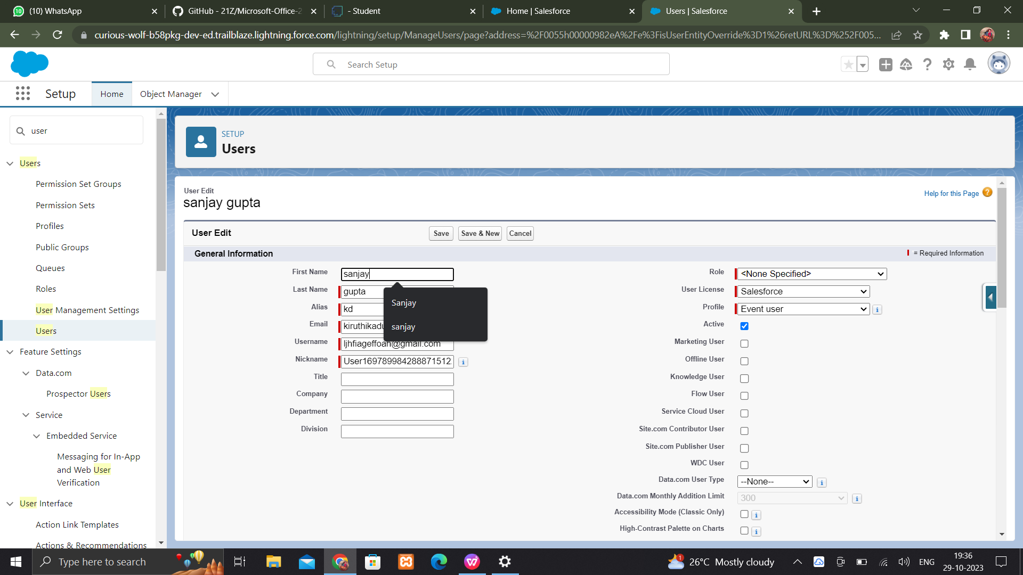

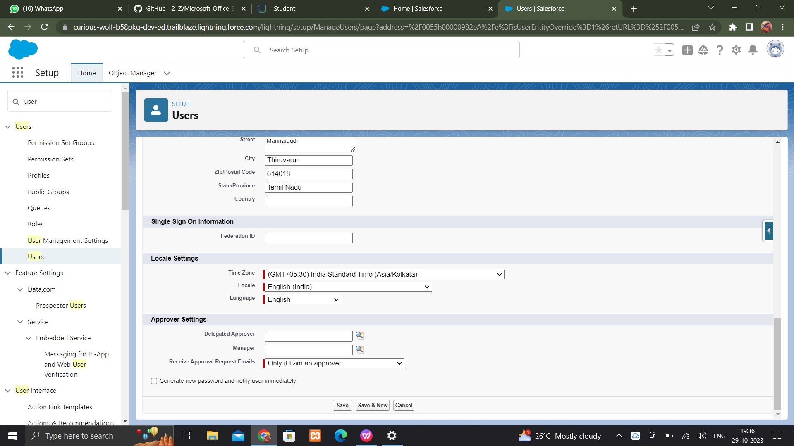

**PERMISSION SETS**

**Create a permission set for two user profiles**

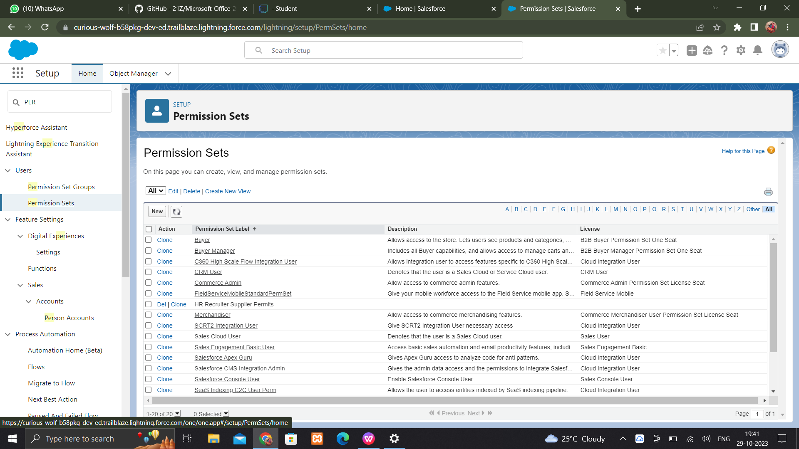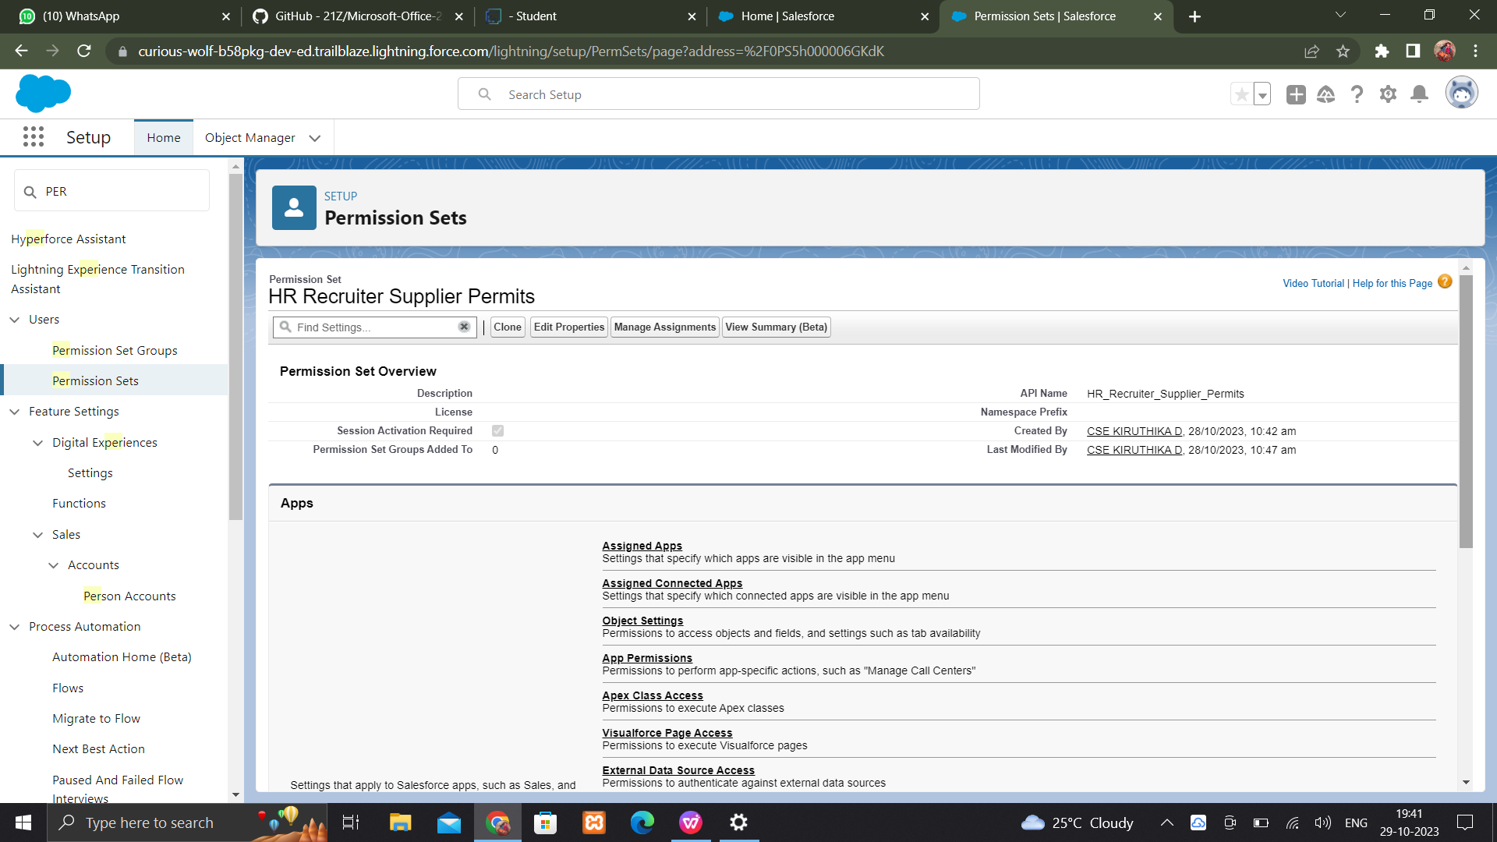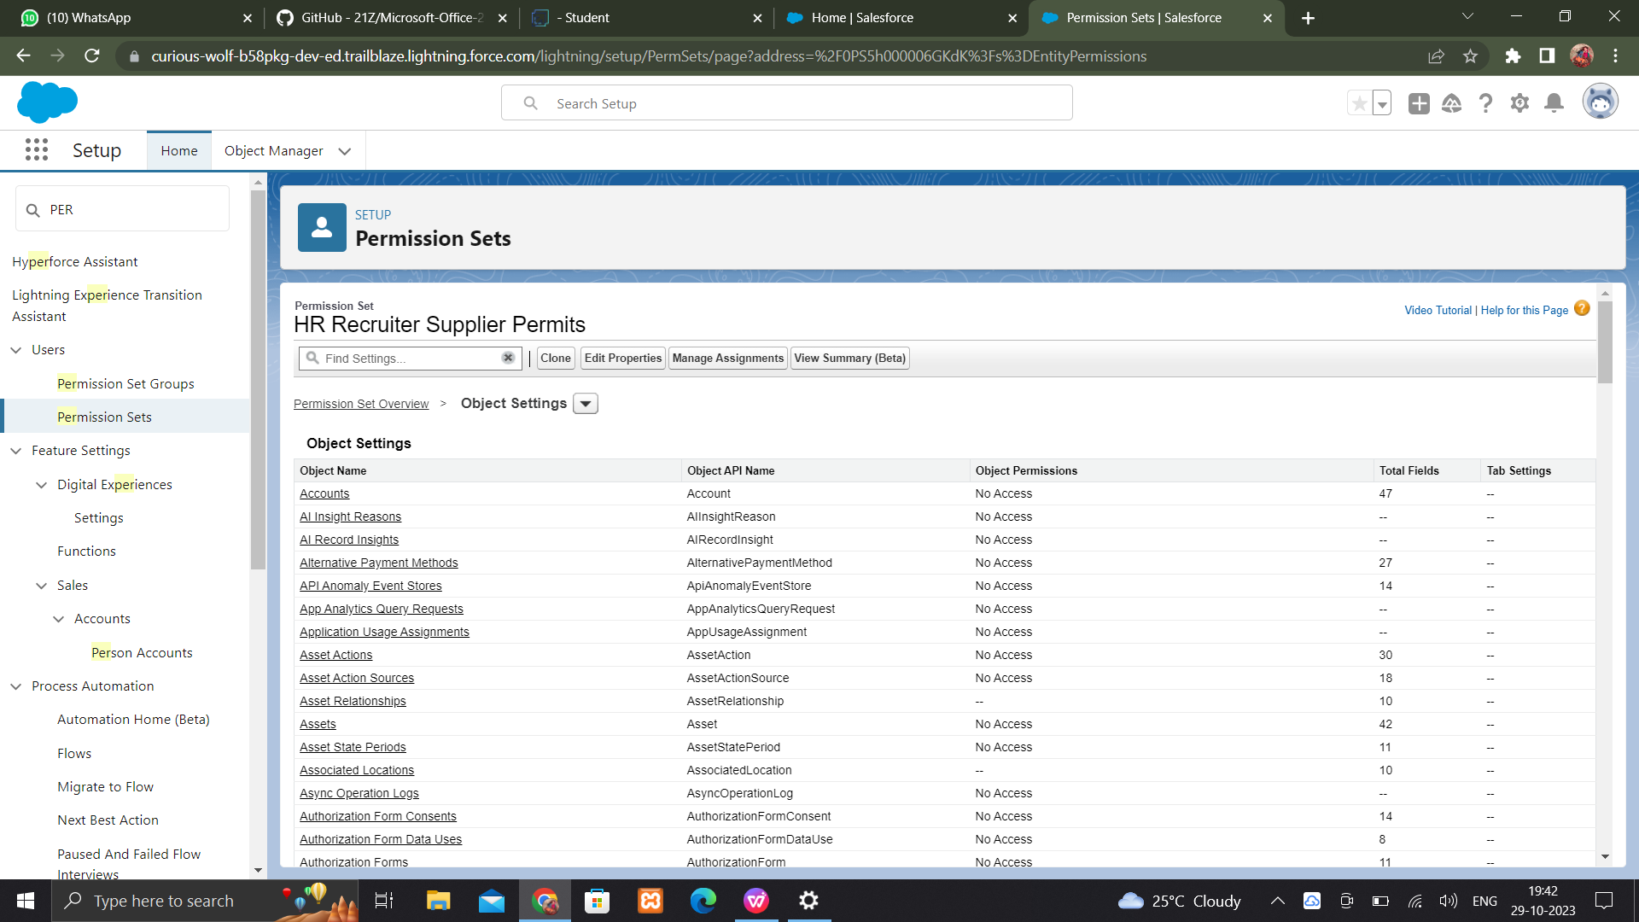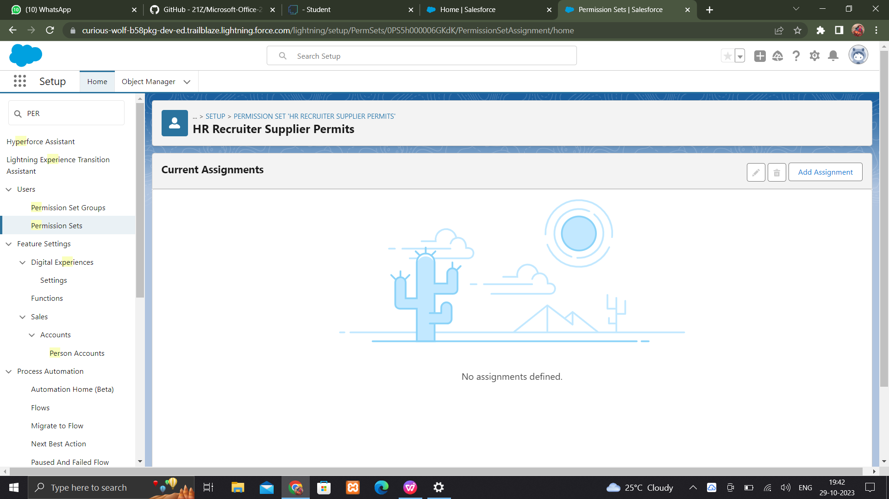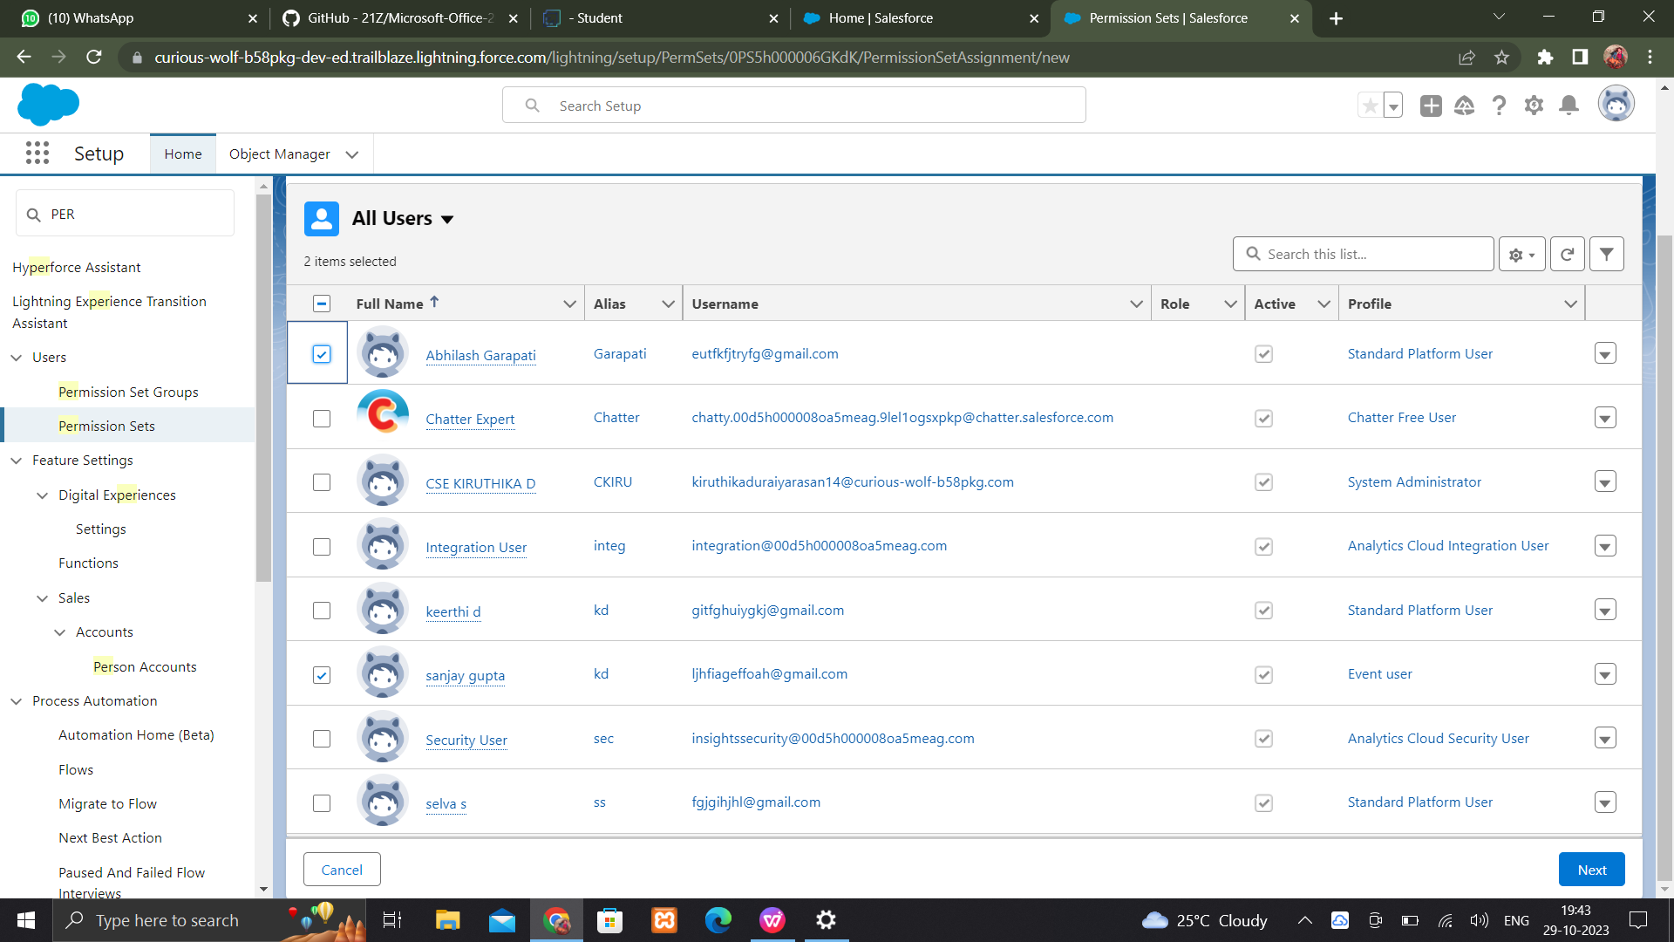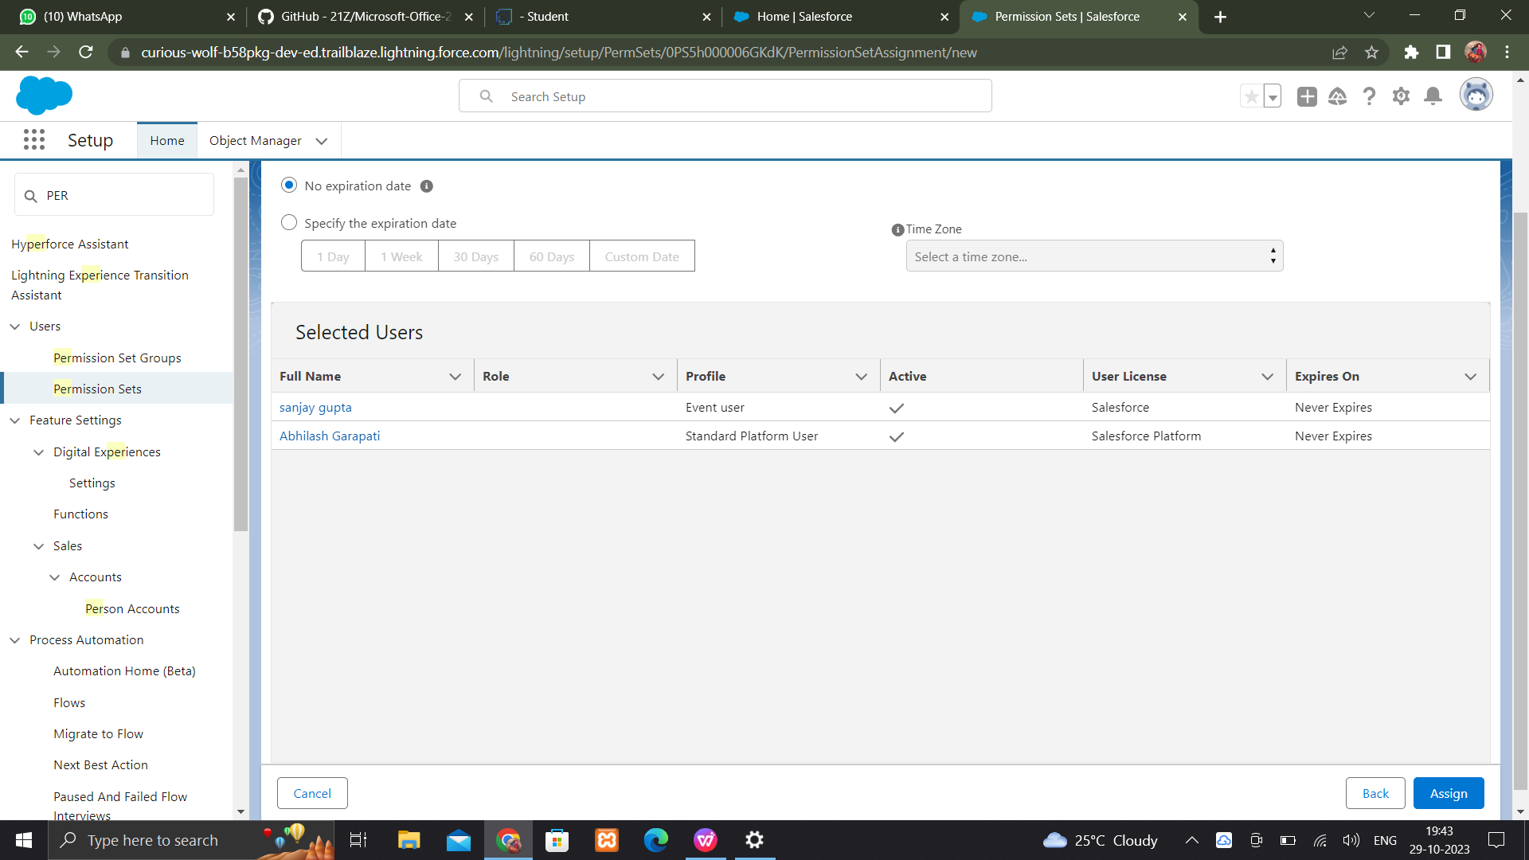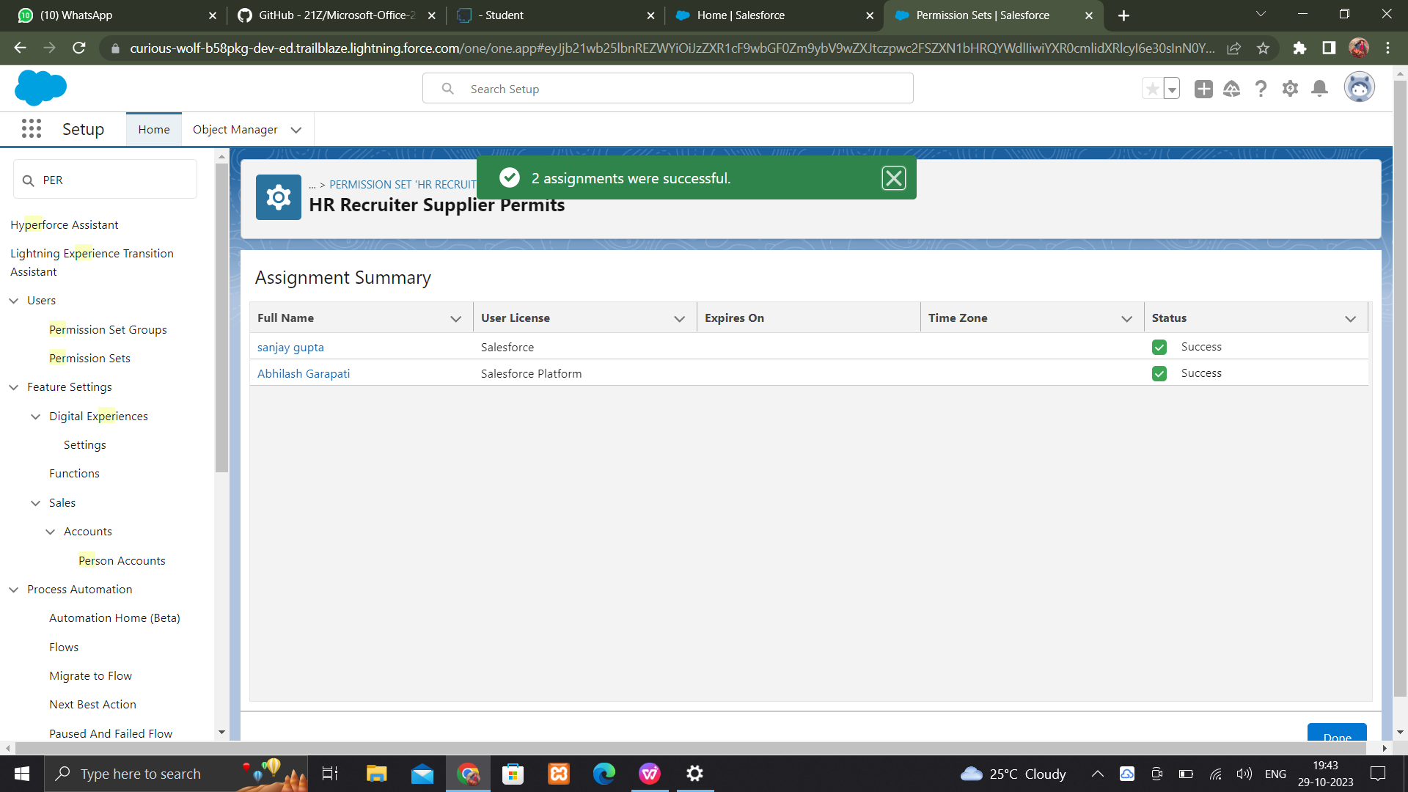

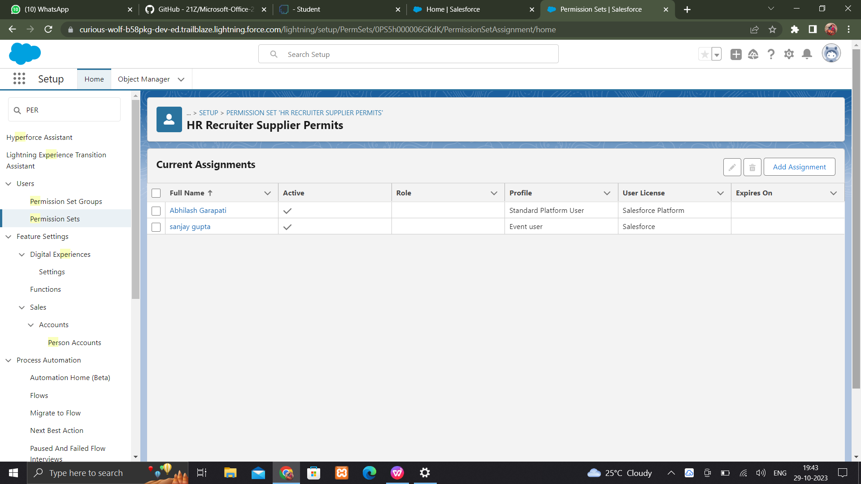

**USER ADOPTATION**

**Create a record adoption**

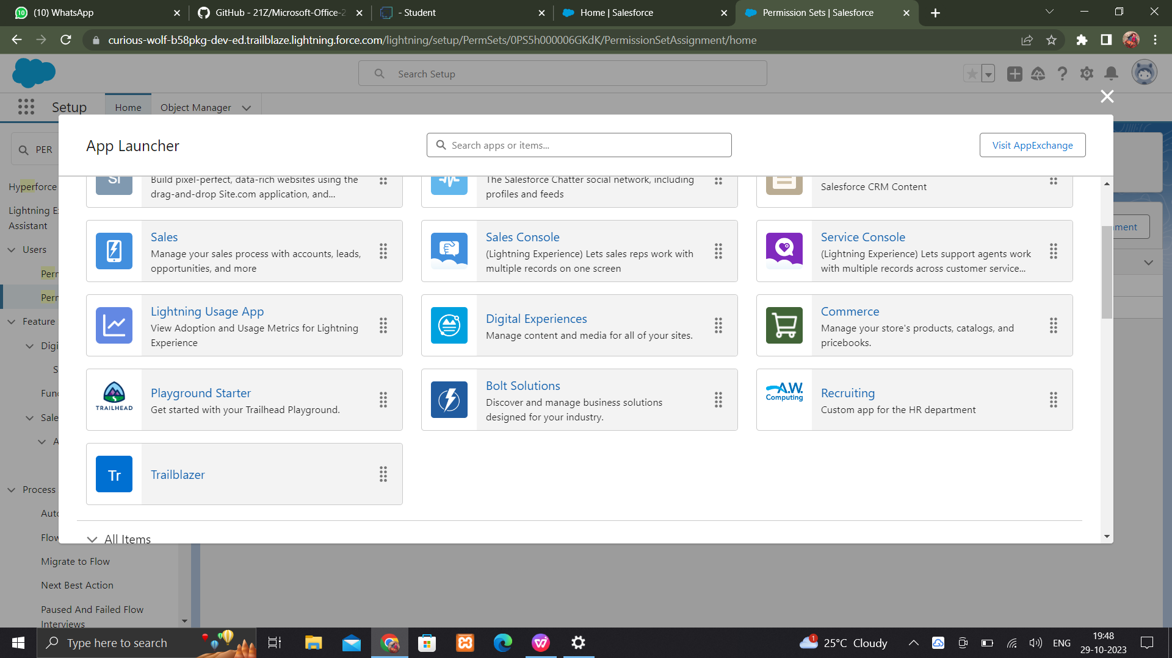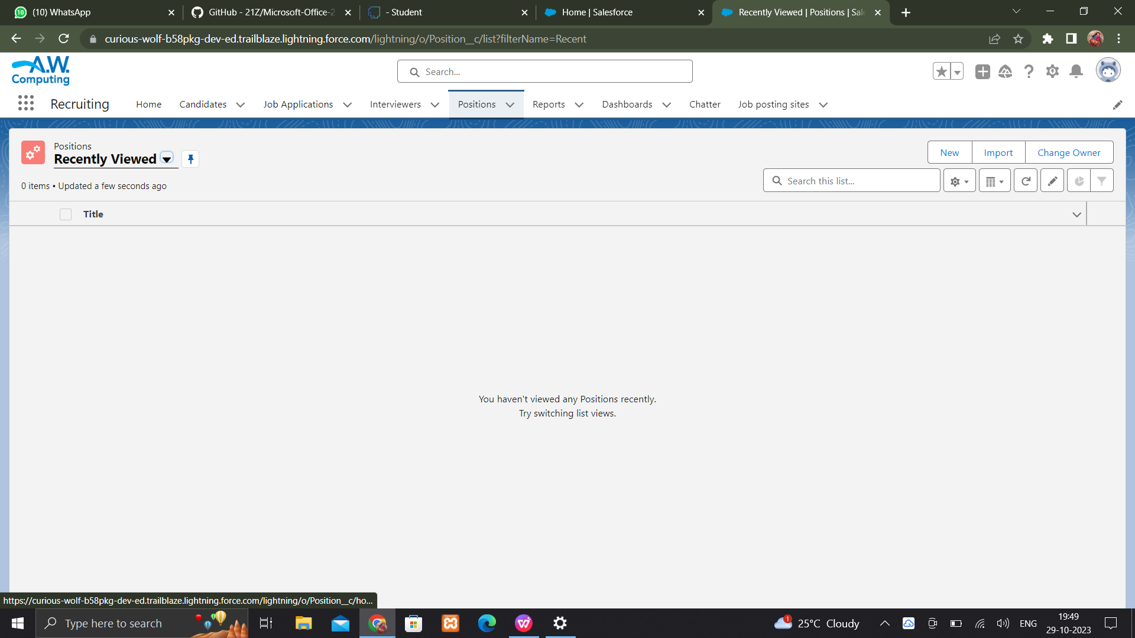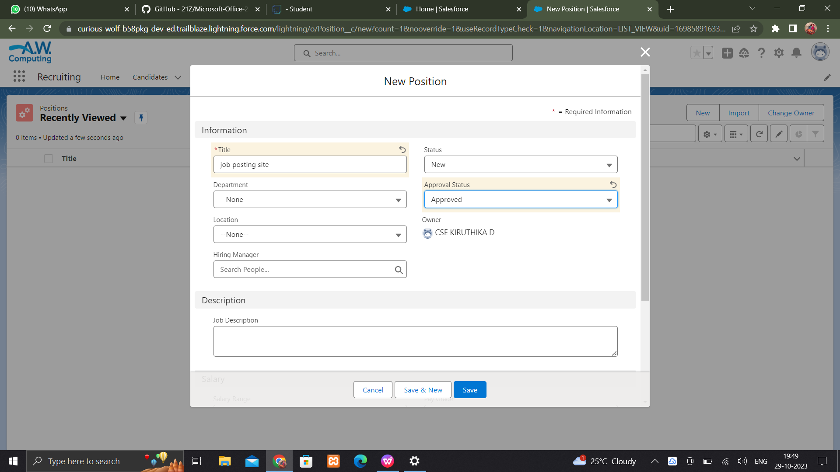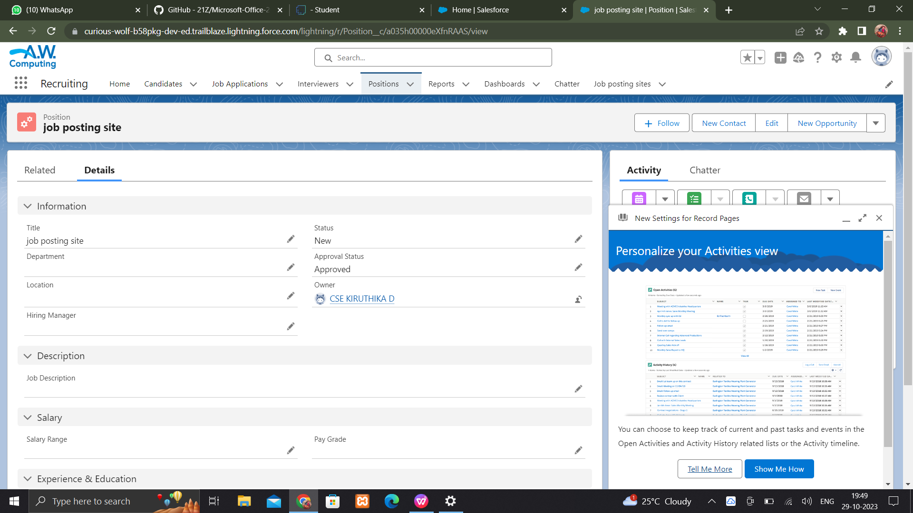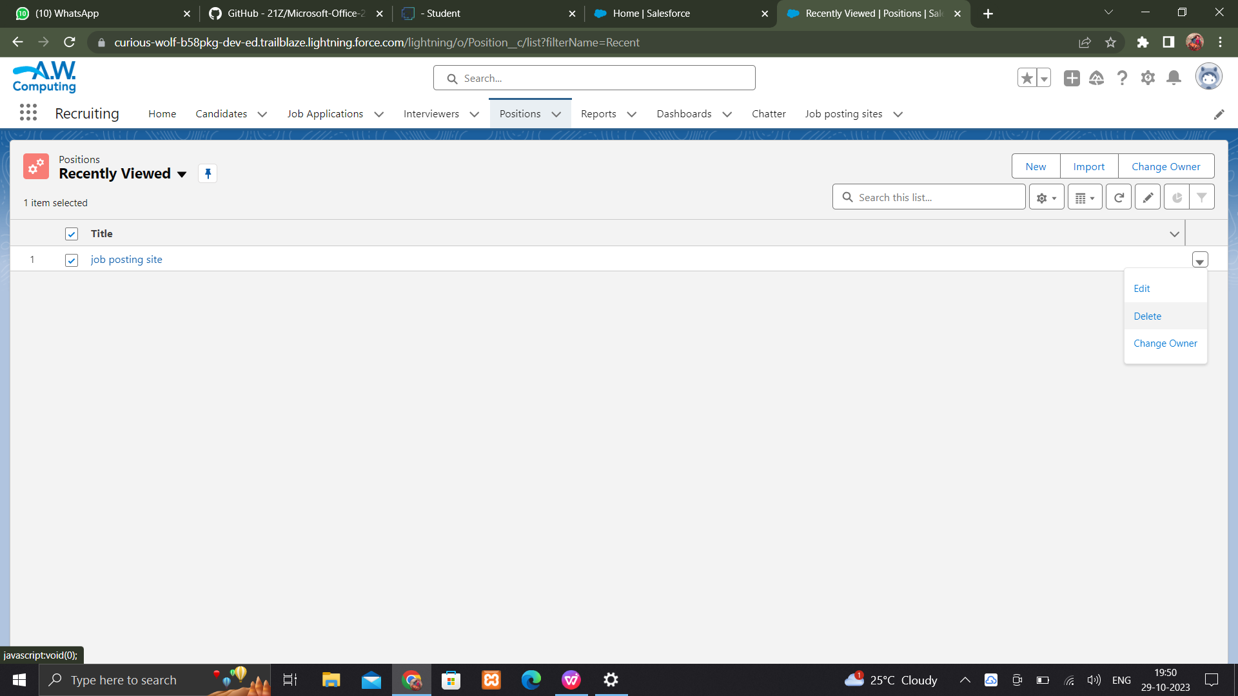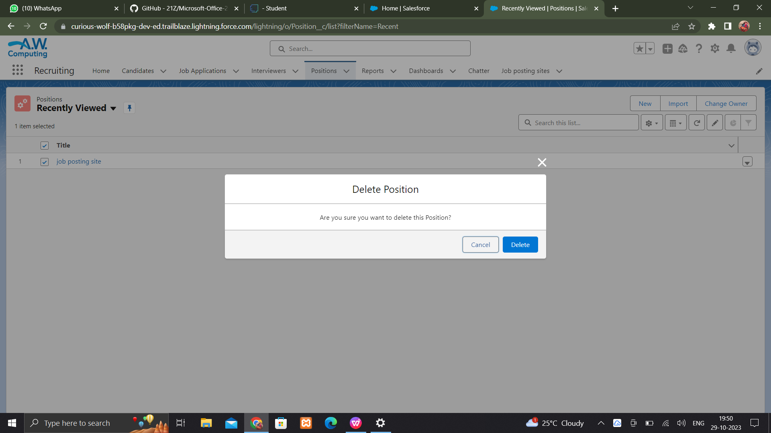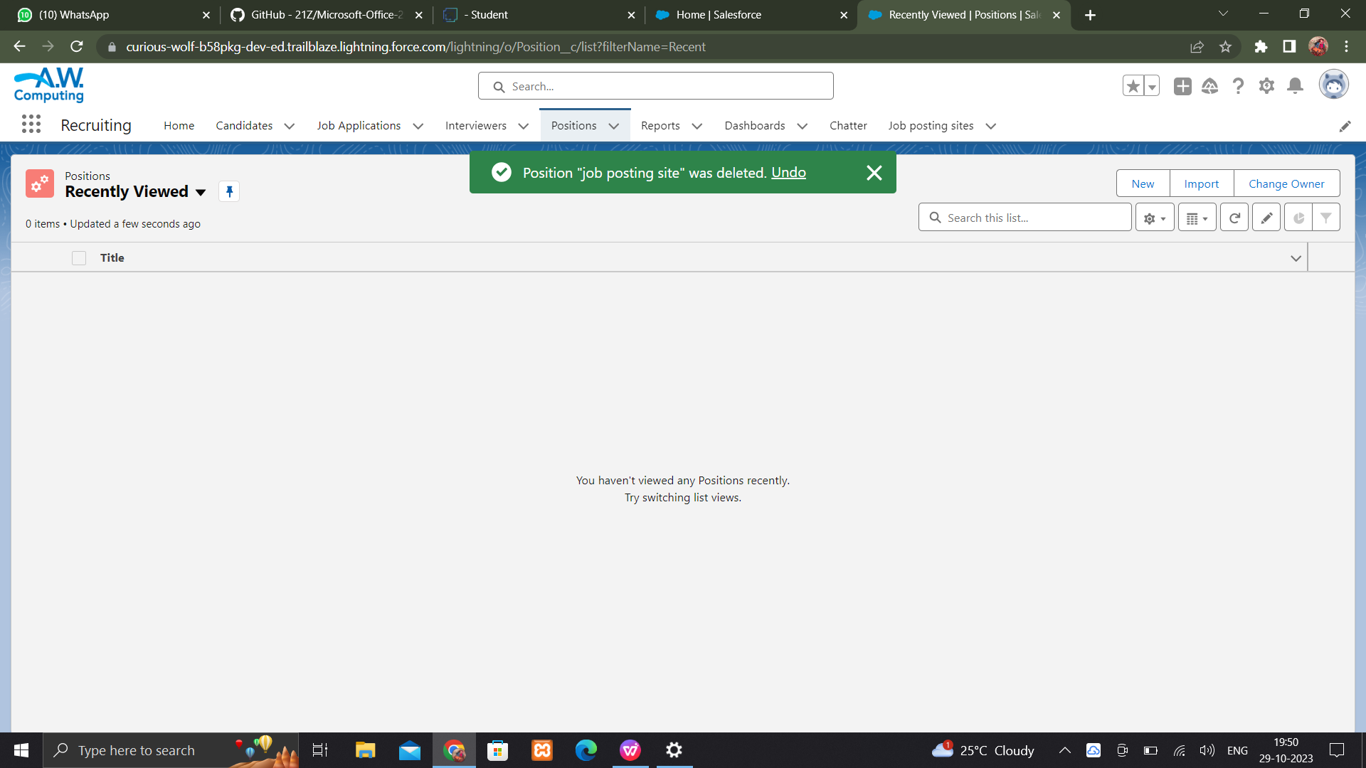

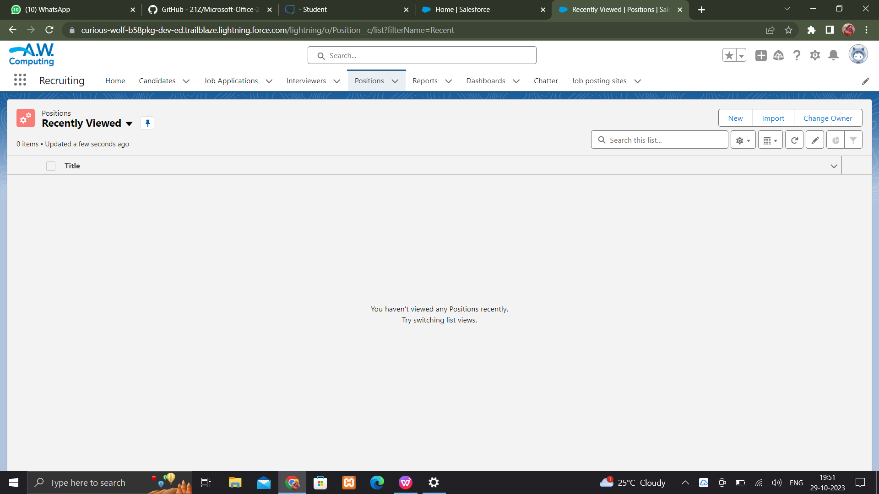

**Creating a reports**

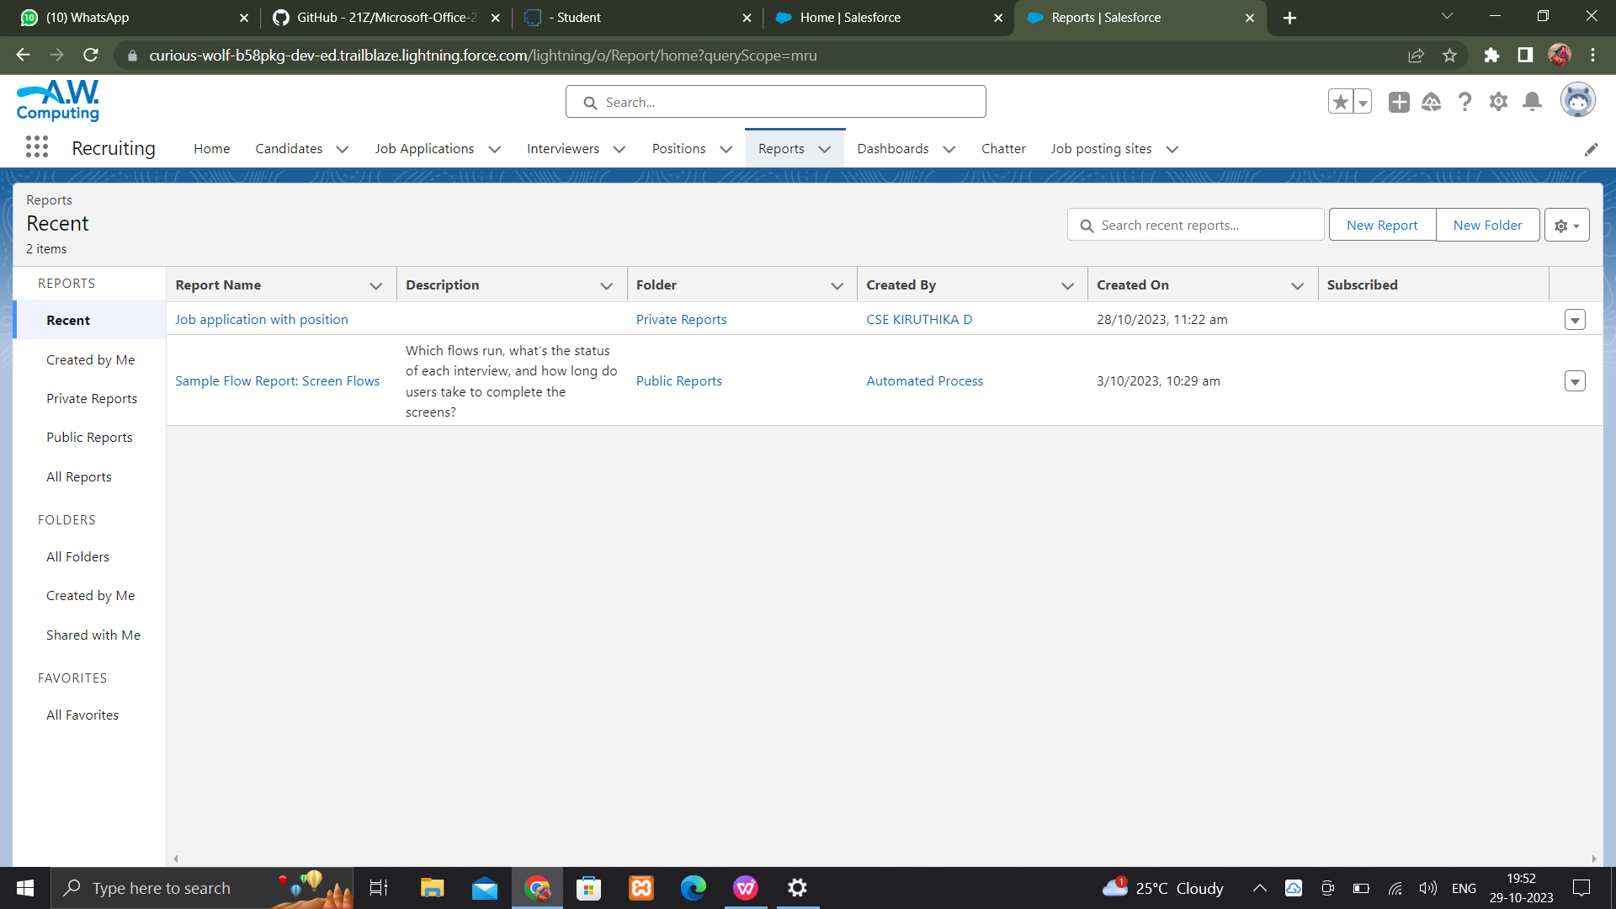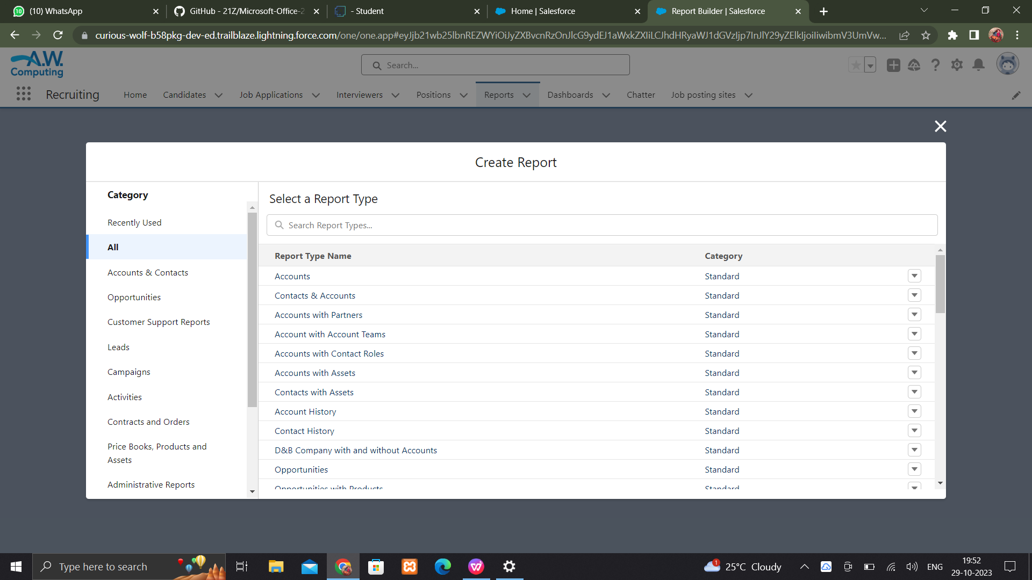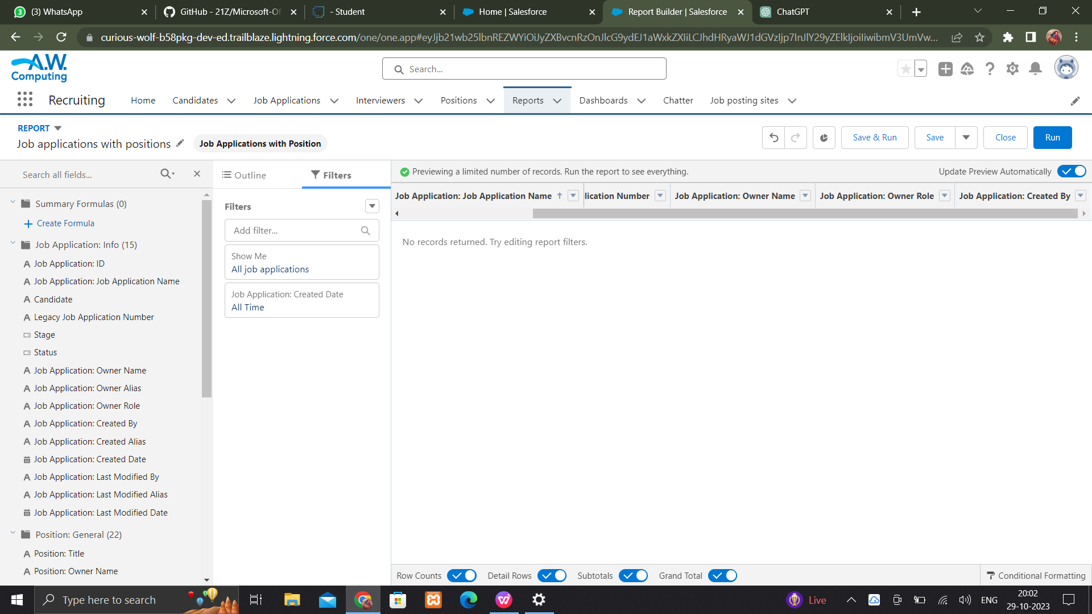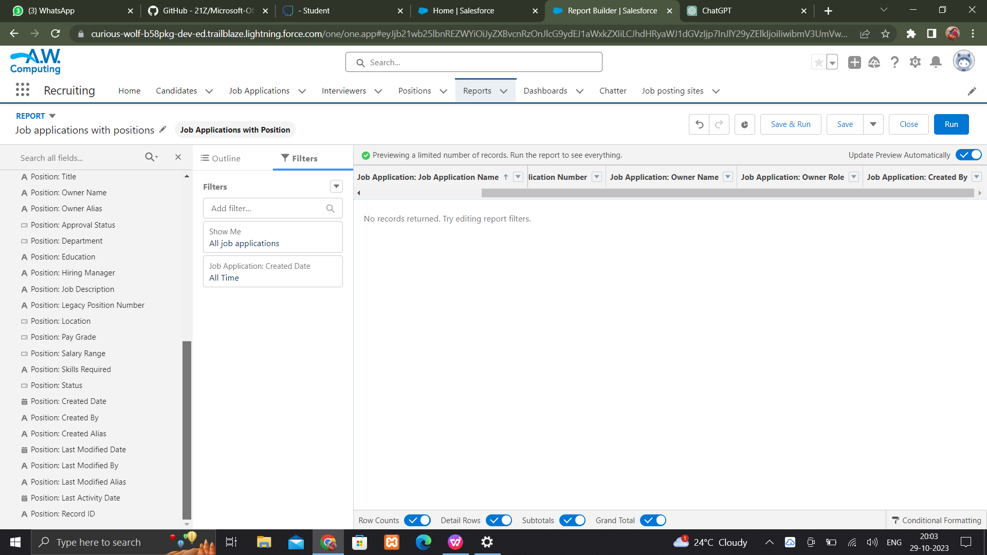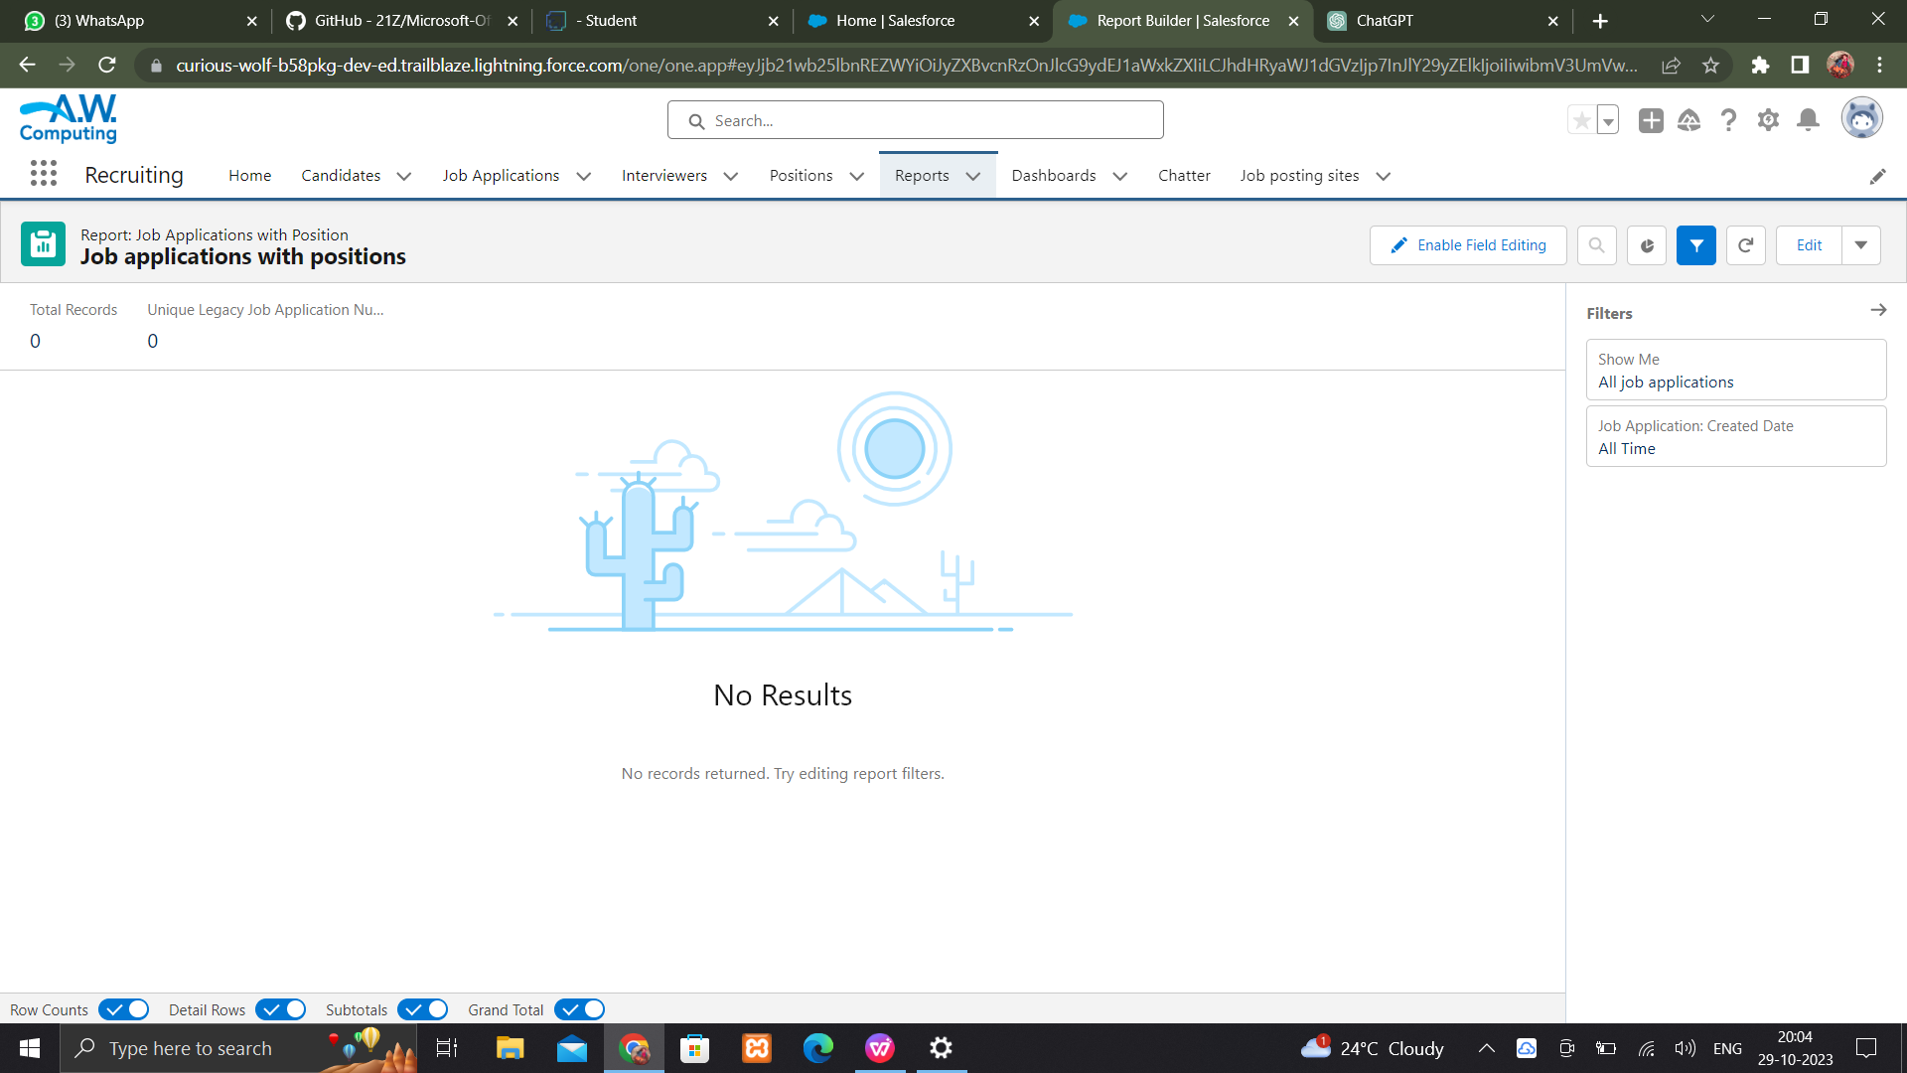

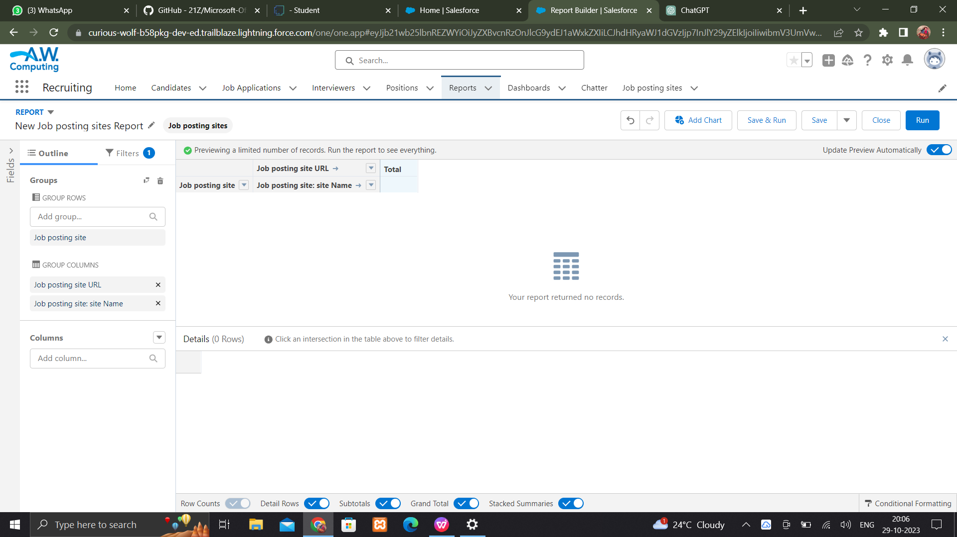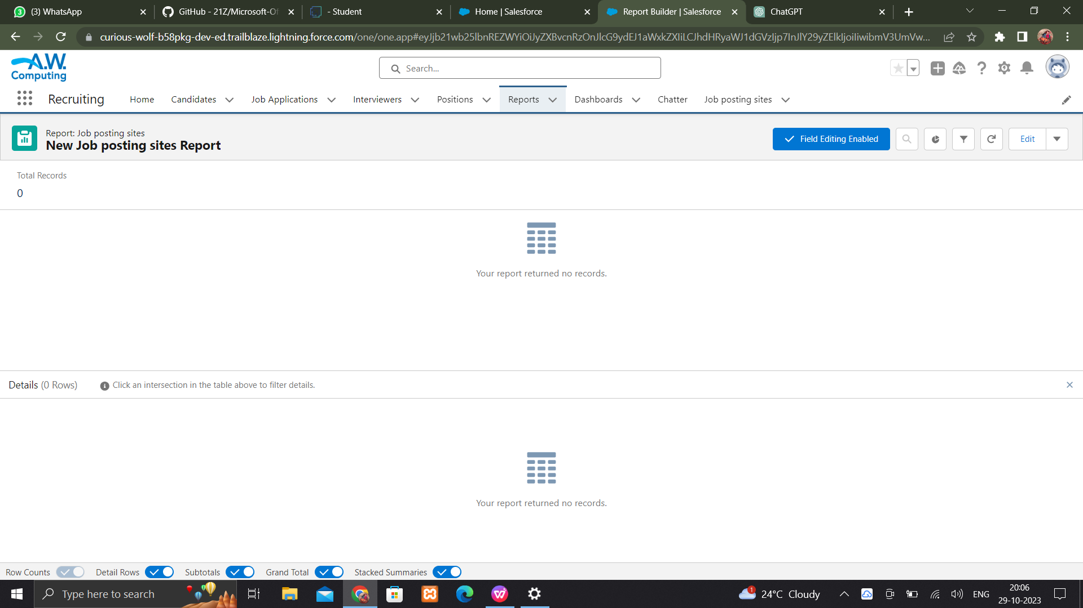



**Create a dash board**

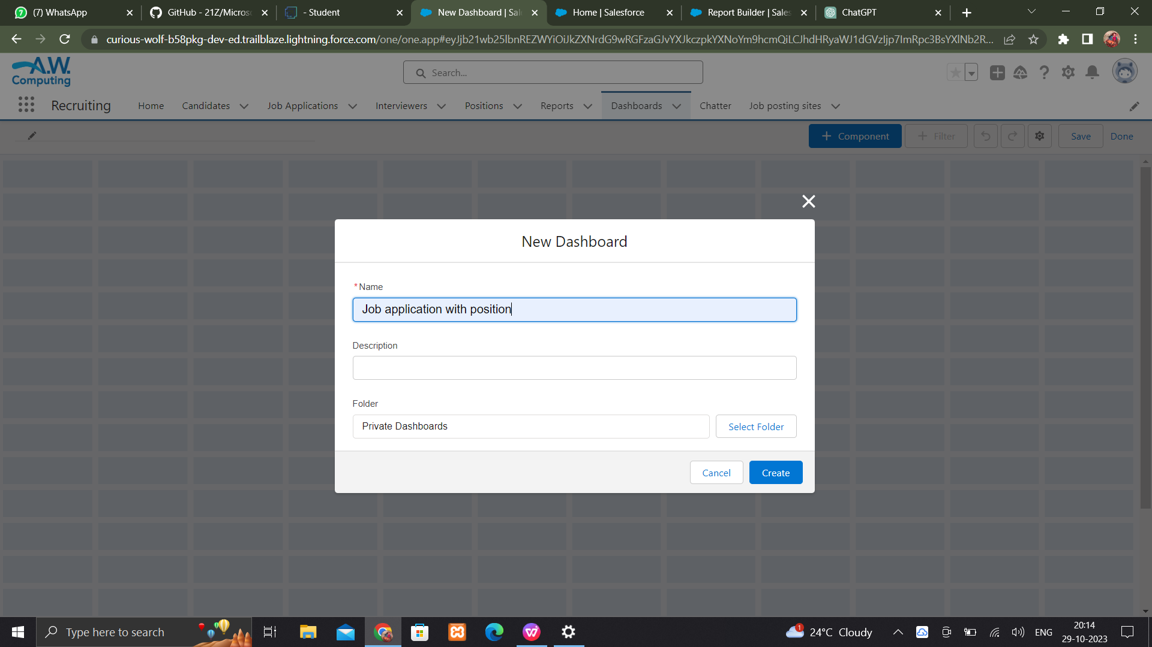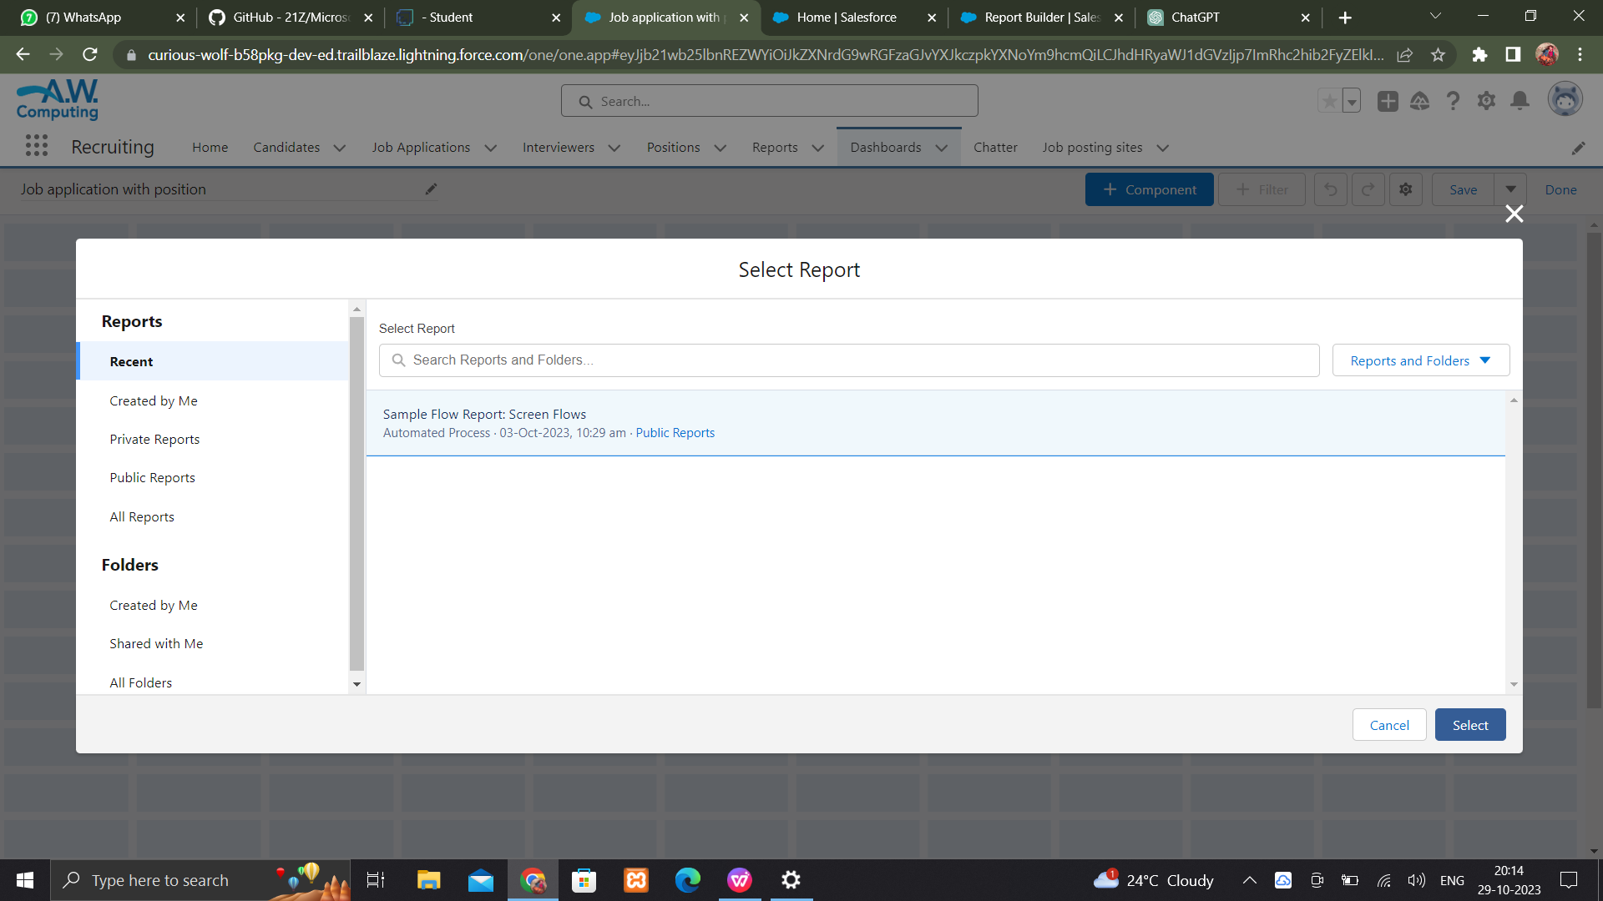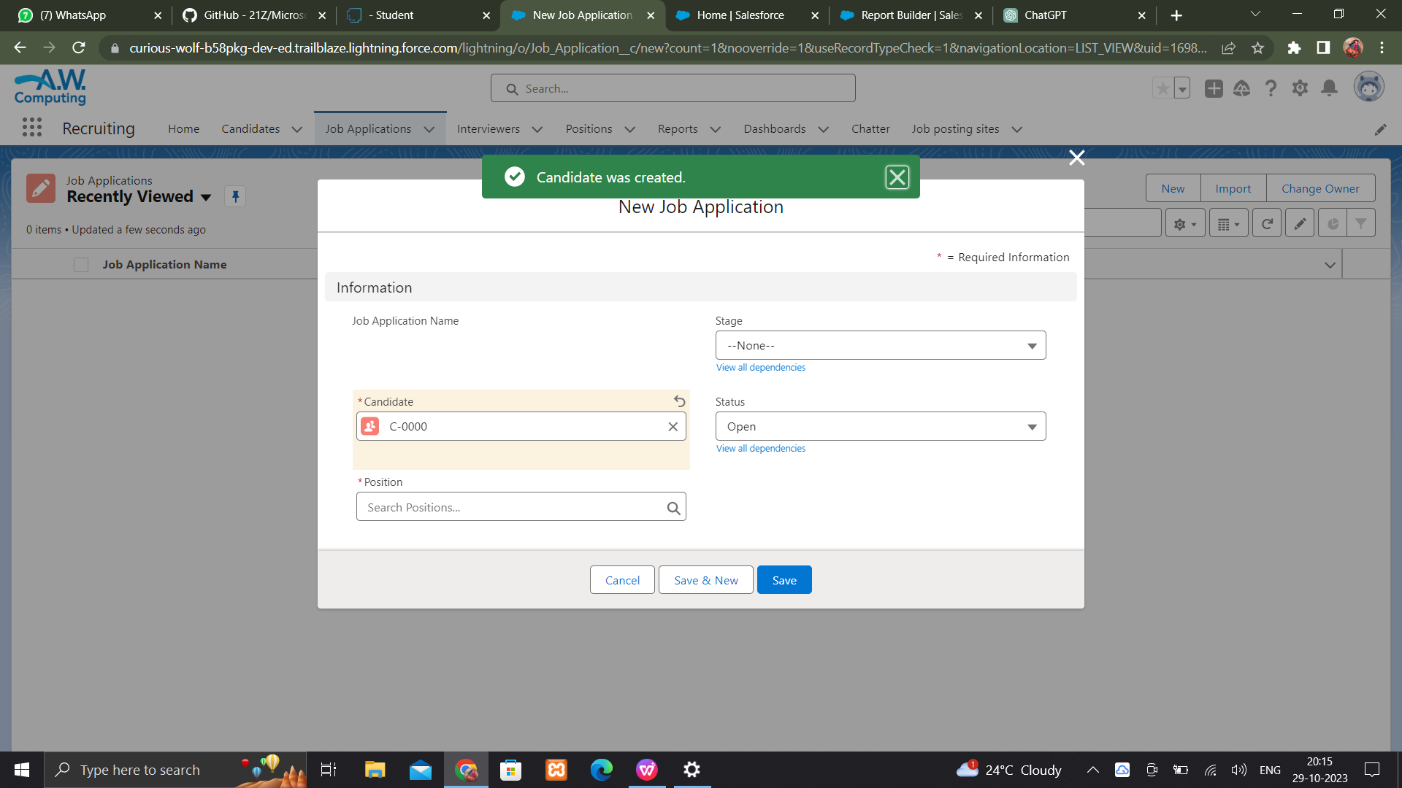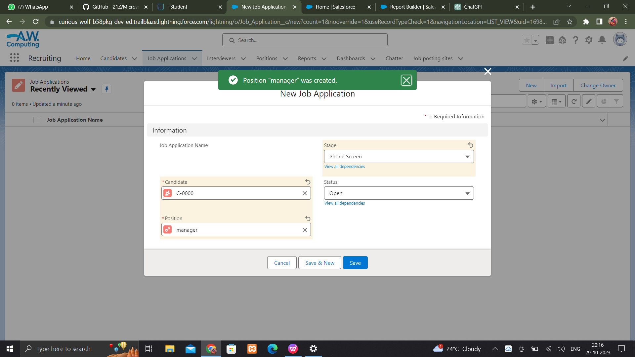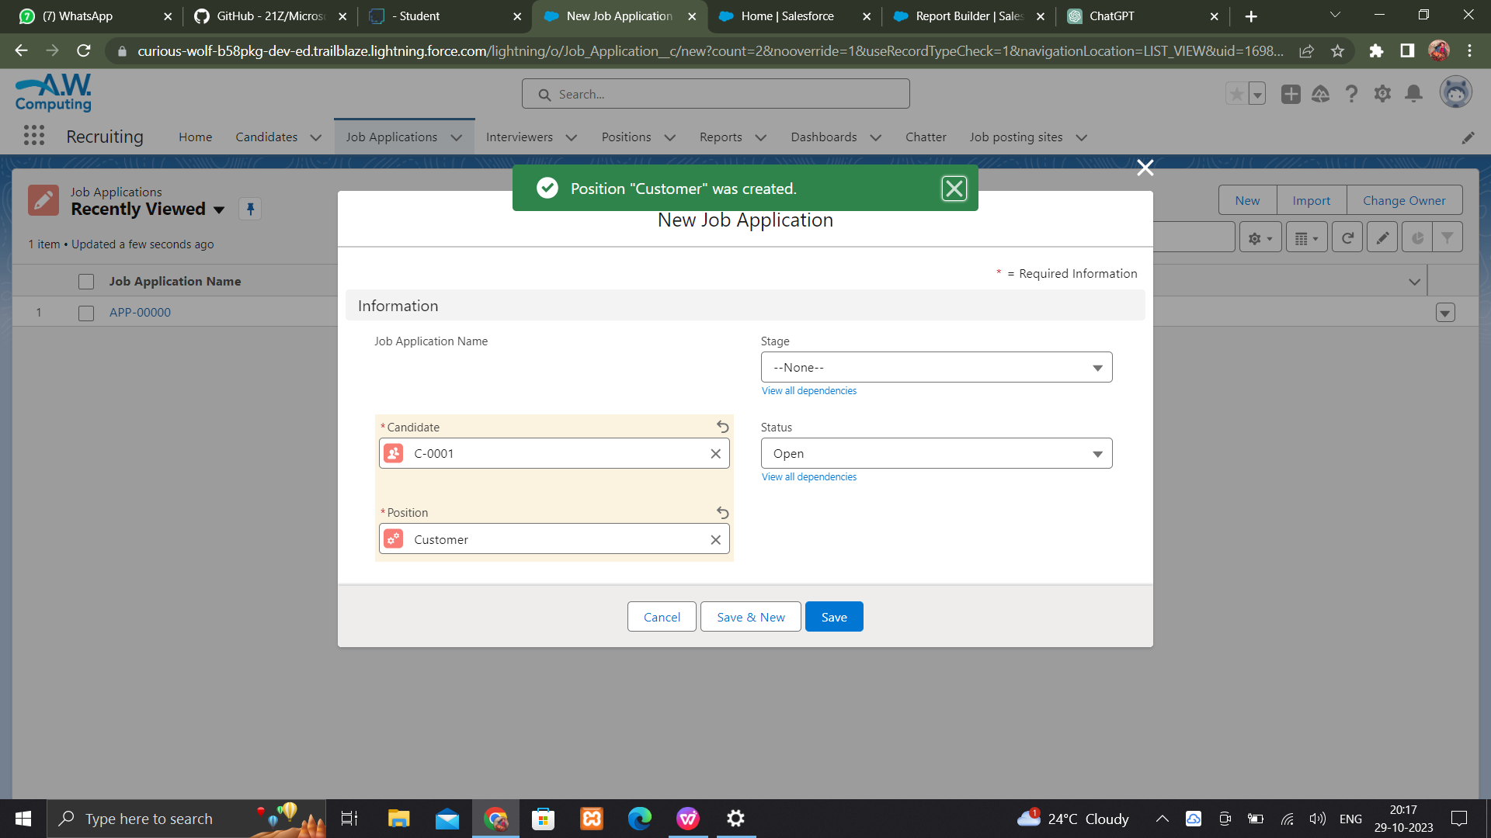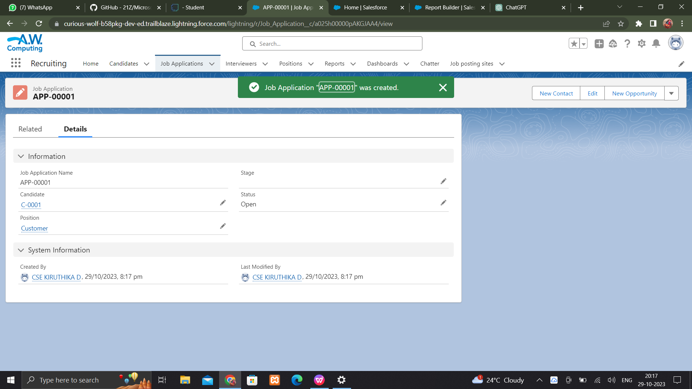

**CREATE A BATCH APEX**

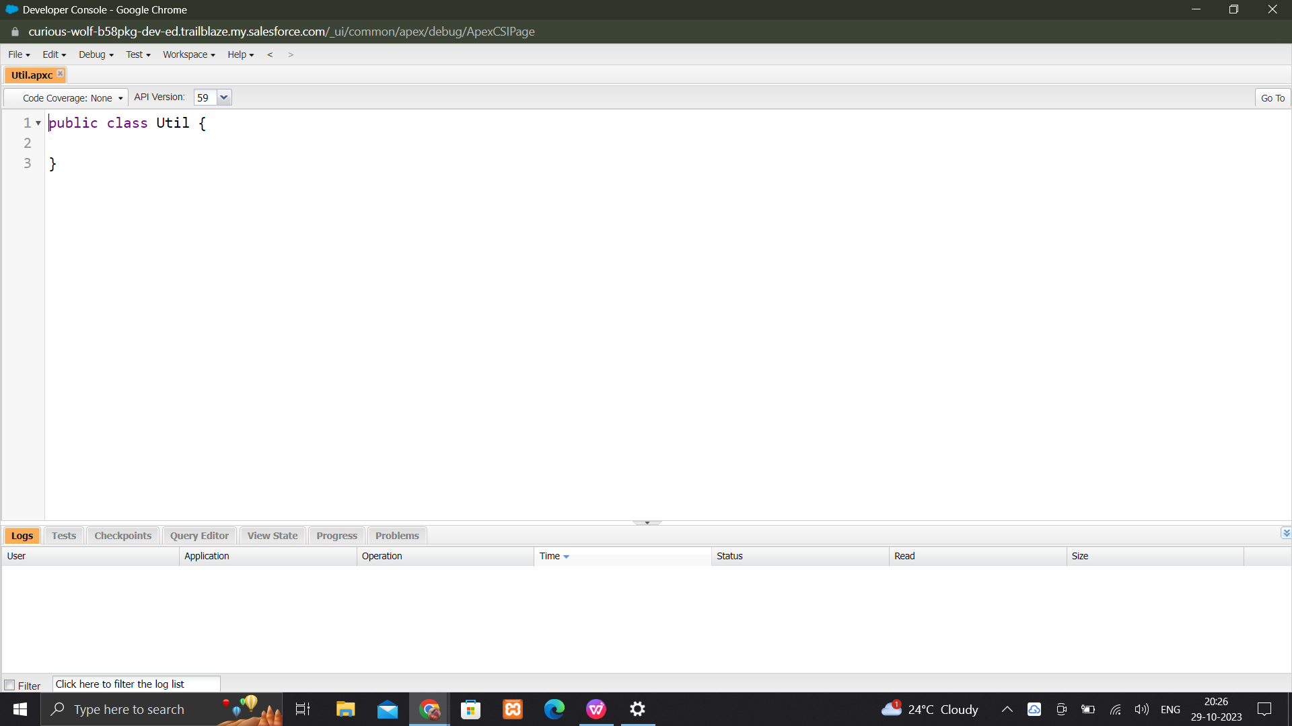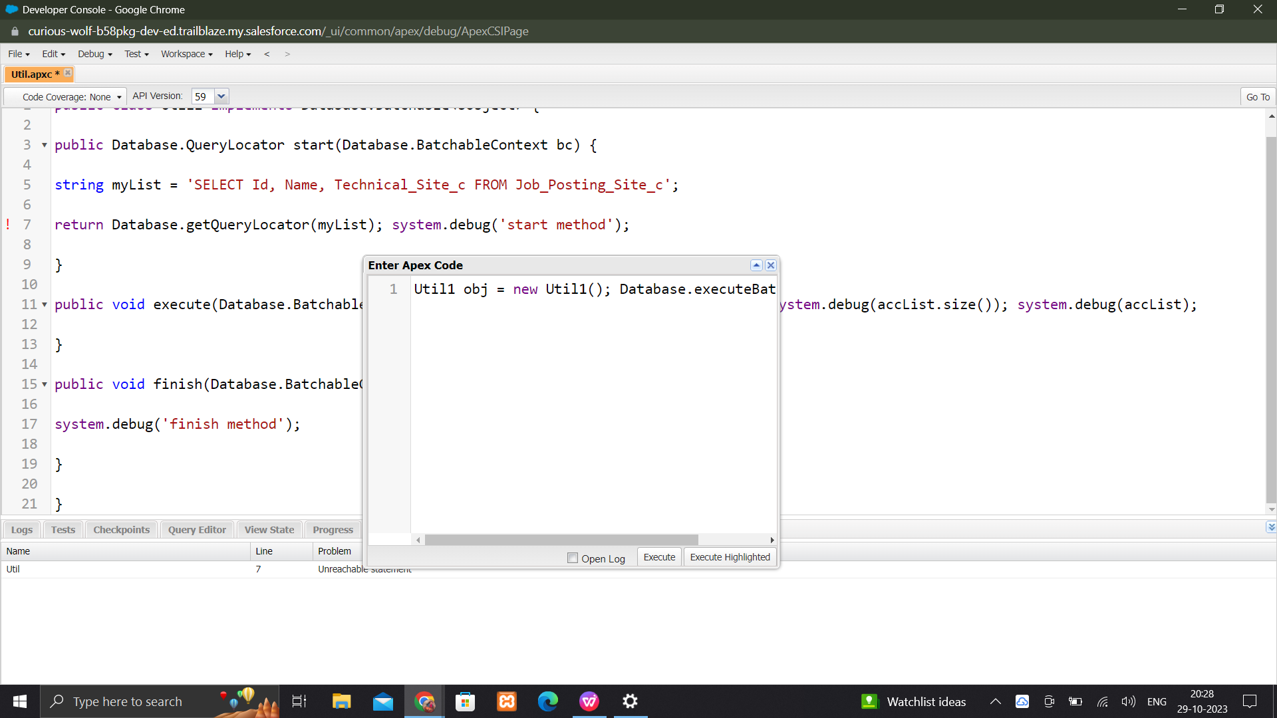

**Check the batch**

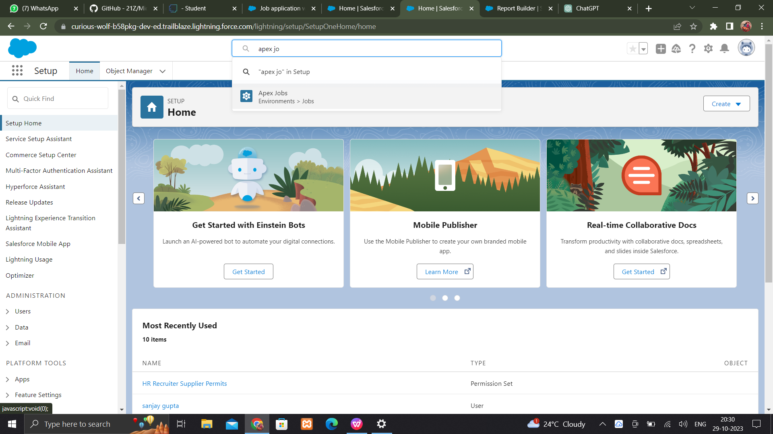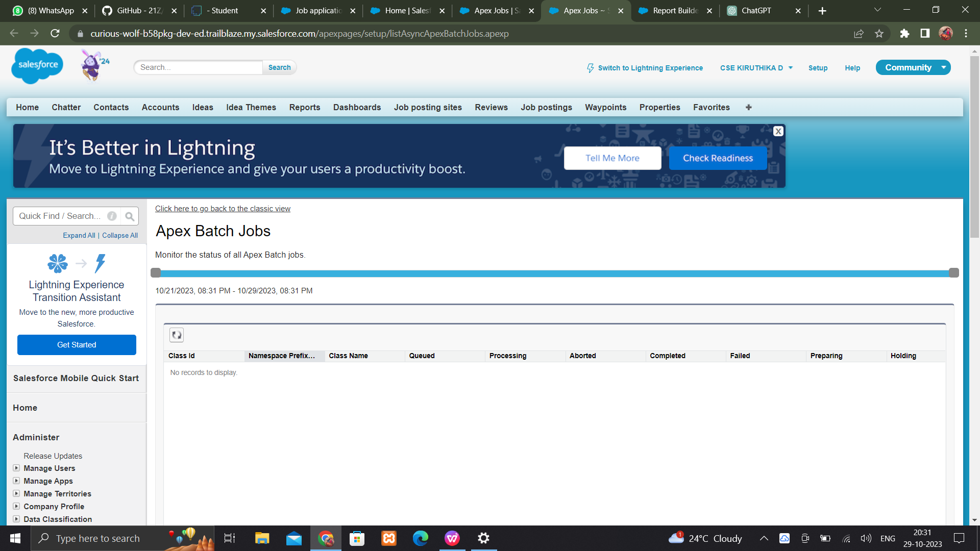

**CONCLUSION**

In conclusion, the "Recruiting Assistance for HR Managers Salesforce Project" presents a comprehensive approach to solving the recruitment challenges faced by HR managers in the context of the Salesforce project. By understanding the problem, proposing effective solutions, and delineating both functional and technical requirements, this project aims to streamline the recruitment process and ensure that the right talent is acquired and integrated into the project successfully.

The project acknowledges the critical importance of hiring skilled personnel who possess the specific expertise required for Salesforce administration, development, consulting, and project management. Through the refinement of job descriptions, the utilization of specialized recruitment channels, and a structured interview process, this project will enable HR managers to identify and select candidates who align with the Salesforce project's goals.

Furthermore, the technical requirements outlined ensure that the recruitment system is robust, secure, and capable of managing candidate data efficiently. The integration with HR and project management systems, as well as a focus on data security and compliance, underscores the project's commitment to delivering a reliable and compliant recruitment solution.

Ultimately, the success of the "Recruiting Assistance for HR Managers Salesforce Project" will not only facilitate the efficient execution of the Salesforce project but also contribute to its overall success by ensuring that the right talent is in place to drive the project forward. The combination of effective recruitment processes and a well-implemented technical infrastructure will help HR managers and project stakeholders achieve their objectives while adhering to industry best practices and compliance standards.

Githublink:[https://github.com/Kiruthikaduraiyarasan/74BC4F37853BF1E8045468DA6E31B6A0-SALESFORCE.git](mailto:https:/github.com/Kiruthikaduraiyarasan/74BC4F37853BF1E8045468DA6E31B6A0-SALESFORCE.git)

Demo link : [https://drive.google.com/file/d/1-iNs-3JfICUivaU_UEiN-2IO3_EcCCza/view?usp=drive_link](mailto:https:/drive.google.com/file/d/1-iNs-3JfICUivaU_UEiN-2IO3_EcCCza/view?usp=drive_link)